Week 14 - Maths Support Pack
This pack includes your 3 maths lessons for the week. The pack includes:
- Maths starters to keep your brains working fast!
- 3 maths lessons
- Worksheets
- Extension Task
This pack is to help you, so read through as carefully as possible so that you know what to do for your maths this week. In week 14, we are looking at shape. Try your best with everything. Happy Learning Year 5! 😊
Lesson 1 – Teach and Practise – Regular and irregular polygons
Starter – Daily 10
https://www.topmarks.co.uk/maths-games/daily10
Practise the times tables you feel less confident with! (6’s,7’s, 8’s, 9’s or 12’s) Try 7 seconds like we do in class, or less if you want a challenge.
Input – Regular and irregular polygons
Open this link https://whiterosemaths.com/homelearning/year-5/ . Click on Summer Term, Week 11, Lesson 1 to watch the online video.
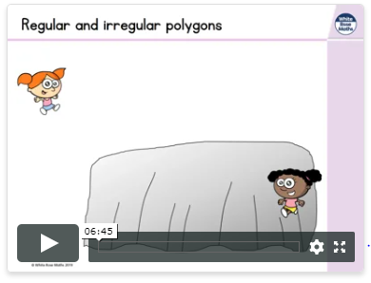

Online video

Activity: Complete the questions that are below. Watch the video for this lesson as many times as you need to. It’s there to help you!
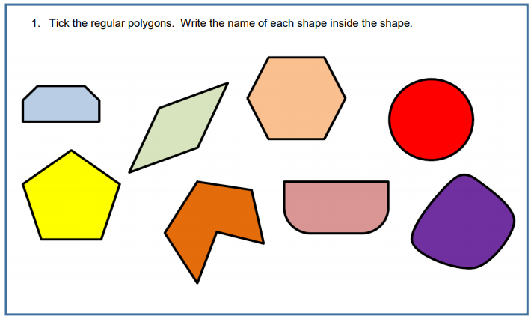
Once you have finished, open the answers document to check your work.

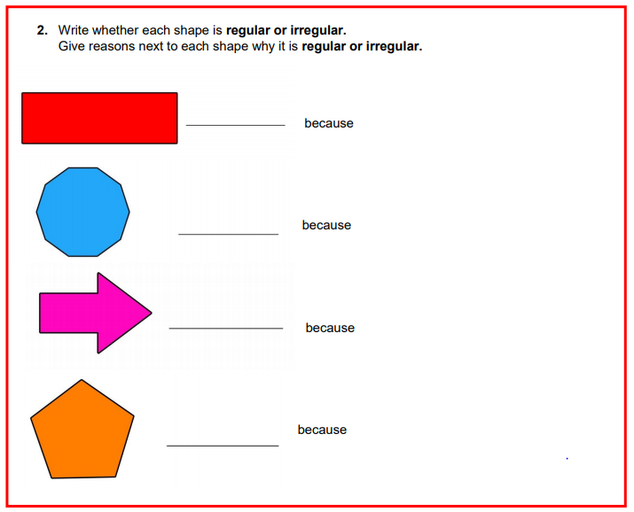

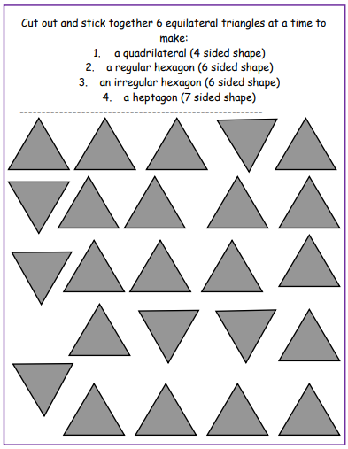

Stick and label your shapes here:

Lesson 2 – Teach and Practise- Reasoning about 3D shapes
Starter – Times Table Rock Stars
Accept your challenges and even challenge the teachers!
https://ttrockstars.com/

Input – Regular and irregular polygons
Open this link https://whiterosemaths.com/homelearning/year-5/ . Click on Summer Term, Week 11, Lesson 2 to watch the online video.
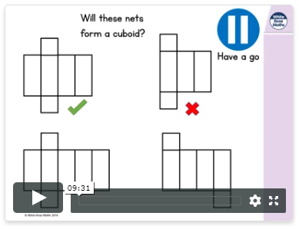
Online video

Activity: Complete the questions that are below. Watch the video for this lesson as many times as you need to. It’s there to help you!
Once you have finished, open the answers document to check your work.
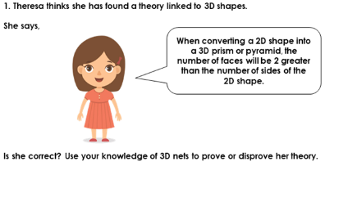
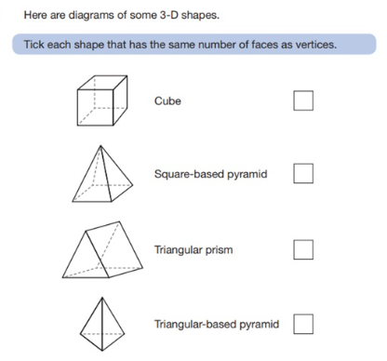

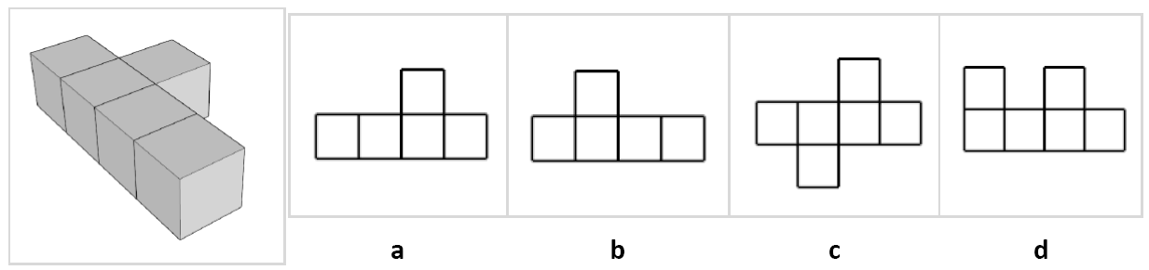
Which 2D shape matches the face of this shape?

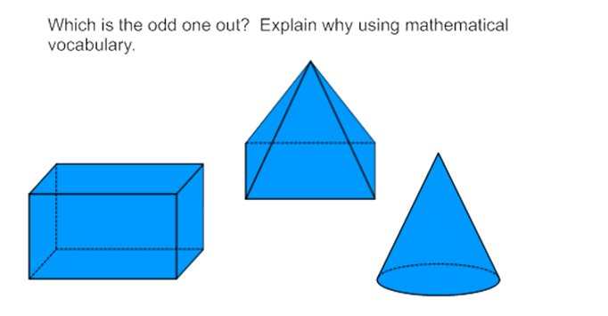

Lesson 3 – Teach and Practise – Reflection and translation
Starter – Maths Challenge Question
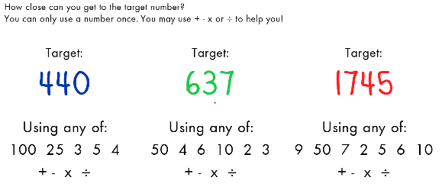
Input – Reflection and Translation
Open this link https://whiterosemaths.com/homelearning/year-5/ . Click on Summer Term, Week 11, Lessons 3 and 4 to watch the online videos.
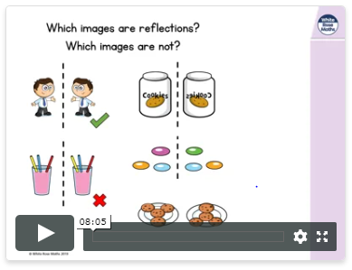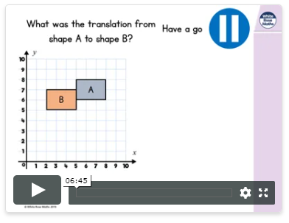
Online videos

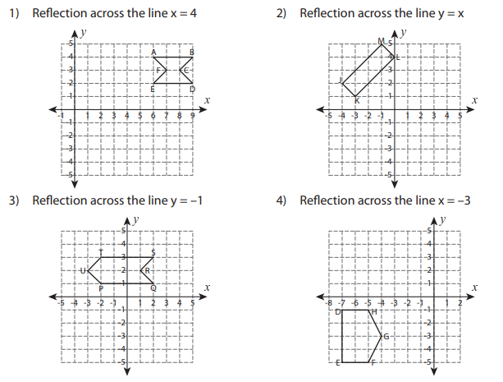
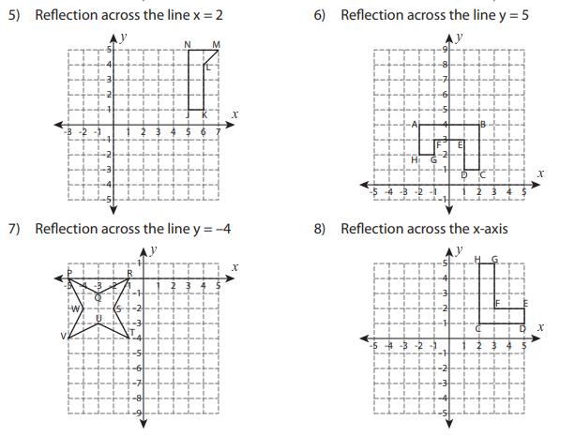
Reflection:
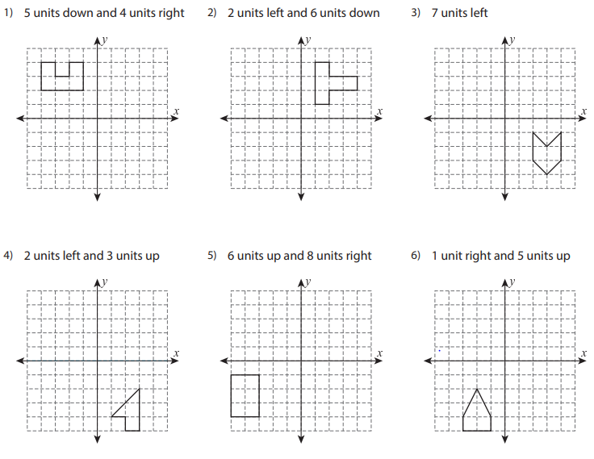
Translation:
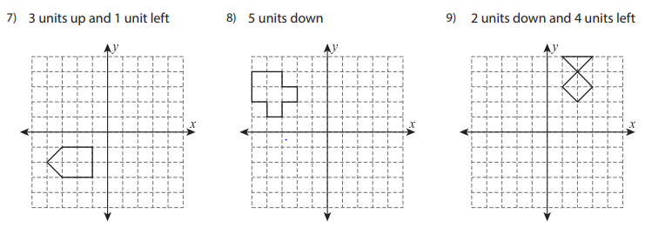

Well done for completing your Maths pack! Have a go at the extension below.

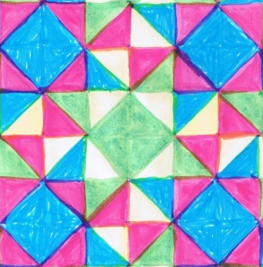
Extension: create your own tessellating pattern! Here is an example:

