Week 13 English Support Pack
In this pack, you will find all of the instructions, resources, and questions that you will need to complete your English lessons for this week. We are carrying on with our Summer text driver, Cogheart. This week, we will be looking at Chapter 4. Chapter 4 is read by Miss Riley and will have the pages of the book shown in the video recording on the website and the VLE.
Lesson 1 – Guided Reading
Starter:
Can you make a word that starts and ends with these letters?
You get a point for each letter in the middle.
Example: a__t ant = 1 point, appointment = 9 points.

u______y
p______e
d______n
s______y

Activity:
Listen to the video recording of Chapter 4 before completing the activity.
You need to write a letter for Lilly giving her some advice on how she is feeling during Chapter Four, as it is a chapter with lots of difficult events in for her. You need to keep it personal and talk to her as if she is your friend.

Below, I have had a go at a very brief model that will give you some ideas to get started with. Please add to it, writing as much advice as you can to give to Lily. You need to use lots of previous evidence from the text to show that you really know Lily.
Dear Lily,
I know times are hard for you at the moment, but I know you will get through it. I cannot imagine how you are feeling after the news about your father, do they have any more information? How is it with the housekeeper? It must be very tricky having no one around you that understands or is warm towards you, so I thought I would give you some advice of how I would handle the situation you are in.
Firstly, with your father, you mustn’t let anyone tell you that you cannot pursue the search for him. You are his only blood relative and you know him the best. I would start mapping out where and what I was going to investigate first. Do you have any ideas of what could have happened?
Secondly, where the housekeeper is concerned, just do what you need to do to keep her happy. You can look for your father and make him proud without her knowing. Just use your sneakiness from school when you were hiding your Penny Dreadfuls.
Please keep safe and let me know if I can do anything to help…

Lesson 2 – Guided Reading
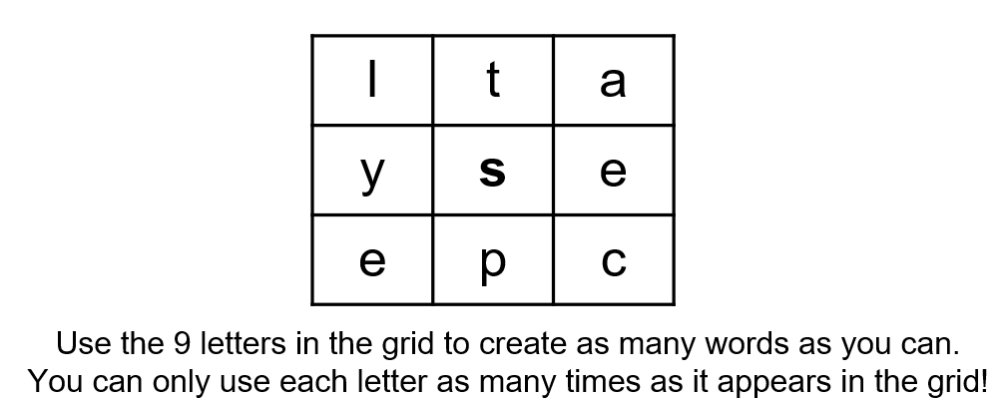
Starter:

Activity:
This activity is called Talk to the Hand. It means that if you could ask the author of a text anything about what they have written, what would it be?
I would like you to focus on Chapter Four, asking the author of Cogheart, Peter Bunzl, 10 questions. The questions could be focused around characters (feelings, events, appearance etc.), settings or events that have taken place, so think carefully about what you would like to ask.

Lesson 3 – Guided Reading/Short Writing
Starter:
Starting with the word ‘star’, how long can you make your word chain? Each word has to begin with the last letter of the word before. E.g. star, robot, tea, apple

Activity:
Watch the video called Girl & Robot, https://www.literacyshed.com/girlandrobot.html.
What might happen next in the video? Your task is to write the next part of the story.

Extension Task
Email your questions about Chapter Four to Peter Bunzl at peter@peterbunzl.com. Let me know if you get a response at any point, try to make your questions as exciting as possible to see if you can get an exciting response.

