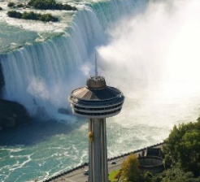
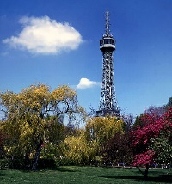
4.5.20-8.5.20
Year 4 Home Learning Tasks

Throughout the week complete the following tasks. If you have any questions, please contact either Miss Bradley or Mr Ward on VLE. Please find attached any helpful resources for the tasks below.
Literacy 1  Find lots of different words that mean the same as the emotions on the separate document. Remember these are called synonyms, such as hard could be tricky or difficult. | Literacy 2  Using what you have read from ‘The Highway Man’ poem, focus on Bess as a character. Plot her emotions on the graph for the different events throughout to poem. | Literacy 3  Follow the model provided to write a diary entry as Bess, focusing on her feelings and emotions of the events. Try to include the style of the poem in your diary entry .e.g. repetition.
Maths 1  Complete the activities given on the separate Maths document, recognising tenths and hundredths. Follow the link and select Week 1 and Lesson 1 for the supporting video. | Maths 2  Complete the activities on the separate Maths document, tenths as a decimal. Follow the link and select Week 1 and Lesson 2 for the supporting video. | Maths 3  Using your knowledge from the previous two Maths activities, complete the test style questions. You will find these on the separate Maths document.
Topic 1 – History  Use the information provided on the Topic document, summarise who the Anglo-Saxons were and why they wanted to come to Britain. | Topic 2 – Computing  To support you later on in your Computing tasks, write a short story on a topic of your choice. You will need to think carefully about sound effects to include later on. You should aim your story to engage Year R or Year 1. | Topic 3 – Science  Using the sheet provided, look at the different electrical items around your home. Write down which ones are operated by the mains and batteries. Are any items both?
Challenge 1: Using the words you found for Literacy 1, choose a synonym for each emotion and put it into a sentence where it is used appropriately.
Challenge 2: Without using Google, draw what you think an Anglo-Saxon person might have looked like. Annotate your drawing, explaining why you think they would look like this.
Challenge 3: Explain how we receive electricity form mains and batteries. Use the information provided and your own research to inform your explanation.

Don’t forget to read at home every night for 10 minutes and practice your times tables. Why not try and watch the BBC iPlayer videos as well.

