Year R Home Learning Menu – Week 8
Try to complete as many of the activities on this menu as you can during the week. If you would like more, log on to Teach Your Monster to Read, Oxford Owls or use some of the websites provided in the original pack. Please remember to take photos of any of the activities and upload onto EyLog so we can see what you have been doing!
The Little Red Hen  Click on the link to read the story of the Little Red Hen. Can you discuss all the characters, and whether you think the little red hen should share the bread.  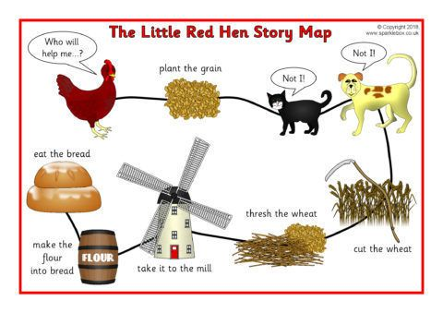  .  For more of a challenge can you write a few sentences to go with part of the story, or you might want to create your own story map. | Farmyard Phonics  Can you use your phonics to write some of the farm animals in the picture? Don’t forget that some have special friends.  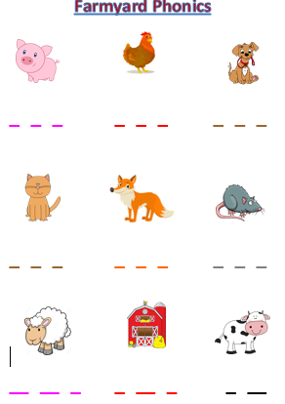  For more of a challenge you could think of your own animals, or even write a sentence about each animal. | Fancy Dress Friday with Joe Wicks  Can you take part in fancy dress Friday with Joe Wicks. You can find his daily workout every day at 9.00am on You Tube.  https://www.youtube.com/channel/UCAxW1XT0iEJo0TYlRfn6rYQ  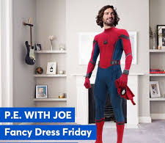  For more of a challenge – Can you come up with your own workout?
Toilet Roll Animals  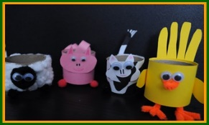  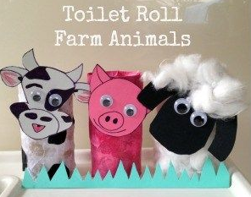  Using any recycling you have or craft resources can you make your own farm animal? You might want to draw around your hand for feathers, draw and stick on some googly eyes or use cotton wool to make a fluffy sheep. Then upload a picture to Eylog.  For more of a challenge you could write a list of instructions to help someone else make one. | Teacher Challenge  Watch Miss Carter’s video on the school website, on sharing objects equally.  Can you create a tea party with toys and equally share out some food?  Have 3 toys with a plate. Can you share out 6, 9 and then 12 pieces of food?  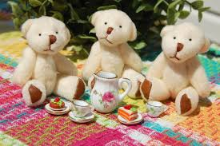  For more of a challenge can you write what you have done as a number sentence? (There is another video to show you how to do this. | Making Music Patterns  Can you come up with your own animal pattern?  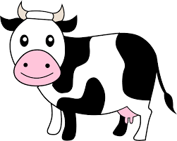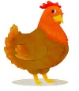  Clap Clap Stamp  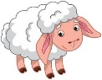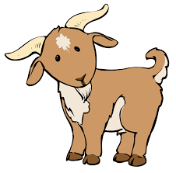  Click Bang Click Bang  For more of a challenge can you create a tricky pattern using 3 animals or more?

