Year R Home Learning Menu – 1.6.20
Try to complete as many of the activities on this menu as you can during the week. If you would like more, log on to Teach Your Monster to Read, Oxford Owls or use some of the websites provided in the original pack. Please remember to take photos of any of the activities and upload onto EyLog so we can see what you have been doing!
Den Building  Can you build a reading den? Try to make it somewhere to take yourself to relax and get some quiet time. You could use blankets, bedding, fairy lights and cushions.  .  For more of a challenge can you send us a short video of you reading your favourite book in your den | Phonics  On a dice or box, stick on small pieces of paper to make a dice with some phonic sounds. Pick the sounds from your sound mat that you have been learning such as ee, sh, ng, igh, th, ow. Then roll the dice and whichever sound it lands on think of a word that contains that sound and write it down.  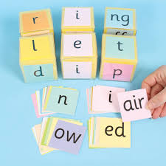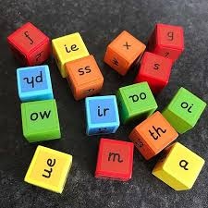  For more of a challenge, can you then write a sentence to go with each word. | Skittles Experiment  On a plate lay out one layer of skittles all the way around the edge of the plate. Then slowly add some warm water to the centre of the plate. Discuss what colour mixing you can see.  https://www.youtube.com/watch?v=4FHbbc8v1Cs  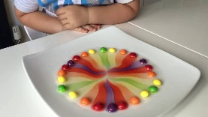  For more of a challenge can you tell us about the colour mixing that you saw
Computing  On your computer or tablet can you type your name using Word? Can you change the font, colour and size?  If you haven’t got Word you could use a paint programme instead.  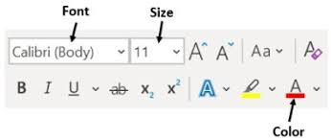  For a further challenge can you type some other words? | Maths  Doubling  Can you make two groups of objects with the same amount in? This is called doubling. How many different doubles can you make?  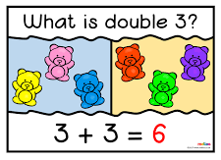  For more of a challenge can you write down all the doubles that you made? | Just Dance Kids  Can you teach your family some of our favourite just dance songs with actions? Including Gummy Bears, Shake Your Sillies Out, Five Little Monkeys  https://www.youtube.com/watch?v=KVE-T2_vLpY  https://www.youtube.com/watch?v=NwT5oX_mqS0  https://www.youtube.com/watch?v=IxF0iayJR-s  