Year 2 Topic Support Pack – Week 13
Topic Task 2 – Sun safety
It has been very hot recently and last week was one of the highest recorded levels of UV rays from the sun which is very dangerous! It is very important to be safe and sensible in the sun. Can you create a poster to advertise how to keep safe in the sun?

Topic Task 3 - History
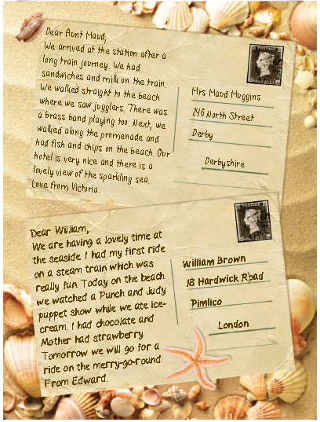
We are continuing to look at what seaside holidays were like in the past. These two postcards were written by children in Victorian times. Read through them to find out about their holidays. Then complete the comparison sheet.
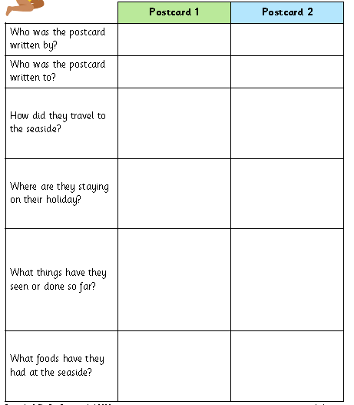
Extension
