Year 4 Home Learning 4.5.20 – 8.5.20
Maths Support Pack
This week we will be focusing on tenths as decimals and fractions. You will have 2 lessons practicing and then a lesson where you will apply your knowledge to a problem. The link is provided as well as the activities in this support document.
Lesson 1: Recognising tenths and hundredths (Week 1- Lesson 1) https://whiterosemaths.com/homelearning/year-4/
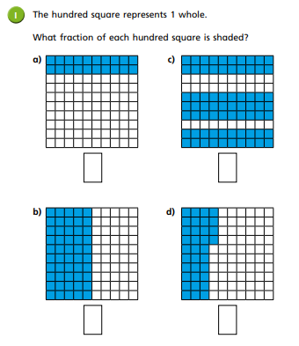

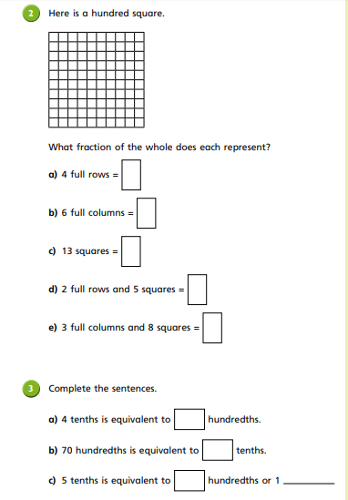

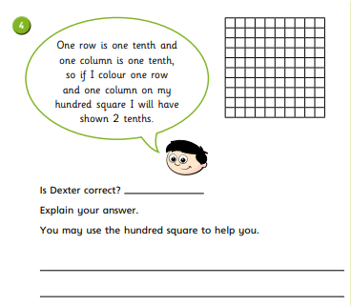

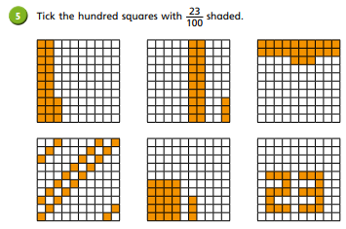

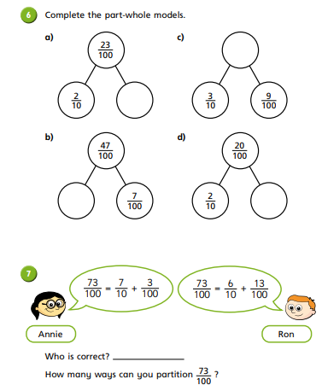

Lesson 2: Tenths as a decimal (Week 1- Lesson 2) https://whiterosemaths.com/homelearning/year-4/
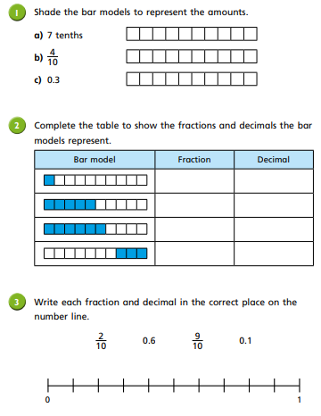

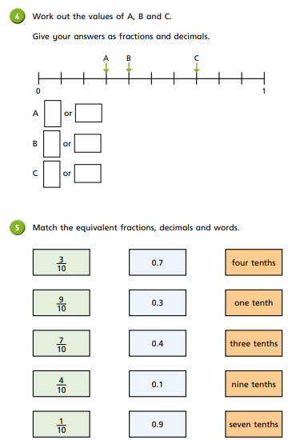

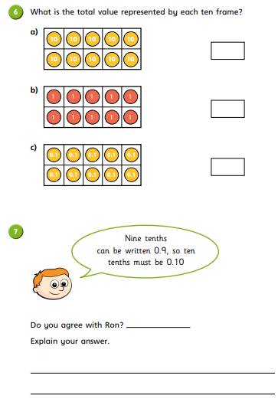

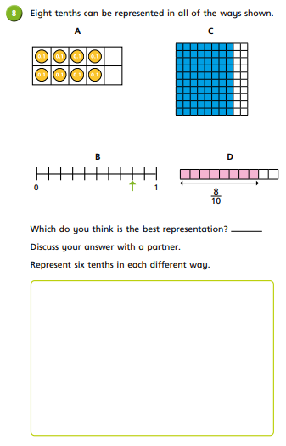

Lesson 3: Test style questions. There are fewer questions here, due to the volume of questions for the two previous activities.
- Order the following decimals from smallest to largest.
0.7, 0.73, 0.4, 0.8, 0.42, 0.95, 0.49
Explain/reason why they are in that order.
- Write the following decimals as a fraction. Can you write it as more than one fraction?
  - 0.2
  - 0.67
  - 0.75
  - 0.40
- Can you create your own question, based on hundredths and tenths, for someone in your family to answer. You will need to mark it and see if it correct.

