Year 1 English Support Pack – Week 6
In this pack, you will find instructions on how to complete your English lessons for this week. This week we are using the story Jack and the Beanstalk as a focus for our English work. You can watch the story read by Miss Ramsier on the VLE or the website, under the Year 1 home learning tab.
Lesson 1:
Watch the story of Jack and the Beanstalk being read by Miss Ramsier and then answer the following questions:
- Who was the main character in this story?
_____________________________________________________________________
- Where is the story set?
____________________________________________________________________________________________
- Draw or write what happens in the beginning of the story?

- Draw or write what happens in the middle of the story?

- Draw or write how the story end?

- What was your favourite part of the story?
__________________________________________________________________________________________________________________________________________
Lesson 2: The Prefix un-
Add the prefix un to the words below. Work out which word fits into which sentence.
Prefixes are a group of letters that change the meaning of a word when they are added to the start. Most prefixes mean a similar thing when they're added to different words.
un usually means not. For example, unhappy, unlocked, unfair
__happy __kind __tidy
__comfortable __locked __lucky

How
Who
Where
When
What
?
First,
Then,
Next,
Later,
Finally,

The giant was ________ to his wife.

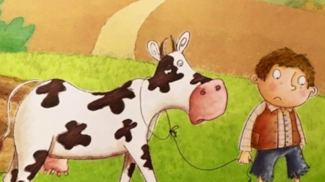
Jack was very _________ because he was poor.
The giant’s wife ___________ the castle door.
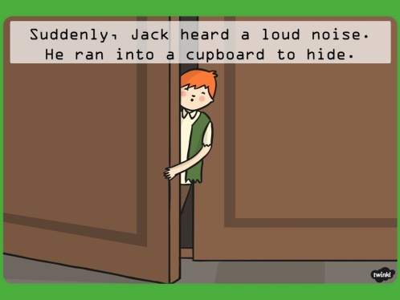
Jack was very _____________ hiding in the cupboard.
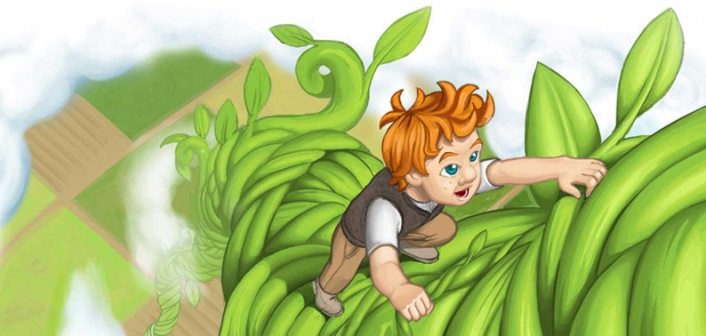
Jack looked ________ after he had climbed the beanstalk.

Lesson 3:
In class you have learnt how to create story maps for lots of different texts. Can you listen to Miss Ramsier reading the story of Jack and the Beanstalk again and create a story map based on the story. I have included an example of a Three Little Pigs map in case you can’t remember.
