Year R Home Learning Menu – Week 7
Try to complete as many of the activities on this menu as you can during the week. If you would like more, log on to Teach Your Monster to Read, Oxford Owls or use some of the websites provided in the original pack. Please remember to take photos of any of the activities and upload onto EyLog so we can see what you have been doing!
Creating A Farm  Can you create your own farm? You can choose how you do this. You might do it with junk modelling materials, with Lego, Playdoh, a drawing or cutting and sticking.  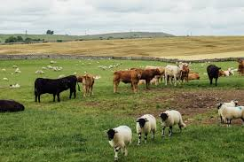  .  For more of a challenge can you make a list of the animals on your farm? Or can you write a sentence? You could start, On my farm there is… | Adding Numbers To Ten  Can you colour in 2 green fields on 2 pieces of paper then draw and cut out ten cows. Can you split the cows between your 2 fields. How many do you have in each field?  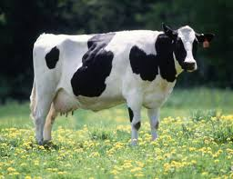  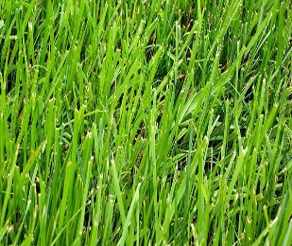  (if you don’t have paper you could pretend 2 books, plates or cushions are the fields).  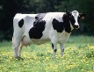  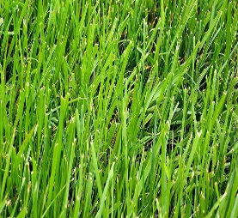  +  For more of a challenge you could write the number sentence to go with your picture. For the one above you would write:  3+5= 8 | Cooking  Can you make the recipe on the school website? You have to measure the ingredients just using a tablespoon.  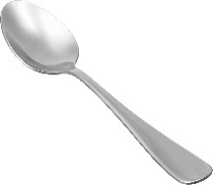  For more of a challenge you could write a list of the ingredients you used. Or write some sentences about what you had to do.
Farmer duck  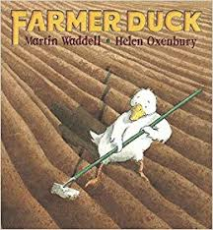  Listen to the story farmer duck being read on YouTube by Michael Rosen. Can you join in with the repeated phrases? Can you draw a picture of part of the story?  For more of a challenge you could write a sentence about your favourite part of the story  https://www.youtube.com/watch?v=wn4b9AqiUbw | Money  Watch Mrs Wilcox video on the website about buying snacks. Can you make your own snack menu? You could draw or write the snacks and then put the price next to them.  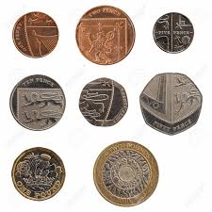  For a further challenge you could try choosing two snacks. Can you count on to see how much they would cost altogether? you could use a number line on the computer to count on. | Making a Mask  Can you draw and cut out a mask of your favourite farm animal.  