Reading Focus!
Year 1 Homework - Autumn 1
Choose at least one of the tasks to complete at home over the next 2 weeks. You can choose when to bring your homework back to school. You can also upload it to Google Classroom or email it to your classes email address. Remember reading is one of the most important skills and will help you in all areas of your learning. Good luck!
Write a book review for one of the books you have read. (Template on Google Classroom)  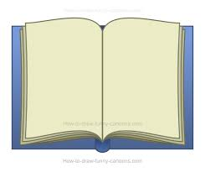 | Read a non-fiction (facts) book with a family member and learn something new together.  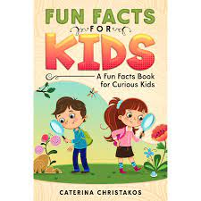 | Practise reading red words and explain to a family member why we can’t sound them out. (List of red words on Google Classroom)  said  was
Challenge yourself to read 5 times this week at home and make sure a grown up puts a note in your reading diary.  (It doesn’t need to be the whole book – just a few pages)  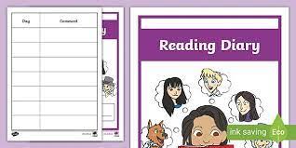 | Find a new spot in your home to read your book, maybe you could make a den. Take a photo and email it to your class email address.  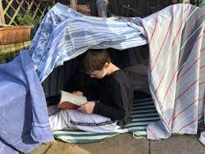 | Listen to a story with a family member and afterwards, talk about the main events in the story and complete a story map, we have done this in class. (Template on Google Classroom)  