Week 9 English Support Pack
In this pack, you will find all of the instructions, resources, and questions that you will need to complete your English lessons for this week. We are carrying on with our Summer text driver, Cogheart. This week, we will be looking at Chapter 2. Chapter 2 is read by Miss Thomas and will have the pages of the book shown in the video recording.
Lesson 1 – Guided Reading
Listen to the video recording of Chapter 2 and answer the questions below:
Literal Questions:
What is the weather like?

What type of dogs are chasing Malkin?

Where was Malkin shot?

Which village does Malkin arrive into?

Inference Questions:
Why does Malkin need to keep moving?

Why couldn’t Malkin swim across the river?

Why is Malkin so determined to escape the man?

Predict:
Do you think the men will catch up with Malkin? (Explain your answer)

Vocabulary:
Find the definitions of the words below. You can use the online dictionary.
https://www.dictionary.com/browse/online-dictionary

- What is an ‘indignity’?
Why does Malkin consider it an indignity to be chased through the woods?

- What does ‘derelict’ mean?

- What does ‘density’ mean?

- What does ‘descended’ mean?
Lesson 2 – Guided Reading
This lesson we are going to look at the start of Chapter 2 and use the description on pages 27 and 28 to draw the woods that Malkin is running through.

Below are pages 27 and 28. You may also listen to the video recording if you prefer. You may wish to highlight descriptive phrases from the text below to help you draw your picture.
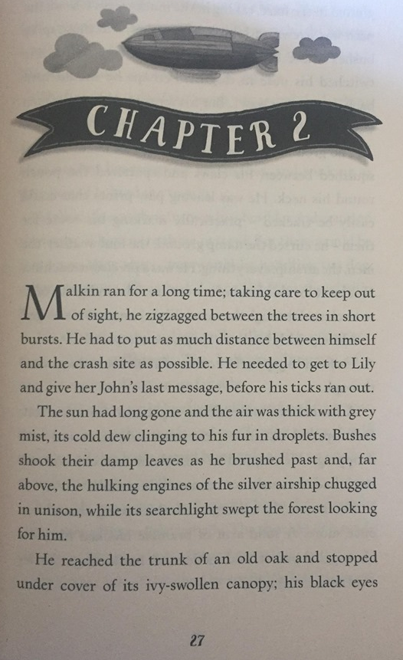

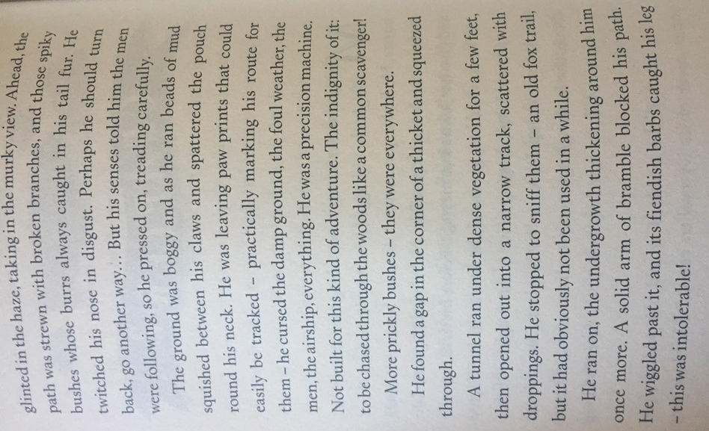

Neatly label your drawing with direct words and phrases from the text. It would be great to see some of you drawings coloured. Think about what colours you will use and why…

Lesson 3 – Writing
This lesson we will be looking at the end of Chapter 2. Your task is to write an alternate route for Malking to run. Instead of turning right, Malkin turns left!
Think about:
What he sees on his route?
What he can he hear?
What he can he smell?
How he is feeling

This is a great opportunity for you to include expanded noun phrases for description and fronted prepositional phrases to describe the direction of objects on his route. You can also vary your types (simple, compound and complex) to vary your pace. Try to write 2 – 3 detailed paragraphs.
Challenge: Can you use a semi-colon to join two linking ideas? E.g. Malkin stumbled over the gigantic, inflamed tree root; his knee scraped the harsh splintered wood.

You can magpie ideas from the text below:

Extension Task
For your extension task draw a map of the alternate route you have written about. We look forward to seeing where your imagination takes you!

