Year 4 Home Learning 18.5.20 – 22.5.20
Literacy Support Pack
Lesson 1 – Reading Comprehension
The highwayman poem is complicated and uses a range of language that we do not use in everyday situations. This makes it incredibly difficult to understand. With some texts, you can read a summary which is the text written in a way that you will be able to understand it.
Your task: Read the section of the text and explain what is happening in your own words.
Original Text | Summary
He'd a French cocked hat on his forehead, and a bunch of lace at his chin;
He'd a coat of the claret velvet, and breeches of fine doe-skin.
They fitted with never a wrinkle; his boots were up to his thigh!
And he rode with a jewelled twinkle--
His rapier hilt a-twinkle--
His pistol butts a-twinkle, under the jewelled sky.
He stood upright in the stirrups; he scarce could reach her hand,
But she loosened her hair in the casement! His face burnt like a brand
As the sweet black waves of perfume came tumbling o'er his breast,
Then he kissed its waves in the moonlight
(O sweet black waves in the moonlight!),
And he tugged at his reins in the moonlight, and galloped away to the west.
They said no word to the landlord; they drank his ale instead,
But they gagged his daughter and bound her to the foot of her narrow bed.
Two of them knelt at her casement, with muskets by their side;
There was Death at every window,
And Hell at one dark window,
For Bess could see, through her casement, the road that he would ride.

Lesson 2 – SPaG
Today we are going to be looking at Onomatopoeia and how this is used within writing.
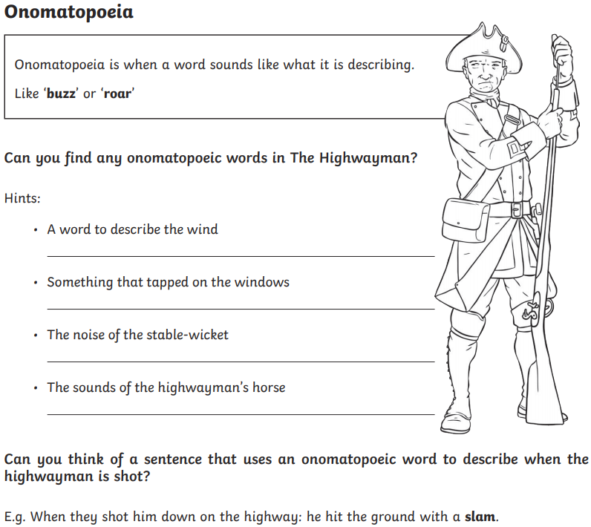

Lesson 3 – Hot Seating and interviewing ‘The Highwayman’
Today I would like you to imagine you are an interviewer and your task is to interview ‘The Highwayman’.

Task 1 - Write down 5 questions that you would like to ask ‘The Highwayman’. These should be meaningful questions such as ‘When did you know that you loved Bess?’ rather than ‘Do you prefer to eat Chicken Korma or Chicken Tikka Masala?

Task 2 – Now pretend that you are ‘The Highwayman’. Using what you know about the poem, try to answer the questions as best you can. Your answers should be at least a paragraph of writing. If you find you cannot do this for your question then you will need to think of a new one.

I have attached the poem below for you to refer to.

PART ONE

The wind was a torrent of darkness among the gusty trees.
The moon was a ghostly galleon tossed upon cloudy seas.
The road was a ribbon of moonlight over the purple moor,
And the highwayman came riding—
Riding—riding—
The highwayman came riding, up to the old inn-door.

He’d a French cocked-hat on his forehead, a bunch of lace at his chin,
A coat of the claret velvet, and breeches of brown doe-skin.
They fitted with never a wrinkle. His boots were up to the thigh.
And he rode with a jewelled twinkle,
His pistol butts a-twinkle,
His rapier hilt a-twinkle, under the jewelled sky.

Over the cobbles he clattered and clashed in the dark inn-yard.
He tapped with his whip on the shutters, but all was locked and barred.
He whistled a tune to the window, and who should be waiting there
But the landlord’s black-eyed daughter,
Bess, the landlord’s daughter,
Plaiting a dark red love-knot into her long black hair.

And dark in the dark old inn-yard a stable-wicket creaked
Where Tim the ostler listened. His face was white and peaked.
His eyes were hollows of madness, his hair like mouldy hay,
But he loved the landlord’s daughter,
The landlord’s red-lipped daughter.
Dumb as a dog he listened, and he heard the robber say—

“One kiss, my bonny sweetheart, I’m after a prize to-night,
But I shall be back with the yellow gold before the morning light;
Yet, if they press me sharply, and harry me through the day,
Then look for me by moonlight,
Watch for me by moonlight,
I’ll come to thee by moonlight, though hell should bar the way.”

He rose upright in the stirrups. He scarce could reach her hand,
But she loosened her hair in the casement. His face burnt like a brand
As the black cascade of perfume came tumbling over his breast;
And he kissed its waves in the moonlight,
(O, sweet black waves in the moonlight!)
Then he tugged at his rein in the moonlight, and galloped away to the west.

PART TWO

He did not come in the dawning. He did not come at noon;
And out of the tawny sunset, before the rise of the moon,
When the road was a gypsy’s ribbon, looping the purple moor,
A red-coat troop came marching—
Marching—marching—
King George’s men came marching, up to the old inn-door.

They said no word to the landlord. They drank his ale instead.
But they gagged his daughter, and bound her, to the foot of her narrow bed.
Two of them knelt at her casement, with muskets at their side!
There was death at every window;
And hell at one dark window;
For Bess could see, through her casement, the road that he would ride.

They had tied her up to attention, with many a sniggering jest.
They had bound a musket beside her, with the muzzle beneath her breast!
“Now, keep good watch!” and they kissed her. She heard the doomed man say—
Look for me by moonlight;
Watch for me by moonlight;
I’ll come to thee by moonlight, though hell should bar the way!

She twisted her hands behind her; but all the knots held good!
She writhed her hands till her fingers were wet with sweat or blood!
They stretched and strained in the darkness, and the hours crawled by like years
Till, now, on the stroke of midnight,
Cold, on the stroke of midnight,
The tip of one finger touched it! The trigger at least was hers!

The tip of one finger touched it. She strove no more for the rest.
Up, she stood up to attention, with the muzzle beneath her breast.
She would not risk their hearing; she would not strive again;
For the road lay bare in the moonlight;
Blank and bare in the moonlight;
And the blood of her veins, in the moonlight, throbbed to her love’s refrain.

Tlot-tlot; tlot-tlot! Had they heard it? The horsehoofs ringing clear;
Tlot-tlot; tlot-tlot, in the distance? Were they deaf that they did not hear?
Down the ribbon of moonlight, over the brow of the hill,
The highwayman came riding—
Riding—riding—
The red coats looked to their priming! She stood up, straight and still.

Tlot-tlot, in the frosty silence! Tlot-tlot, in the echoing night!
Nearer he came and nearer. Her face was like a light.
Her eyes grew wide for a moment; she drew one last deep breath,
Then her finger moved in the moonlight,
Her musket shattered the moonlight,
Shattered her breast in the moonlight and warned him—with her death.

He turned. He spurred to the west; he did not know who stood
Bowed, with her head o’er the musket, drenched with her own blood!
Not till the dawn he heard it, and his face grew grey to hear
How Bess, the landlord’s daughter,
The landlord’s black-eyed daughter,
Had watched for her love in the moonlight, and died in the darkness there.

Back, he spurred like a madman, shrieking a curse to the sky,
With the white road smoking behind him and his rapier brandished high.
Blood red were his spurs in the golden noon; wine-red was his velvet coat;
When they shot him down on the highway,
Down like a dog on the highway,
And he lay in his blood on the highway, with a bunch of lace at his throat.

. . .

And still of a winter’s night, they say, when the wind is in the trees,
When the moon is a ghostly galleon tossed upon cloudy seas,
When the road is a ribbon of moonlight over the purple moor,
A highwayman comes riding—
Riding—riding—
A highwayman comes riding, up to the old inn-door.

Over the cobbles he clatters and clangs in the dark inn-yard.
He taps with his whip on the shutters, but all is locked and barred.
He whistles a tune to the window, and who should be waiting there
But the landlord’s black-eyed daughter,
Bess, the landlord’s daughter,
Plaiting a dark red love-knot into her long black hair.

