Year 2 Maths Support Pack – Week 14
In this pack, you will find instructions on how to complete your Maths lessons for this week. We are continuing to learn about Measurement this week and you will need to watch some short videos and read through some information to help you. Follow the links on your home learning menu to watch the videos. You can then complete the worksheets by printing them, or viewing them on the screen and writing the answers on your own paper.

Lesson 1 – To use millilitres
First complete the quiz to see what you already know. Then watch the video, pausing at the correct moments, to recap what capacity and volume mean and how to read millilitres on a scale. The worksheet needed for the independent task is below. The answers are then given on the video, when you are ready. There are extra questions on the next page for you!
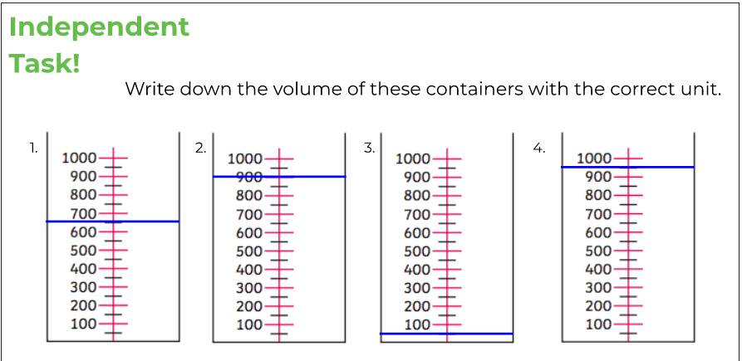

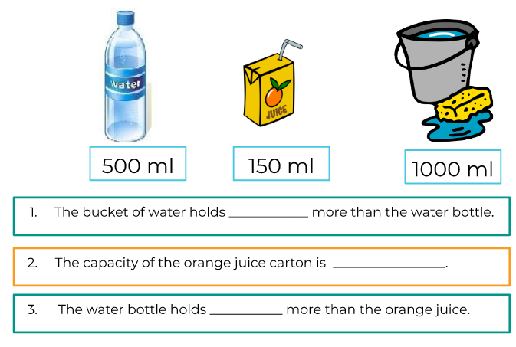

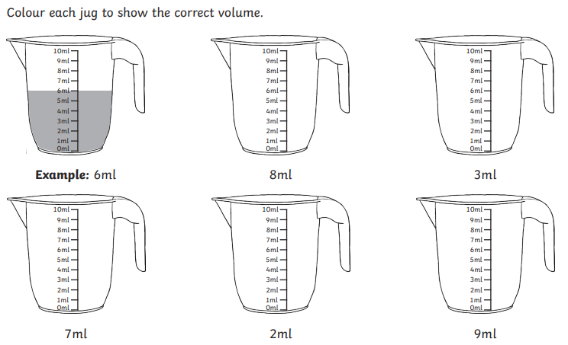

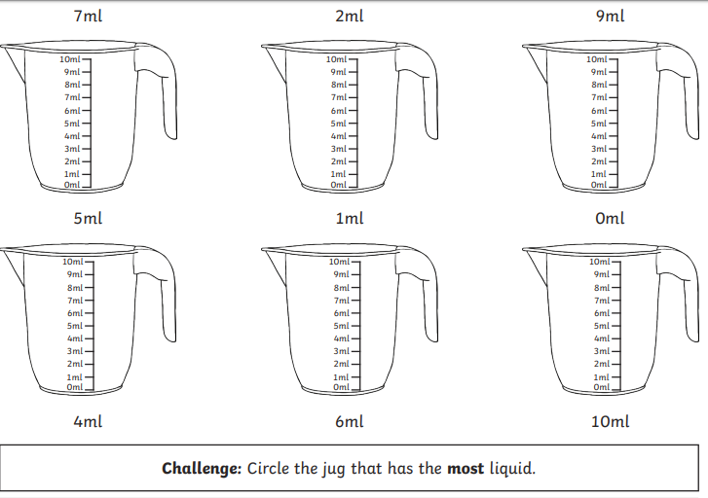

Lesson 2 – Measuring mass in grams
First, watch the video for a short introduction to what mass is. In this lesson you will be learning how to measure the mass of different objects. When you want to find the mass of small, everyday objects, you measure in grams. Grams is shortened to ‘g’. After reading through the learning summary on BBC Bitesize, complete the activities below to show your understanding of how to read scales to find the mass of an object using grams.
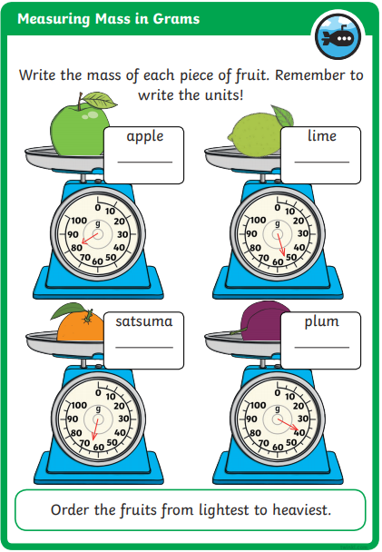

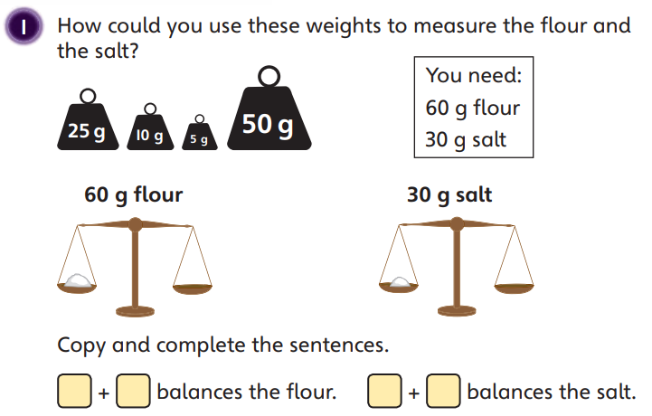

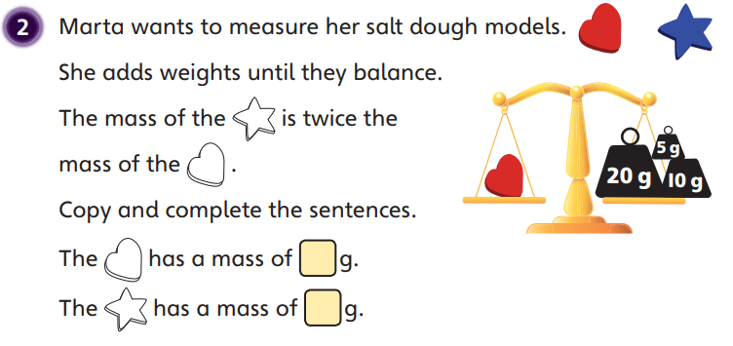

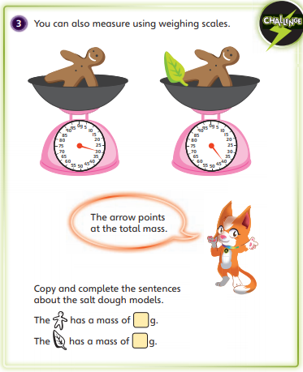

Lesson 3 – Measuring mass in kilograms
In this lesson you be continuing to learn how to find the mass of different objects. When you want to measure the mass of an object that weighs more than 1000 grams you use kilograms. Kilograms are shortened to ‘kg’. 1 kilogram = 1000 grams or 1 kg = 1000 g. After reading through the learning summary on BBC Bitesize, complete the activities below to show your understanding of how to read scales to find the mass of an object using kilograms.
