Topic: PSHE
Go through the Emotions PowerPoint and then complete the below activity to show how each person is feeling.

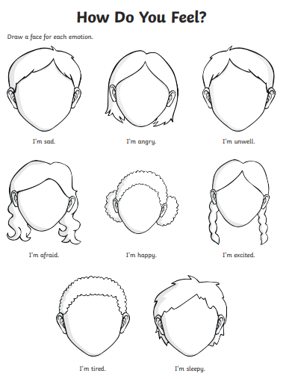
Challenge: Can you think of a time when you have felt…excited, afraid, angry, happy?

Topic: RE
What is your special book?
Why is it special to you?
________________________________________________________________________________________________________________________________________

Topic: History

Which countries were involved in ‘The Space Race’?
__________________________________
Who was the first man in space?
__________________________________
What animal was first in space?
__________________________________
Which country had the first satellite in space?
__________________________________
What was the satellite called?
__________________________________
Who was the first women in space?
__________________________________

Who were in the first crew to land on the moon?
____________________________________________________________________
__________________________________

How many countries are involved in the international space station?
__________________________________

