**Year 4 Maths Answers 18.5.20-22.5.20**

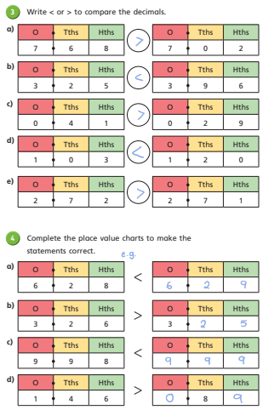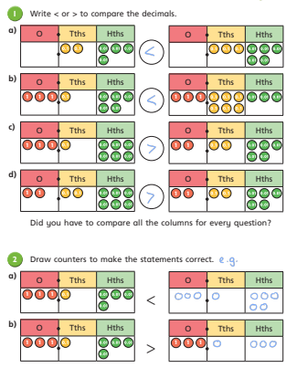**Lesson 1: Comparing Decimals**

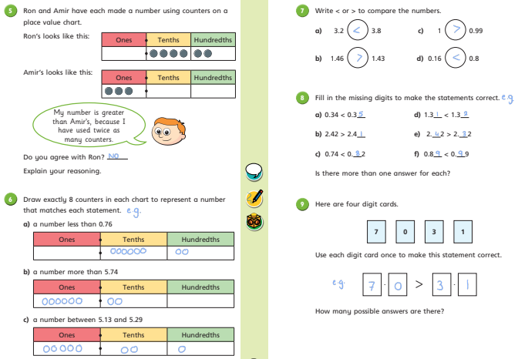

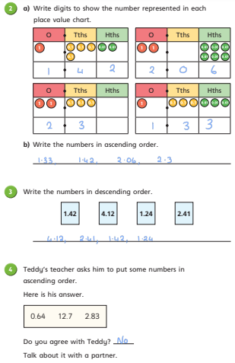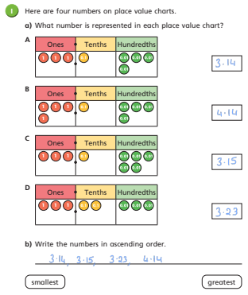**Lesson 2: Order Decimals**

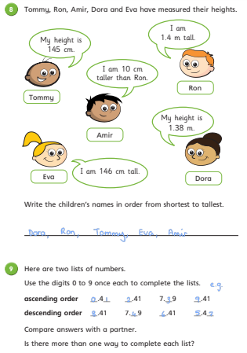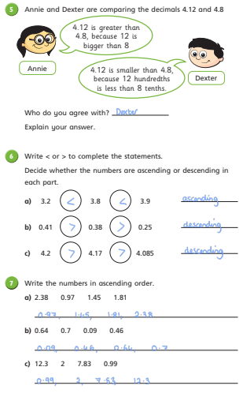

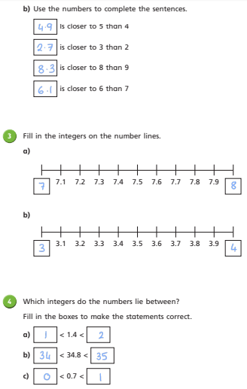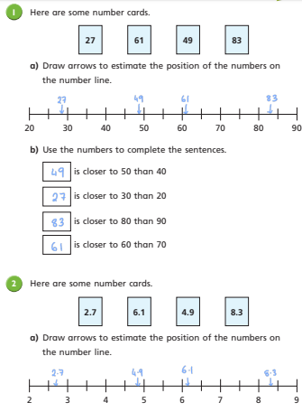**Lesson 3: Round Decimals**

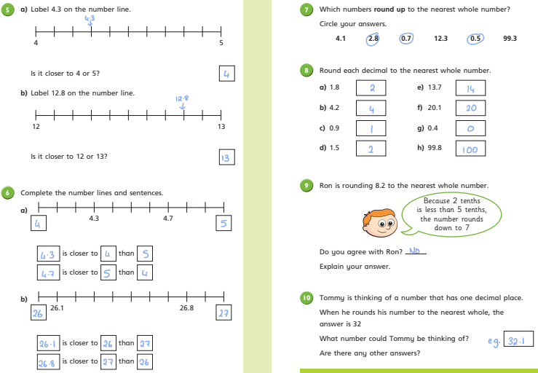

**Extension/Challenge: Test Style Questions**

6.01 – 6

9.51 -10

7.75 -8

540 – 500

236 – 240

1 ¾ (1.75) – 2

1 ½

1.3

1.4

1 3/5 (1.6)