Maths Support Pack – Week 9
This pack includes your 3 maths lessons for the week. The pack includes:
- Maths starters to keep your brains working fast!
- 3 maths lessons
- Links to online lessons for Lesson 1 and 2
- Worksheets and answer sheets
- Extension Task
This pack is to help you, so read through as carefully as possible so that you know what to do for your maths this week. In week 9, we are focusing on Adding and Subtracting Decimals with a different number of decimal places. Try your best with everything. Happy Learning Year 5! 😊

Lesson 1 – Teach and Practise - Adding decimals with a different number of decimal places
Starter – Daily 10
https://www.topmarks.co.uk/maths-games/daily10
Practise the times tables you feel less confident with! (6’s,7’s, 8’s, 9’s or 12’s) Try 7 seconds like we do in class, or less if you want a challenge.
Input – Adding decimals with a different number of decimal places
Open this link https://whiterosemaths.com/homelearning/year-5/. Click on Summer Term, Week 2, Lesson 3 to watch the online lesson.
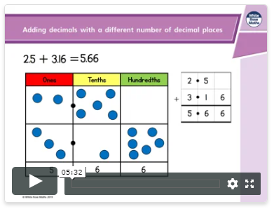
Online video

Activity: Complete the questions that are below. Watch the video for this lesson as many times as you need to. It’s there to help you!
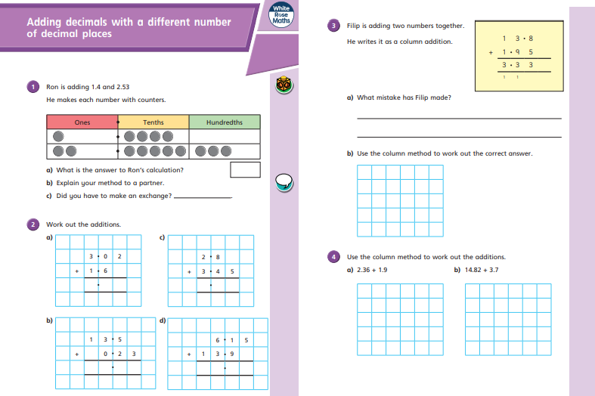
If you struggle with any of the questions, just go back and rewatch the video to check you are happy. Once you have finished, open the answers document to check your work.
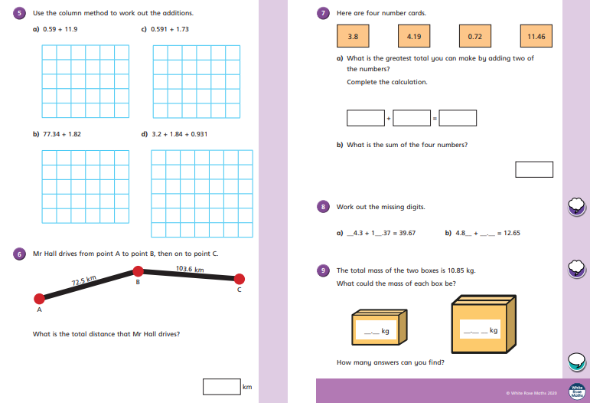
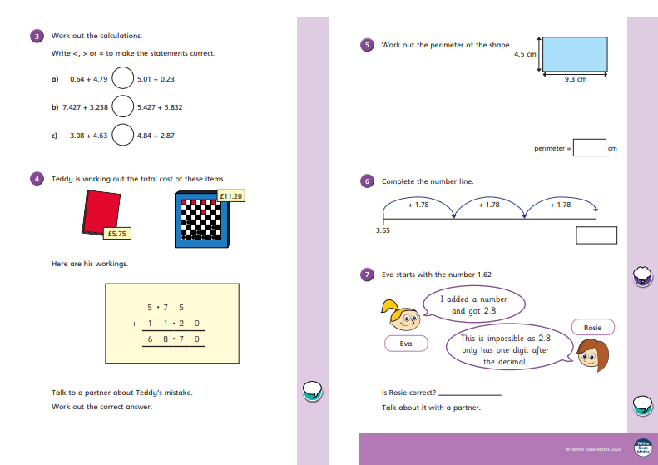
Lesson 2 – Teach and Practise- Subtracting decimals with a different number of decimal places
Starter – Maths Challenge Question
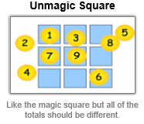
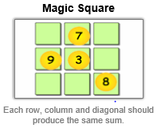
Fill in the blank squares. Make sure you only use each number once so that each square has the numbers 1-9 in!

Input – Subtracting decimals with a different number of decimal places
Open this link https://whiterosemaths.com/homelearning/year-5/ . Click on Summer Term, Week 2, Lesson 4 to watch the online lesson.
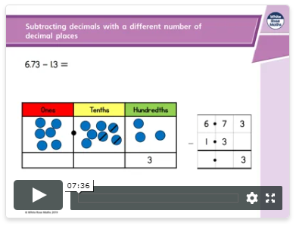
Online video

Activity: Complete the questions that are below. Watch the video for this lesson as many times as you need to. It’s there to help you!
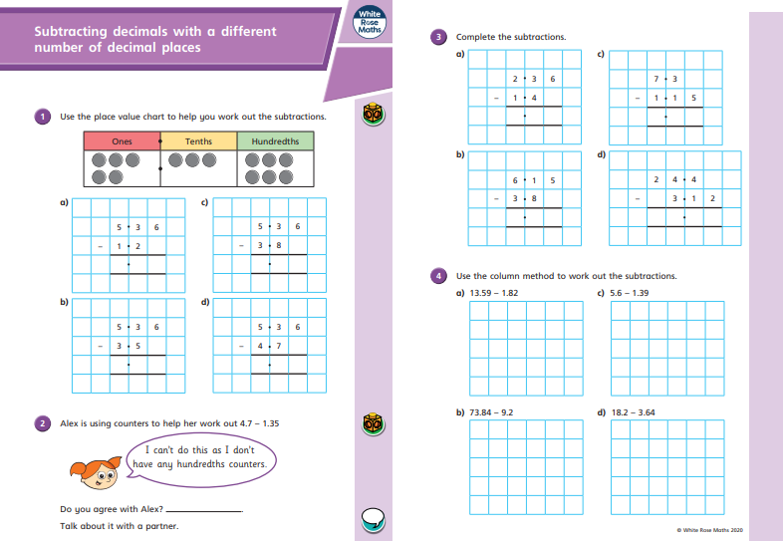
If you struggle with any of the questions, just go back and rewatch the video to check you are happy. Once you have finished, open the answers document to check your work.

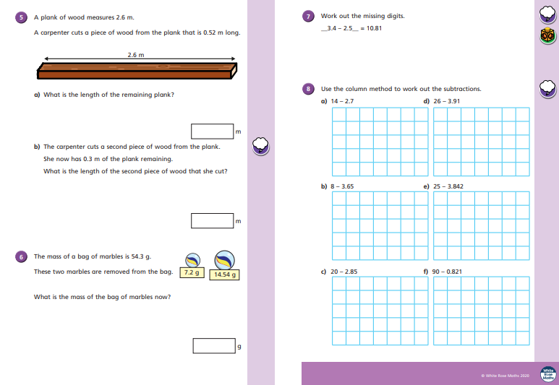

Lesson 3 – Challenge/Apply
Starter – Quick 10
Answer these 10 questions - these are all things you know! It’ll help to train your brain back to being able to answer those quick-fire questions!
Question | Answer | Question | Answer
EXAMPLE: 3 X 4 = | 12
1. 1262 + 6967 = |  | 6. 6 x 6 =
2. 12 squared= |  | 7. 48 x 1000 =
3. 6 x 8 = |  | 8. 30 x 6 =
4. 7 x 9 = |  | 9. 3732- 2059 =
5. 560 + 600 = |  | 10. 25235 + 23452 =

Activity: There are different challenge questions based on all areas of maths! These are to keep your brain working and refresh any areas of your maths learning that you may have forgotten!
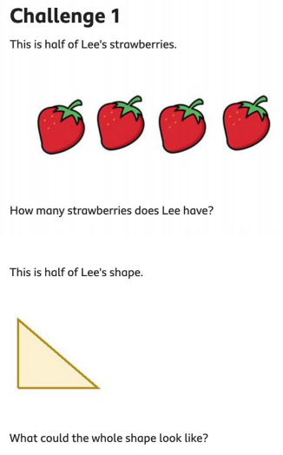
3.
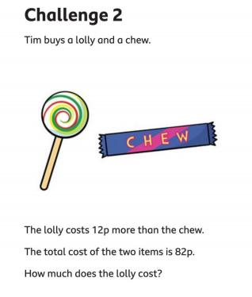

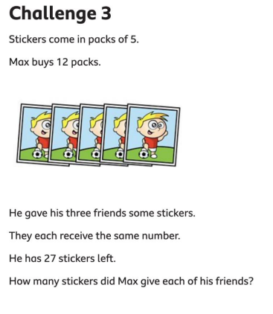

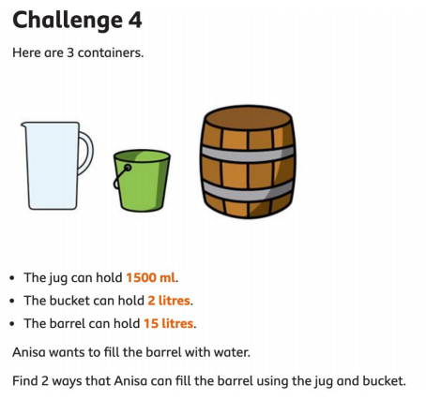

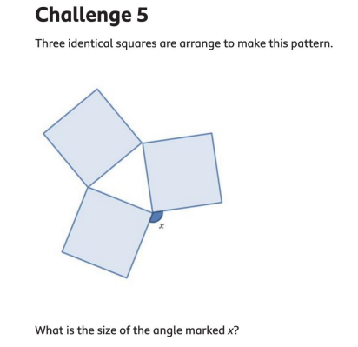

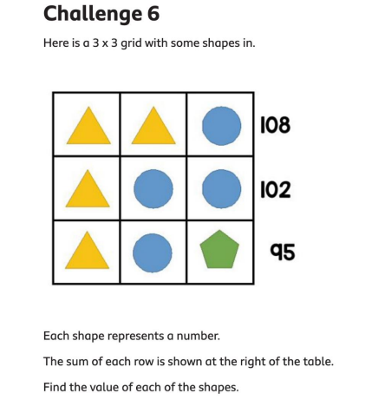

Well done for working your way through your Maths Worksheets. I can’t wait to see how well you’ve done! Don’t forget to check all your work against the answers! If you would like an extra challenge, have a go at the extension questions below!
Extension Task
This extension task is a problem solving task from NRICH. Remember you are multiplying the numbers together on each route to find the product.
