Year R Home Learning Menu – 8.6.20
Try to complete as many of the activities on this menu as you can during the week. If you would like more, log on to Teach Your Monster to Read, Oxford Owls or use some of the websites provided in the original pack. Please remember to take photos of any of the activities and upload onto EyLog so we can see what you have been doing!
Dinosaur  Read a dinosaur story or listen to the one below. Draw your favourite part and write a sentence about it.  https://www.youtube.com/watch?v=IxiYyXIc3Co  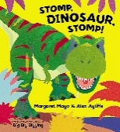  For more challenge can you talk about the story to a friend or grown up. Can you write down any new words you have heard in the story? | Phonics  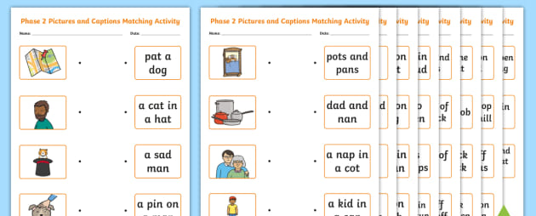  Using the sheets in the pack. Try to match the caption to the picture. Read carefully, remembering to look for special friends.  For more challenge, can you draw a picture and write your own caption? | Dinosaur Games  Follow the links below to play some dinosaur games  https://www.bbc.co.uk/games/embed/gyz8pctpfx?exitGameUrl=https%3A%2F%2Fwww.bbc.co.uk%2Fcbeebies%2Fgames%2Fandys-dinosaur-adventures-game  https://www.ictgames.com/dinosaurEggs_phonics/mobile/  https://www.ictgames.com/mobilePage/tellATRex/index.html
Labelling a Dinosaur  With a grown up, use the websites below to learn some facts about dinosaurs. You could draw a dinosaur and label it or use one of the pictures in the pack.  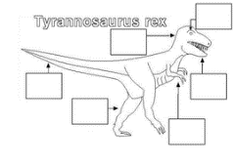  For a further challenge can you write some facts down. Can you use words like carnivore and herbivore?  You can watch Miss Carter’s video on the school website, to help you with some of the things you need to remember when you are writing sentences.  https://www.nhm.ac.uk/discover/dinosaurs.html?gclid=EAIaIQobChMIu7CQ743t6QIVAeztCh1OtQywEAAYASAAEgJs5PD_BwE  https://www.bbc.co.uk/cbeebies/curations/dinosaur-facts | Maths  Number Bonds  How many ways can you make 10? Use your fingers to help you and write them down using + and =.  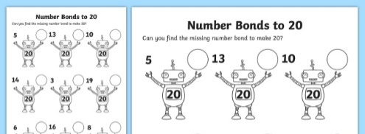  For more of a challenge can you find all the ways to make 20? | Cosmic Kids Yoga  Let’s do some yoga, dinosaur style!  https://www.youtube.com/watch?v=rnlDBKD2S78  For more challenge, can you make some of your own dinosaur moves?

