Maths answers Week 11

Lesson 2: Code breaking
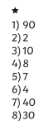
Lesson 3:

