Year R Home Learning Menu – 15.6.20
Try to complete as many of the activities on this menu as you can during the week. If you would like more, log on to Teach Your Monster to Read, Oxford Owls or use some of the websites provided in the original pack. Please remember to take photos of any of the activities and upload onto EyLog so we can see what you have been doing!
Describing a dinosaur  Think of a dinosaur and describe it to someone in your family. They have to guess the dinosaur you are thinking of. Remember to use adjectives to describe  the dinosaur e.g I am big, I have a long neck.  You could use an information book to find out what they look like.  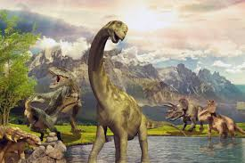  For more of a challenge, can you draw a dinosaur then stick a flap over the top, so it is hidden. Then write clues underneath, for someone to guess what dinosaur is under the flap. | Rhyming words  Using the sheet in the pack can you draw a line to match the words that rhyme.  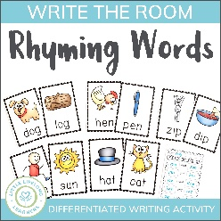  For more of a challenge, can you use the other rhyme sheet to make lists of words that rhyme? | Red words  Can you look in a book and find any of these red words.  Was all we  My she he  For more of a challenge, can you create a tally chart to record how many times you find each word?
Salt Dough Fossil  Can you follow the instructions and make some salt dough fossils. You could print toy dinosaurs into your dough or shape the dough into bones or teeth.  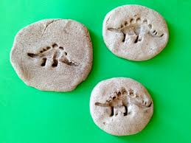  https://www.littlepassports.com/blog/craft-diy/make-dinosaur-fossils-using-salt-dough/  To challenge yourself, can you write what you had to do. | Maths-Teacher challenge  Watch the video on the school website about sharing by drawing pictures. Use the dinosaur sheet or you can draw your own dinosaurs, then draw leaves underneath each dinosaur to find the answer to these problems.  6 leaves shared between 3 dinosaurs.  8 leaves shared between 2 dinosaurs  12 leaves shared between 3  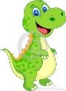  For more of a challenge, can you write the division number sentence. | Dinosaur Dance  Let’s do the dinosaur stomp.  https://www.youtube.com/watch?v=Imhi98dHa5w  For more challenge, can you create your own dinosaur dance and teach it to someone in your family.

