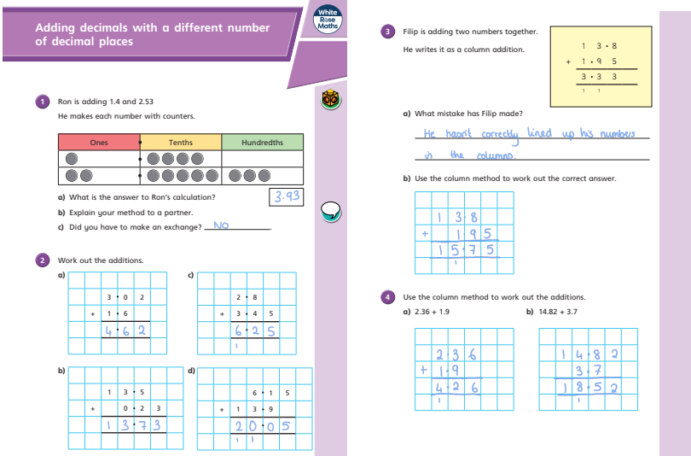
Lesson 1 – Teach and Practise – Adding decimals with a different number of decimal places
Maths Answer Pack – Week 9
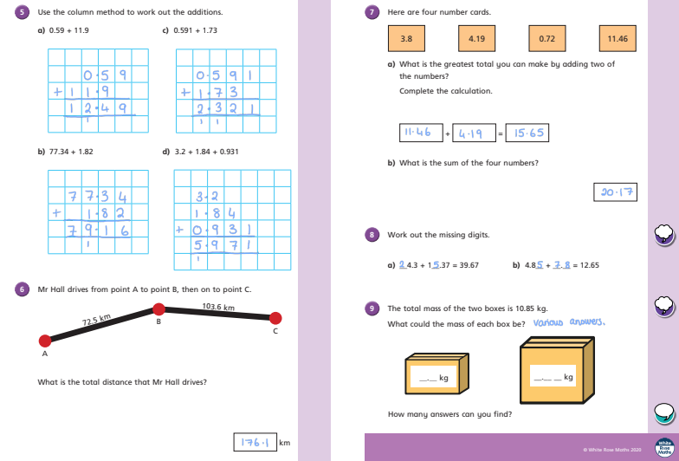
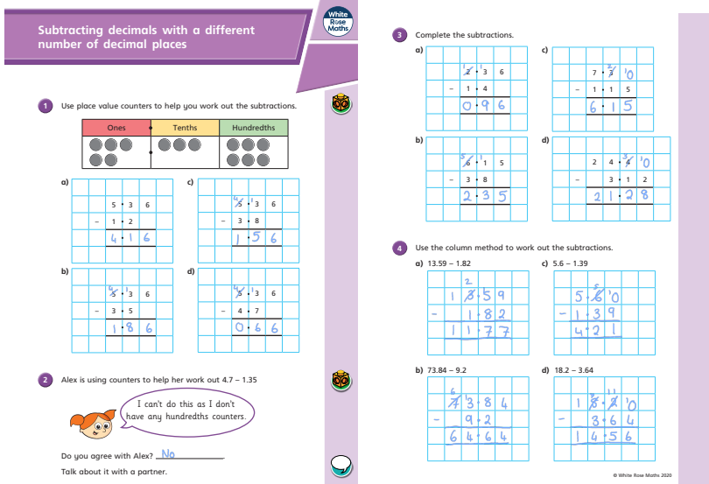
Lesson 2 – Teach and Practise – Subtracting decimals with a different number of decimal places
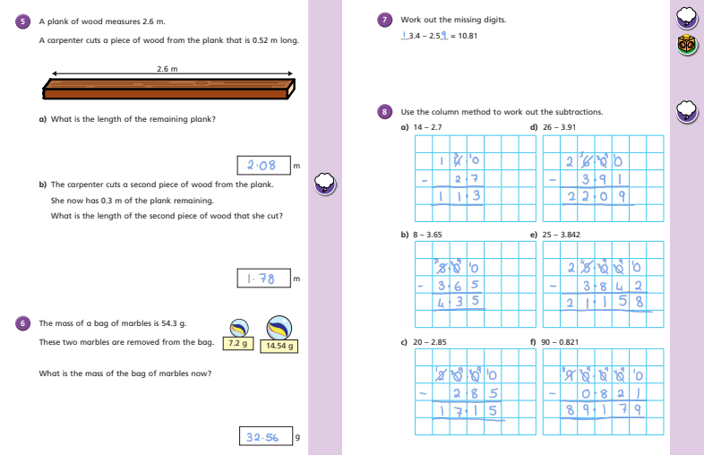
Question | Answer | Question | Answer
EXAMPLE: 3 X 4 = | 12
1. 1262 + 6967 = | 8229 | 6. 6 x 6 = | 36
2. 12 squared= | 144 | 7. 48 x 1000 = | 48000
3. 6 x 8 = | 48 | 8. 30 x 6 = | 180
4. 7 x 9 = | 63 | 9. 3732- 2059 = | 1673
5. 560 + 600 = | 1160 | 10. 25235 + 23452 = | 48687
Lesson 3 - Apply/Challenge

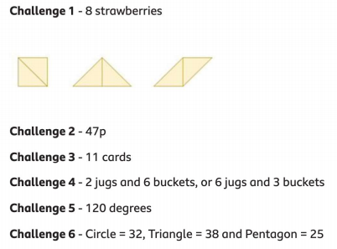
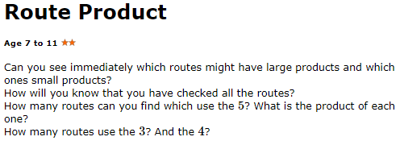
- Solution
- Getting started
Extension – NRICH Problem
