Year 4 Home Learning 11.5.20 – 15.5.20
Literacy Support Pack
Lesson 1 – Finding meaning in a text using inference
Using your knowledge and understanding of ‘The Highwayman’, write what the feelings of the characters using the extracts from the poem.
But first, read the definition below of inference.
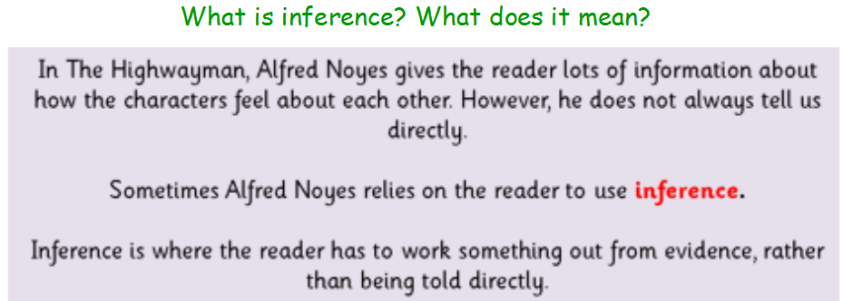
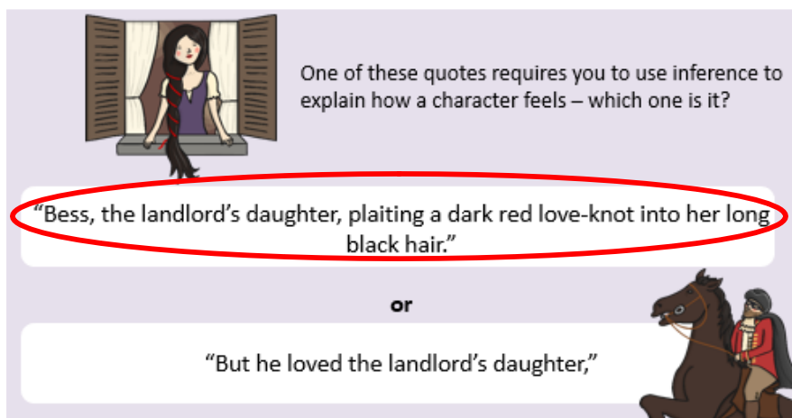
We know from the poem that Bess is in love. We know this because she is ‘plaiting a dark red love-knot into her long black hair’. She would only do this because she is in love.
In Part 1, you can see the different feelings between each of the three characters. Tom, the ostler is in love with Bess. Do you think that the rest of the relationships featured are true?
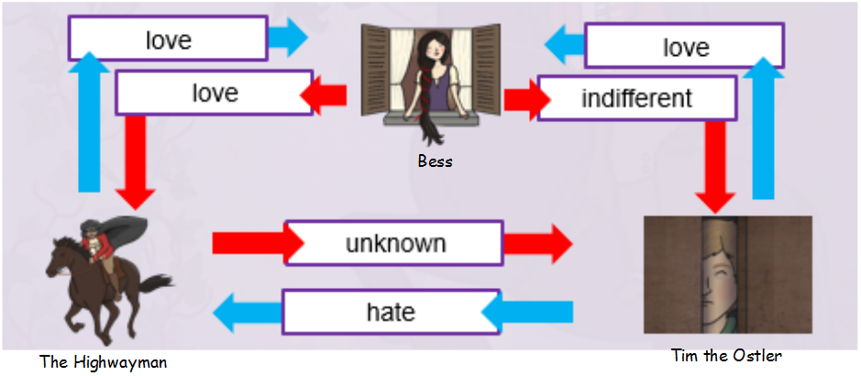
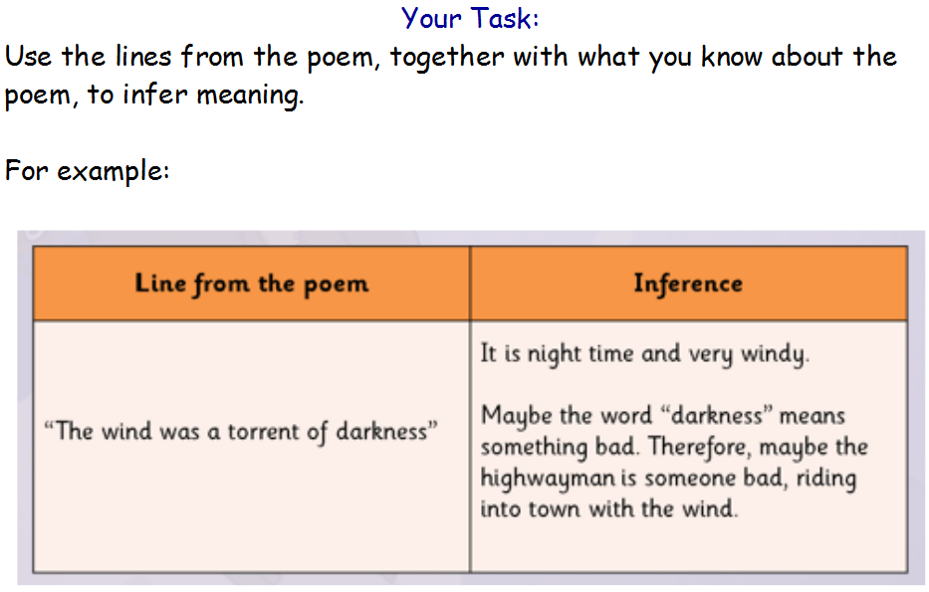
There are three levels of task, Romans, Anglo-Saxons and Vikings. Please choose the appropriate task for you. After you have had a go at the tasks below, answer one of these plenary questions.
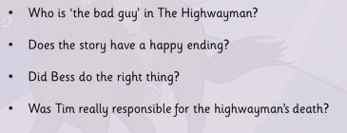
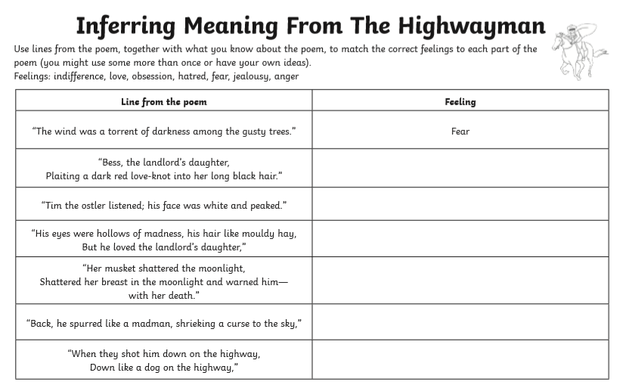
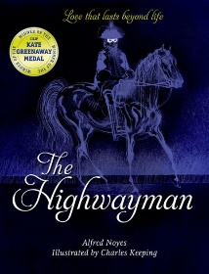

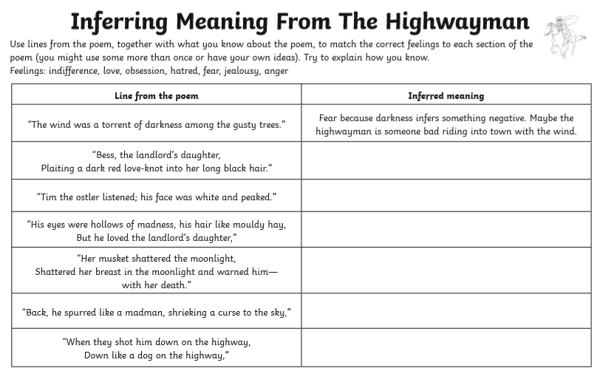
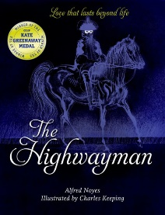
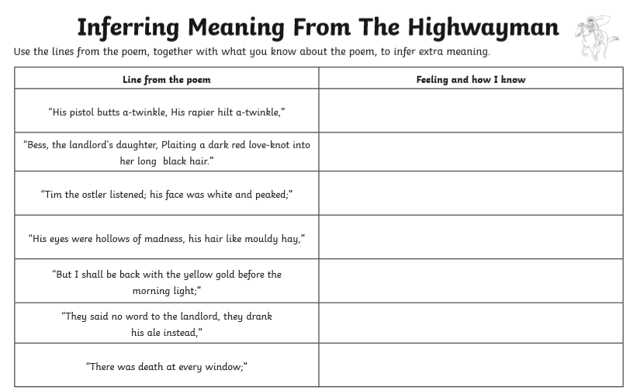
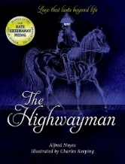
Lesson 2 – Emotions Graph for Bess during ‘The Highwayman’
I have included the poem below as a reminder.
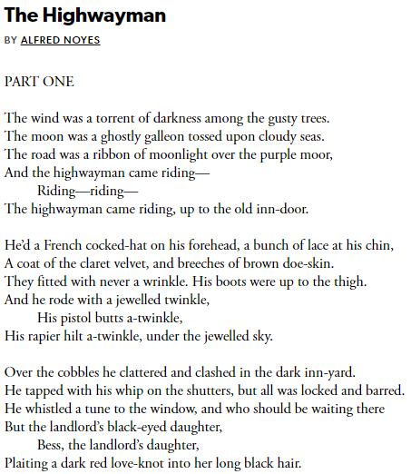
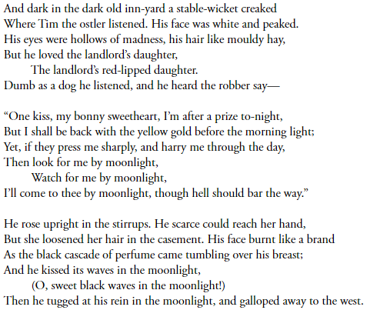
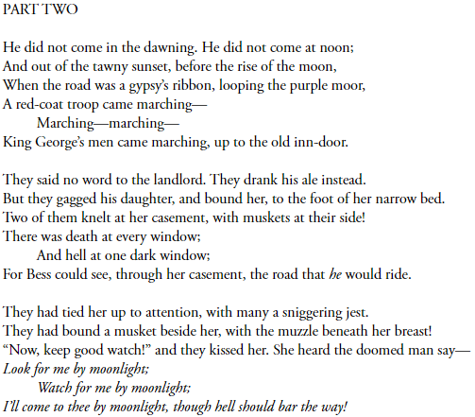
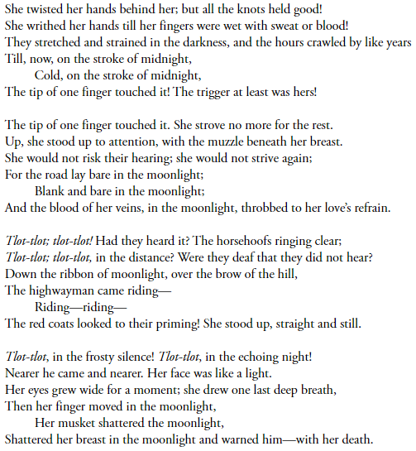
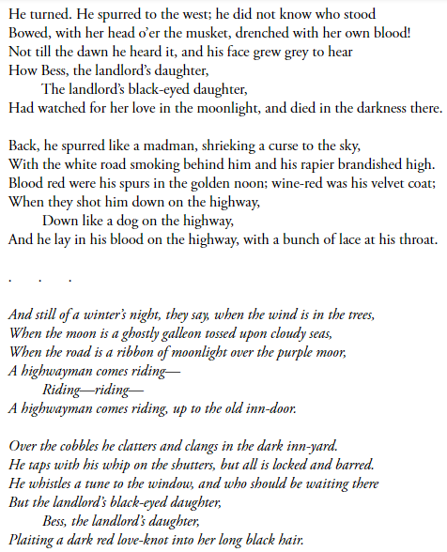
Today, you are going to write a love letter as Bess. You are to imagine that The Highwayman is late returning to you and in your worry, you have decided to write a love letter to him.
ALL: I can organise paragraphs into points and then support it with extra detail.
MOST: I can include a variety of sentence structures, including; ISPACE, simple, compound and complex sentences.
SOME: I can include detail from the poem to support points of each paragraph.
Here is a copy of your success criteria.

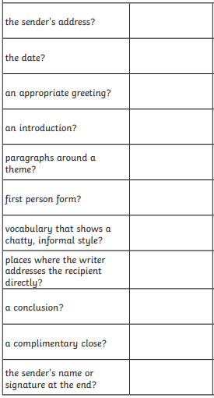
This checklist should help you with features that need to be included. As well as this, you will find an example of a love letter below which will give you some clues and pointers on what to include.

Remember your love letter should be informal.

The Highway Man,
Oak Country Road,
1NN HWM1
Bess the Landlords Daughter,
Purple Moor Road,
1NN BLD1
Dear my bonny sweetheart, Bess,
Long black hair. That is what engulfs my daydream, each time I close my eyes. Your one sweet kiss was not enough to last my tiresome journey. I am writing to share the great love that I feel for you when we are apart. Heading into danger, I had to share my feelings for you, just in case this is the last time.
When I return, we will share the rest of our days together. I promise you this. There will be no more long cold nights of you waiting-waiting at your inn window. Although, I will miss watching you plait that dark red love knot, in your long black waterfall of hair. I know I have to complete this job for this to happen. I long you understand I have to complete these dangerous jobs for our future.
Waiting. I know this is one of the things you hate about us being apart. Anxiety and worry rushing through you, until you hear the clacking of my horses hooves, coming up the purple moor. Just think, our great love keeps me fighting on these dangerous jobs. Knowing, soon I will be staring into you loving black eyes. I could get lost in them for hours. Watching every emotion flick and dance.
Sadly, it has come to that time. I need to venture the country road to my next job. Know always, that my heart will forever belong with you. That your sweet smile is the last thing I think of before I drift off to a peaceful sleep.
I will see you in goodtime my beloved. Be watching for me on the purple moor from your inn window.
Forever and always yours,
The Highwayman x
Lesson 3 – Expanded noun phrases of items around your home and garden
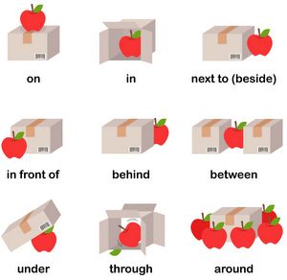
Determiner + adjective + comma + adjective + noun + Prepositional phrase

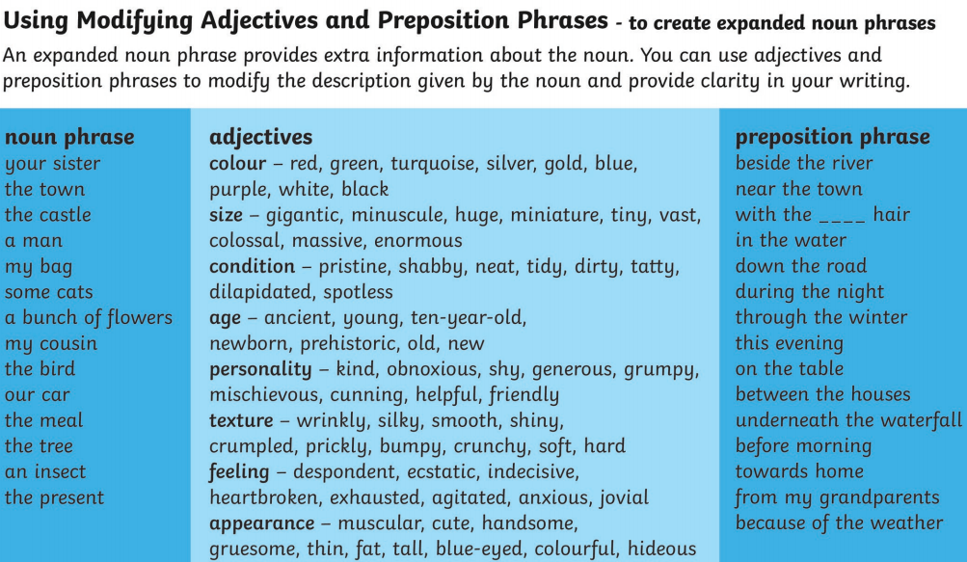
Using the documents above you can expand a simple sentence to include more information.
For example: The town was big.
This could be expanded to: The huge, lively town sat between two quiet villages.
We have expanded the sentence by adding additional adjectives and a prepositions which tells us where something is.
Your Task
As best as you can, describe a scene using expanded noun phrases. At school we would have walked around the grounds, try and replicate this by looking out of a window, walking round your garden or any other way you can think of.

