Week 8 – Topic Support Pack
In this pack, you will find all the instructions, resources and questions that you will need to complete your Science Lessons for this week’s learning! Our topic for the Summer term is Materials.
Lesson 1 – Properties of Materials
There are many different materials out there, but why does it matter what one we use?
Watch the BBC Bitesize video clip on ‘How to Identify Materials’: https://www.bbc.co.uk/bitesize/topics/z4339j6/articles/zx8hhv4 which explains why the choice of material is important for different objects.
For Lesson 1, draw 8 different objects that you can find around your house. Label the object with its name and material and then write a sentence about each object to explain why it is a good choice of material.
Example:
Name of object: Door
Material: Wood
The door is made out of wood which is effective because it stops the heat from escaping in the room when the door is shut and it helps block sound so it will be quieter in other rooms.
Once you have labelled 9 objects, see if you can put them into groups in terms of their materials e.g plastics, wood, metals…

Lesson 2 – Properties of Materials
Ellen has run out of Kitchen paper and towels! She is looking round her kitchen to see what she can use to mop up the water she has spilt!
Using your knowledge of properties of materials, plan your own science investigation to test the absorption (how well it soaks up water) of different materials in your house! This may be items of food you might use in your cupboards. Fill out the planning sheet below. Remember to plan a fair test. It might be the amount of liquid you add, or the time you wait till you check how well the material has soaked up the water.
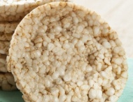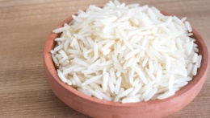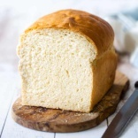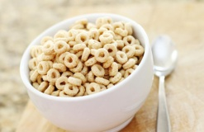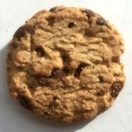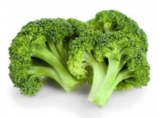
Equipment:  (What you will need) | My prediction:  (What do you think will happen?)
Method:
(What will you do in your experiment?)

Control variables:
(What I have done to make it a fair test)

Lesson 3 – Properties of Materials
For Lesson 3, conduct your investigation and record your results in a bar chart. You may wish to include a scale of how well the water soaked up out of 5, 1 – being bad and 5 – being it soaked up all of it! It would be great to see some pictures of you undertaking your investigations!

Extension
Using your knowledge of the food groups you have learnt in food technology last week; label the food groups of the foods you have used.

