Topic Lesson 1 Geography, where in the world is Barnaby Bear?

Can you watch the following video: https://www.bbc.co.uk/bitesize/clips/z7hvcdm . This video is of Barnaby Bear in Dublin, the capital city of Ireland. Can you write down 5 facts you learnt about Ireland from watching the video.
1.________________________________________________________________________________________________________________________________
2.________________________________________________________________________________________________________________________________
3.________________________________________________________________________________________________________________________________
4.________________________________________________________________________________________________________________________________
5.________________________________________________________________________________________________________________________________

Topic Lesson 2 RE, Special Books
In Summer we would be comparing special books from different religions. Our first Special Book that we would look at is the Bible.

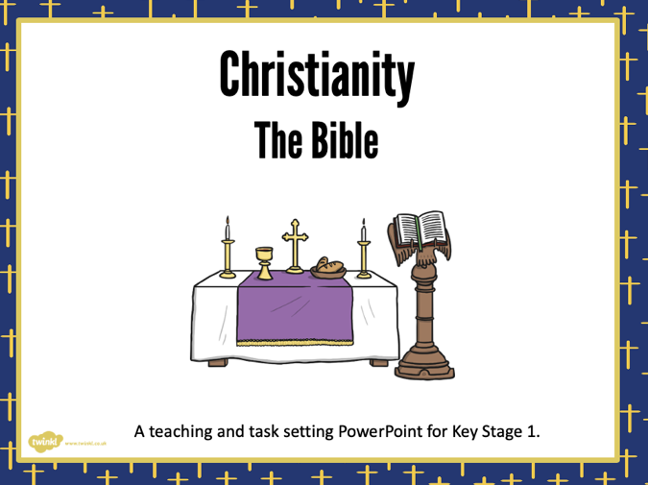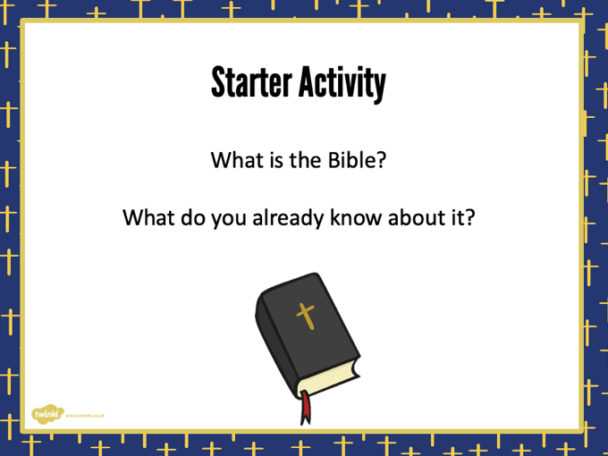

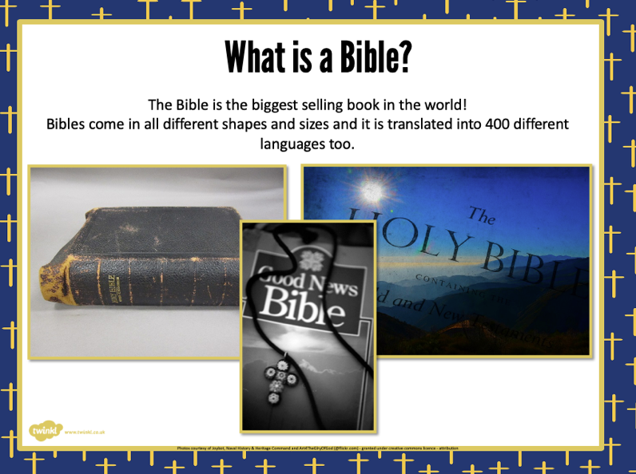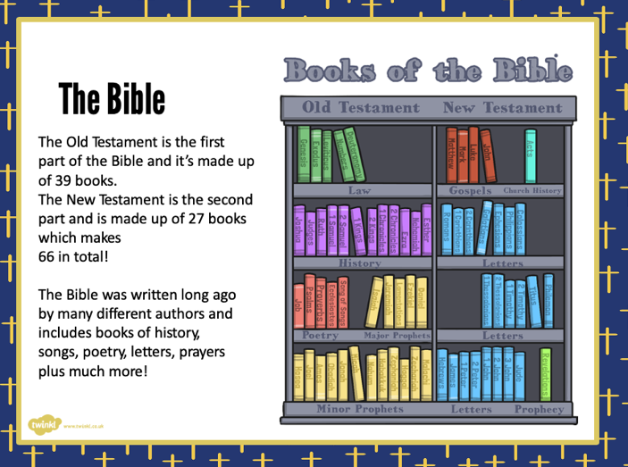

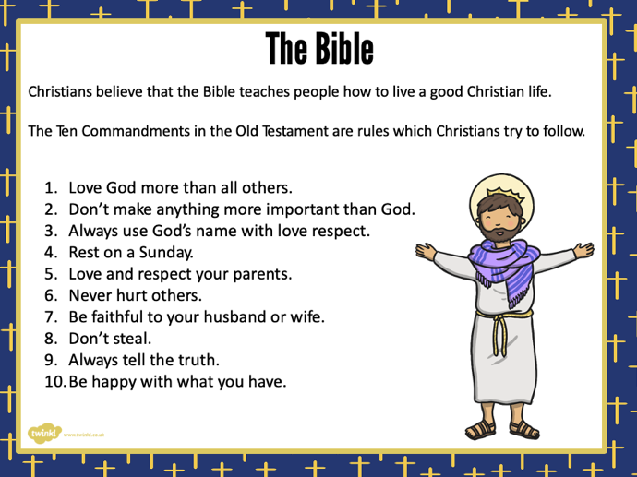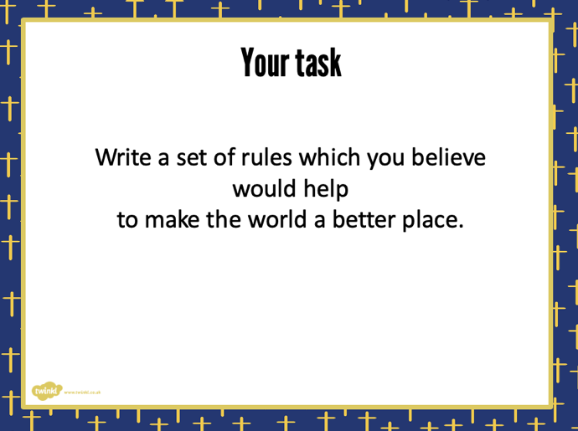

Topic Lesson 2 Science Grouping Animals
Go through the PowerPoint Presentation together, either in this pack or online, then complete the activity.
