Year 2 English Support Pack – Week 13
Lesson 1 – Inference and prediction
Have a look at the picture below. What can you see? What do you notice? Discuss with a grown up your thoughts about the picture.

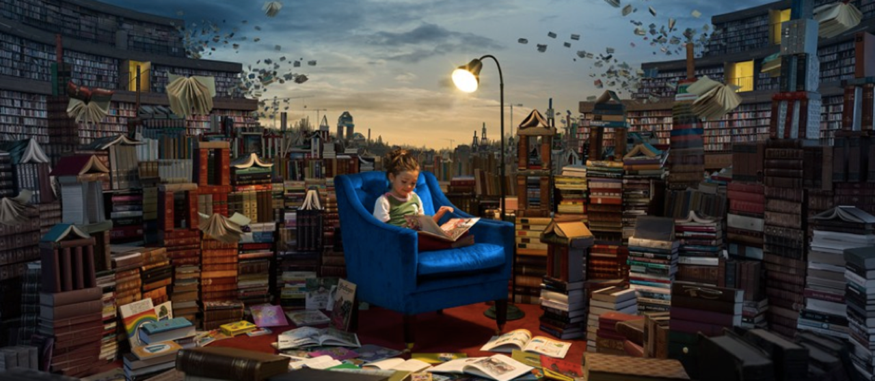
Now have a go at answering these questions:

How do you think the girl feels about being in the library? Why?
_________________________________________________________________________________________________________________________________________________________
Why do you think the little girl enjoys being in this library so much?
_________________________________________________________________________________________________________________________________________________________
What book do you think she is reading?
_________________________________________________________________________________________________________________________________________________________
Where do you think all the books at the back are flying off to?
_________________________________________________________________________________________________________________________________________________________
How do you think the books are able to fly?
_________________________________________________________________________________________________________________________________________________________

Lesson 2 – Creative drawing
The picture from Lesson 1 is from a story about books that come alive! All the books in the library come alive and act like the characters in them.
Can you draw a picture of your favourite book coming alive? Think about whether it would be friendly or nasty! Will it behave like one of the main characters perhaps?

Lesson 3 – Creative writing
Here is the beginning of the story that goes with the picture of the girl in the library. Read it carefully and try to imagine the library in your head.

The Greatest Library
The books had minds of their own.
This was no ordinary library.
Books about knights and castles would gallop all over the library, bravely and boldly ordering the other books around. The books about thieves would sneak around, lurking behind bookshelves in the shadows. Books about wild animals would occasionally roar and bite other books. The ones containing stories set in the winter would often shiver, covering their neighbours with snow and frost.
Lucy loved this place like no other. Reading was the most exciting thing in the world here: everything she read seemed to come alive out of the pages…

Now can you continue the story? Use your most imaginative ideas to describe what happens to Lucy whilst she is in the library.

______________________________________________________________________________________________________________________________________________________________________________________________________________________________________________________________________________________________________________________________________________________________________________________________________________________________________________________________________________________________________________________________________________________________________________________________________________________________________________________________________________________________________________________________________________________________________________________________________________________________________________________________________________________________________________________________________________________________________________________________________________________________________________________________________________________________________________________________________________________________________________________________________________________________________________________________________________________________________________________________________________________________________________
Extension
Read through these sentences carefully. There are lots of mistakes. Can you spot them? Can you edit the sentences to make them better?

the books floatd high into the ski as they set of on their journey

lucy thought the library woz the best library she had ever bin in?

She dreamed that she cud jump into a book and let it tak her away to a magical land

