Year 2 Maths Support Pack – Week 9

Lesson 1 – Part Whole relationships and fact families
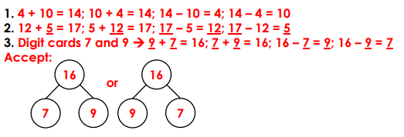
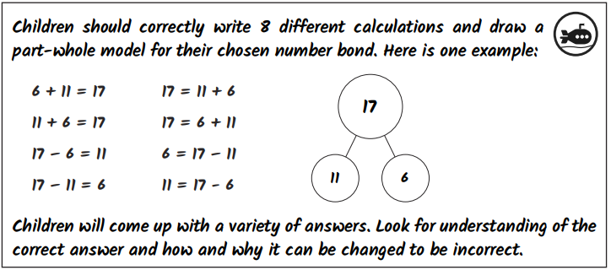
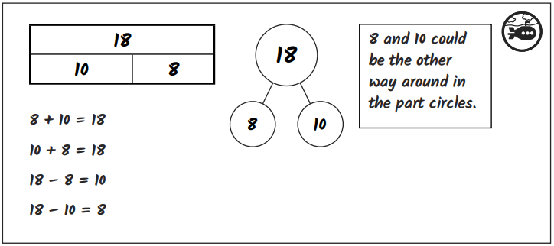
Challenges

Lesson 2 – Comparing number sentences
>  7 + 5 4 + 6 | >  8 + 4 6 + 2
<  3 + 9 5 + 8 | <  12 + 4 11 + 7
<  18 + 9 21 + 7 | 23 + 8 17 + 9  >
>  25 + 7 24 + 8 | =  33 + 7 30 + 10
=  14 – 3 17 - 6 | >  19 – 5 20 – 7
<  26 – 7 28 - 5 | 30 – 5 20 + 5  =

Lesson 3 – Number facts

11
14
20

9
20
6
20
17
3
14 + 6 = 20
6 + 14 = 20
20 - 14 = 6
20 - 6 = 14

11 + 9 = 20
9 + 11 = 20
20 - 9 = 11
20 - 11 = 9

17 + 3 = 20
3 + 17 = 20
20 - 3 = 17
20 - 17 = 3
20
19
1
15
5
20
12
8
20
19 + 1 = 20
1 + 19 = 20
20 - 1 = 19
20 - 19 = 1

15 + 5 = 20
5 + 15 = 20
20 - 5 = 15
20 - 15 = 5

12 + 8 = 20
8 + 12 = 20
20 - 8 = 12
20 - 12 = 8

Challenge!
