Week 12 – Topic Support Pack
In this pack, you will find all of the instructions, resources and questions that you will need to complete your Topic lessons for this week. This week we will be carrying on looking our topic, Jurassic Jaunt.
Lesson 1 – Geography, Features of the Jurassic Coast
Using your knowledge from last week, make a list of the physical features and the human features that you can see in this image.
Physical features are things that are natural such as land, soil, sand, water, plants, rocks etc.
Human features are things that are man-made (made by humans) such as buildings etc.
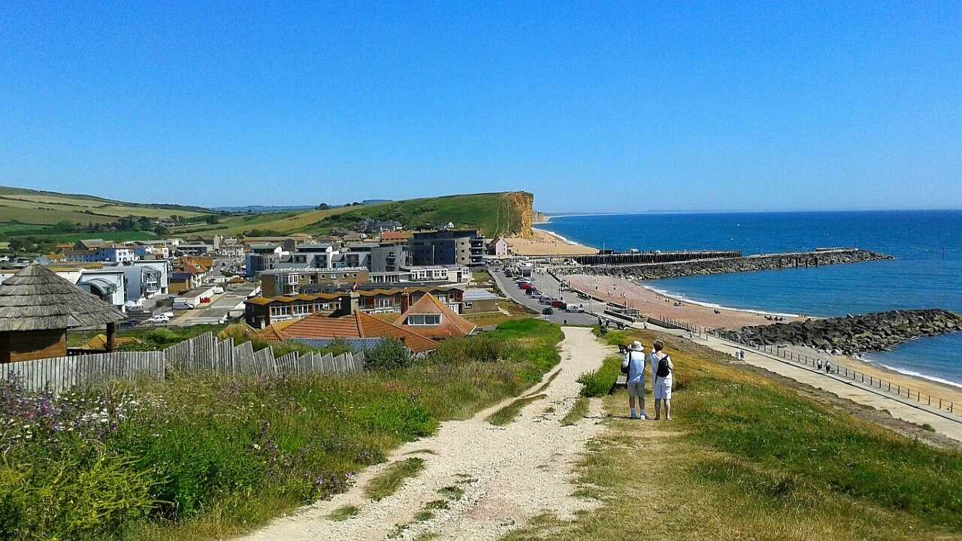
Physical features:

Human features:

Do you think physical features can change? Explain your answer…
Lesson 2 – Geography, Features of the Jurassic Coast
Think back to what the world might have been like 100 years ago…
Watch the video clip below and make some notes in the box below about features that might have changed over time.
https://www.visit-dorset.com/explore/jurassic-coast

Physical features such as rocks can change over time. Use the online dictionary to find the definition of erosion. https://www.dictionary.com/browse/online-dictionary
Erosion –

Click on the link to find out about the 4 main causes of rock erosion. Bullet point your answers below.
http://www.oum.ox.ac.uk/thezone/rocks/cycle/stage2.htm

Lesson 3 – Geography, Features of the Jurassic Coast
Research how physical features of the have changed over time. Create a poster to celebrate 100 years of the Jurassic Coast. You might want to include facts that you have researched and a drawing to show how a part of the Jurassic coast has changed over the years (100 years ago roughly and now).
Extension: Plan a party to celebrate the natural beauty of the Jurassic Coast. Think about how many people might come, what food you might have and where you have it.

