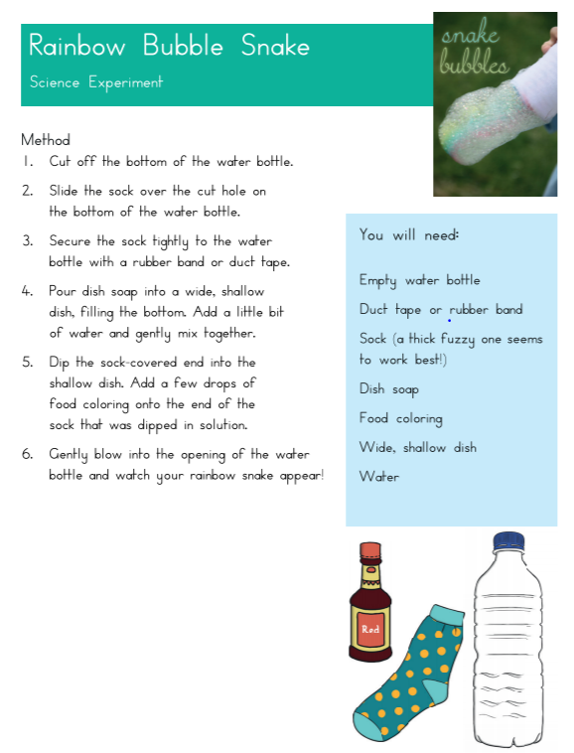

Rainbow bubbles
- a shallow plastic box or deep tray
- bubble mix shop bought or made using washing up liquid and water
- a whisk
- several different shades of glitter
- watered down paint (1:3 water:paint)
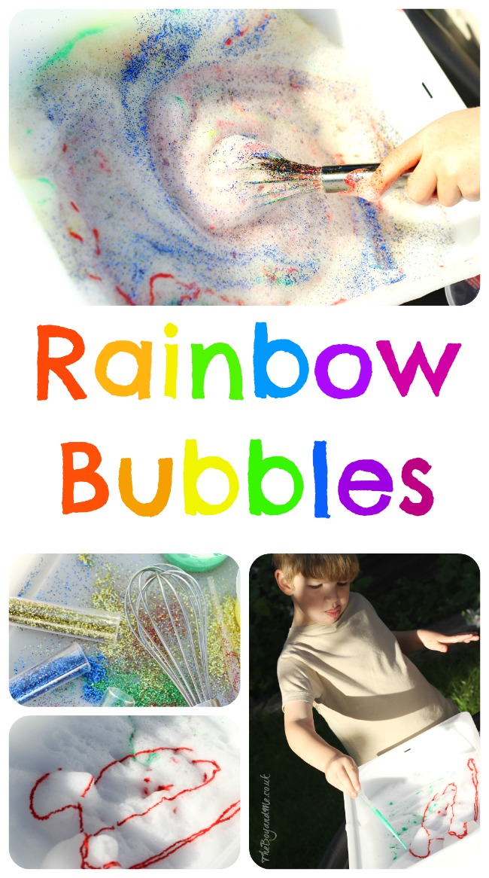
- pipettes or medicine syringes
- Pour the bubble mix into the tray to a depth of two inches. It will need to be this deep to be whisked effectively.

- Use the whisk to froth up the bubble mix, this does take a good few minutes to gather about an inch or so of bubbles, but it's best to get as much as possible to be most effective with the paint and glitter.

- Add the glitter and watered down paint to the froth and then stir it in to make a rainbow effect. (It's great for colour mixing, and if sequins or heavier craft items were used then you could investigate which 'floats' in the bubbles and which 'sinks' into the liquid due to density.)

