Year 2 Topic Support Pack – Week 14

**Topic Task 2 – Seaside Shoebox**

Our seaside topic has come to an end! To showcase everything that you have learnt. Can you create your own seaside shoebox scene? You can choose how you would like to design the project, what materials you would like to use, etc. Here are a few examples:

**[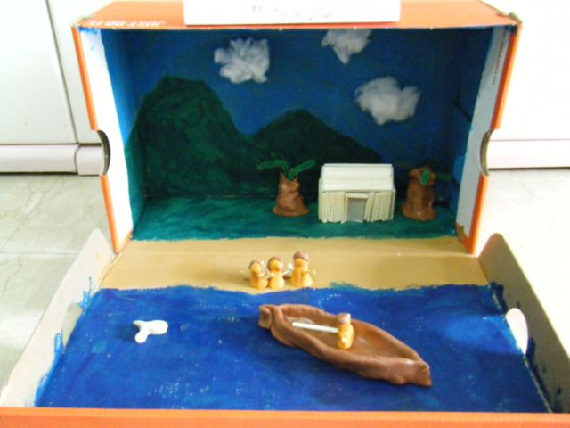](http://www.google.co.uk/url?sa=i&rct=j&q=&esrc=s&source=images&cd=&cad=rja&uact=8&ved=0ahUKEwj6roP287DUAhXCWRQKHZjuCpQQjRwIBw&url=http://learninghippiemom.com/2010/09/06/dioramas-of-singapore-tales/&psig=AFQjCNF466Lir2fasSg7OxVKbRBgRJPsvA&ust=1497100350750141)[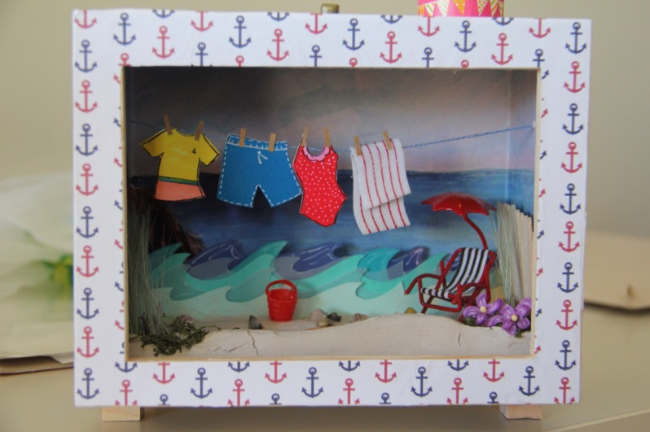](https://www.google.co.uk/url?sa=i&rct=j&q=&esrc=s&source=images&cd=&cad=rja&uact=8&ved=0ahUKEwjxua6E9LDUAhWHWBQKHflxDrUQjRwIBw&url=https://www.pinterest.com/pin/186125397077990255/&psig=AFQjCNF466Lir2fasSg7OxVKbRBgRJPsvA&ust=1497100350750141)[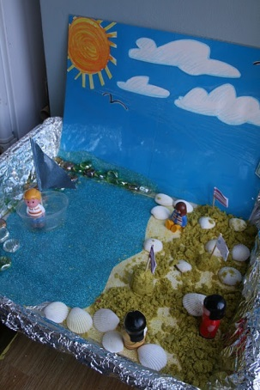](https://www.google.co.uk/url?sa=i&rct=j&q=&esrc=s&source=images&cd=&cad=rja&uact=8&ved=0ahUKEwjs-7T_9LDUAhXLWxoKHch0Dv8QjRwIBw&url=https://www.pinterest.com/evelynyamilex/maquetas-escolares/&psig=AFQjCNF0HhW9OxumNPlXXn-_PDJT9Go-9Q&ust=1497102805450318)**

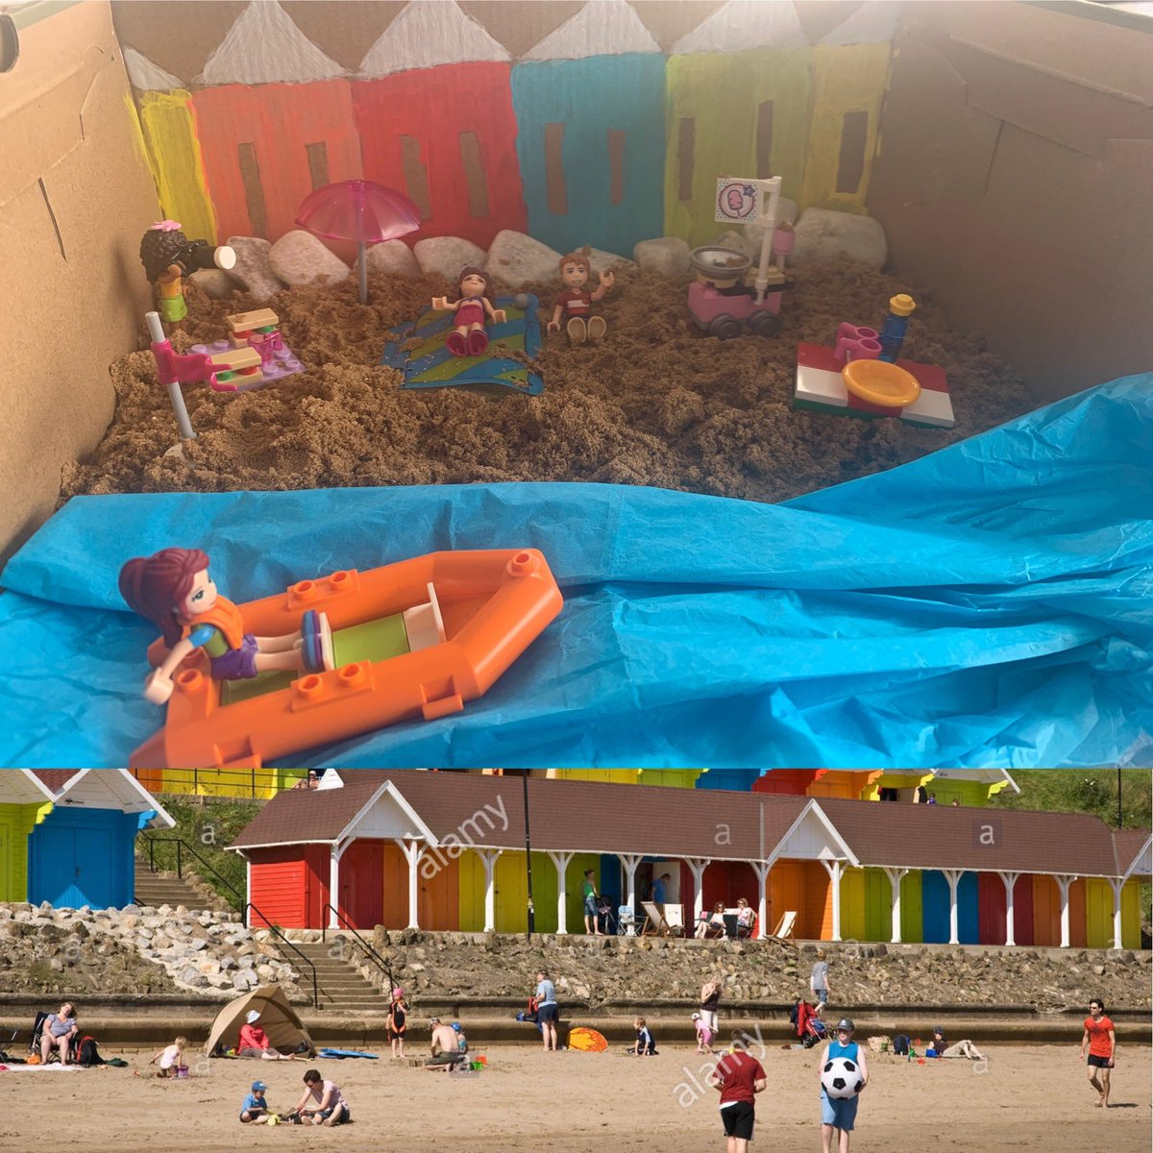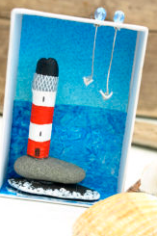**[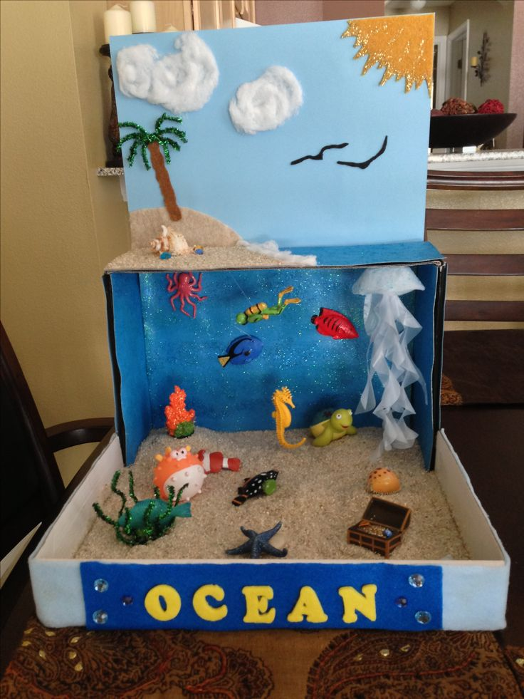](https://www.google.co.uk/url?sa=i&rct=j&q=&esrc=s&source=images&cd=&cad=rja&uact=8&ved=0ahUKEwjR5fCe9bDUAhWIbhQKHQv7BxkQjRwIBw&url=https://uk.pinterest.com/explore/ocean-diorama/&psig=AFQjCNFrIro9lEBYF1Bp48_ou76HWuQUcA&ust=1497100348340882)**

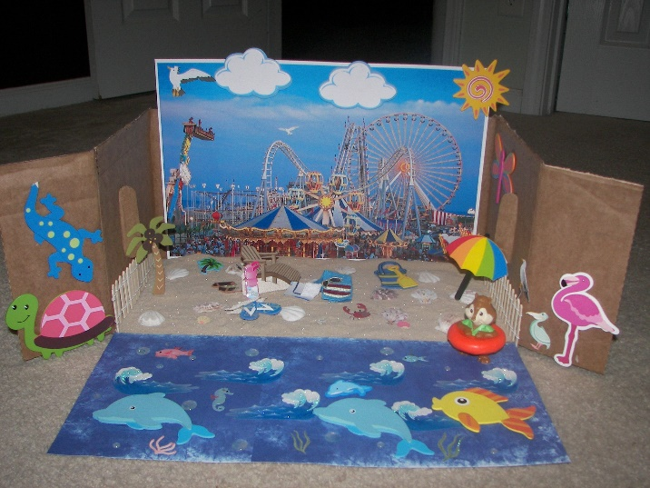

**Topic Task 3 – History**

Look through the slides to find out more about seaside holidays from the past. Can you tell the difference between seaside holidays from 100 years ago, 50 years ago and now?

Then cut out and sort the selection of images into those from the different time periods.

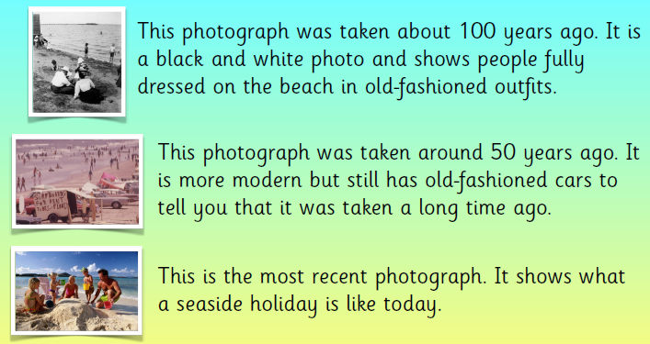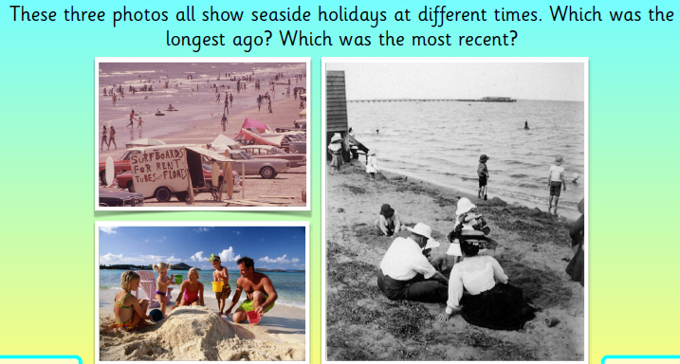

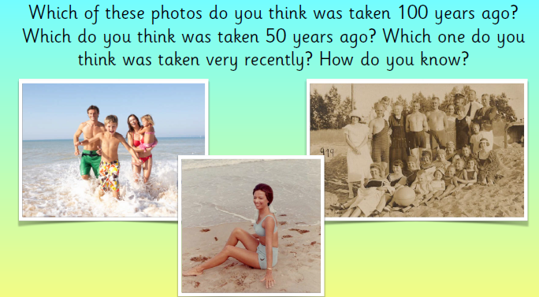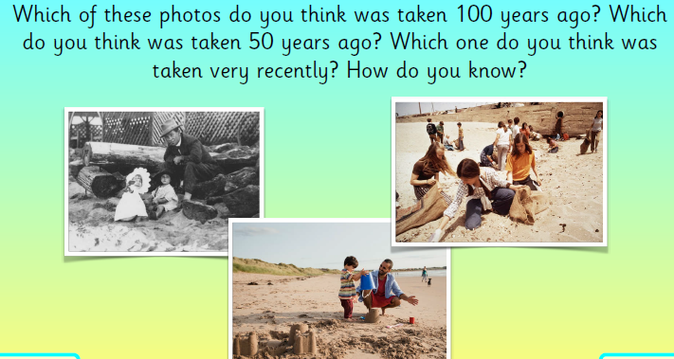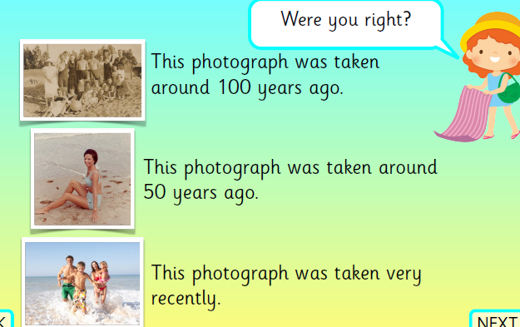

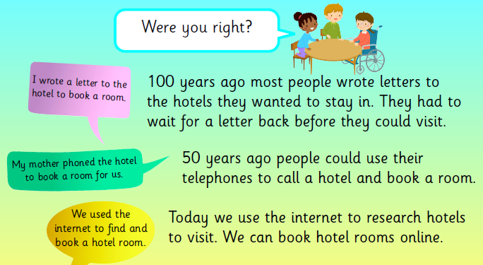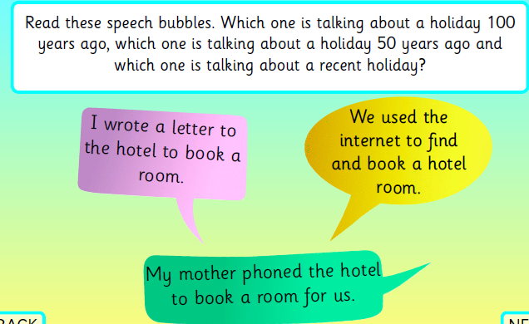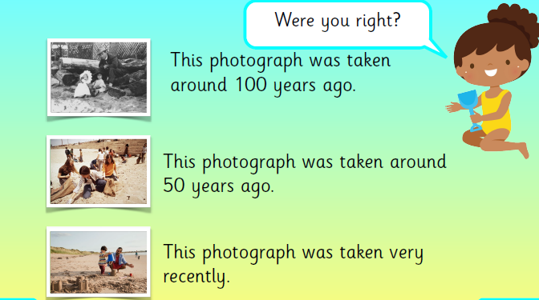

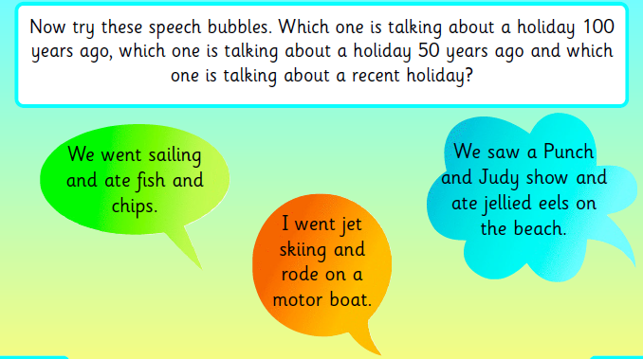

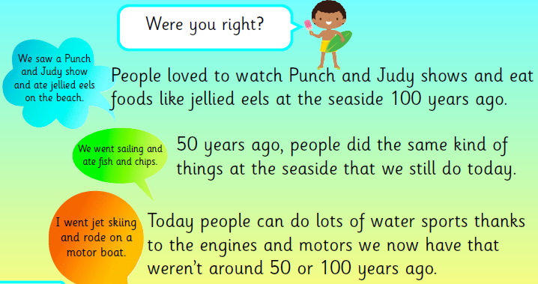

**Now cut out the pictures on the next page and sort them into those that were taken 100 years ago, those that were taken 50 years ago and those from seaside holidays now.**

