Week 14 Maths Answer Booklet
Lesson 1:
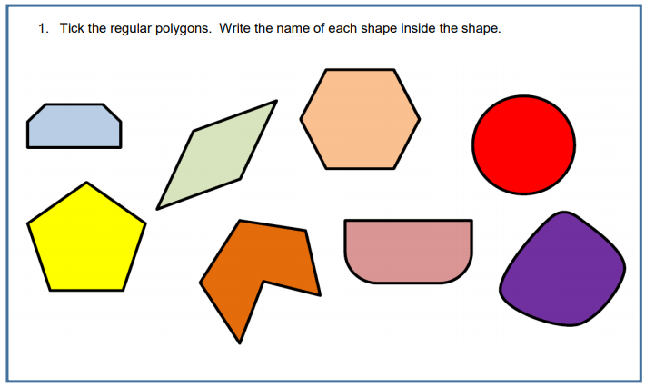

Hexagon
Circle
Rhombus

Pentagon

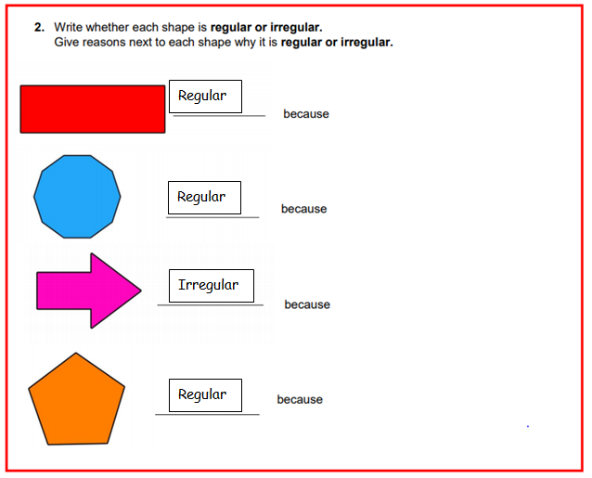

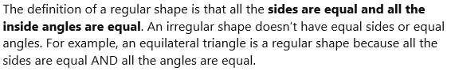

When checking the shapes you have made, check that you have the correct amount of sides!

Lesson 2:
- Square based pyramid and triangular based pyramid.
- She is wrong. 3D shapes might have a different amount of faces, less than double sometimes.

Lesson 3:
