Maths Support Pack – Week 12
This pack includes your 3 maths lessons for the week. The pack includes:
- Maths starters to keep your brains working fast!
- 3 maths lessons
- Links to online lessons for Lesson 1 and 2
- Worksheets and answer sheets
- Extension Task
This pack is to help you, so read through as carefully as possible so that you know what to do for your maths this week. In week 12, we are focusing on fractions. Try your best with everything. Happy Learning Year 5! 😊

Lesson 1 – Teach and Practise – Equivalent fractions
Starter – Daily 10
https://www.topmarks.co.uk/maths-games/daily10
Practise the times tables you feel less confident with! (6’s,7’s, 8’s, 9’s or 12’s) Try 7 seconds like we do in class, or less if you want a challenge.
Input – Equivalent fractions
Open this link https://whiterosemaths.com/homelearning/year-5/. Click on Summer Term, Week 4, Lesson 2, (w/c 11th May) to watch the online lesson.
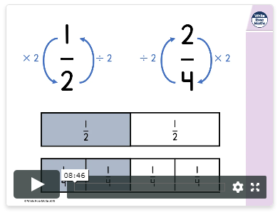
Online video

Activity: Complete the questions below. Watch the video for this lesson as many times as you need to. It’s there to help you!
Once you have finished, open the answers document to check your work.

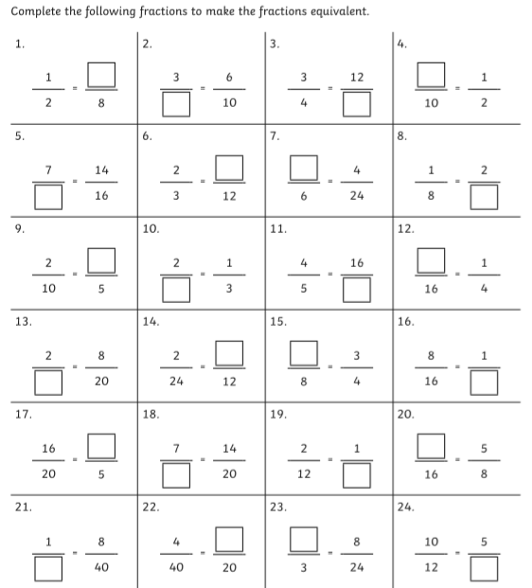

Lesson 2 – Teach and Practise- Converting improper fractions to mixed numbers and vice versa
Starter – Maths Number of the day
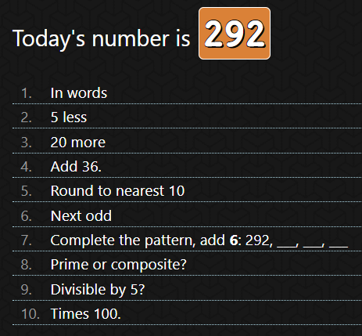

Input - Converting improper fractions to mixed numbers and vice versa
Open this link https://whiterosemaths.com/homelearning/year-5/. Click on Summer Term, Week 4, Lesson 3, (w/c 11th May) to watch the online lesson.
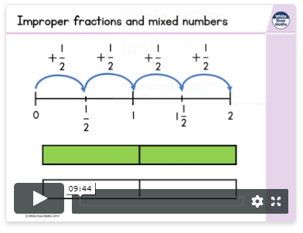
Online video

Activity: Complete the questions below. Watch the video for this lesson as many times as you need to. It’s there to help you!
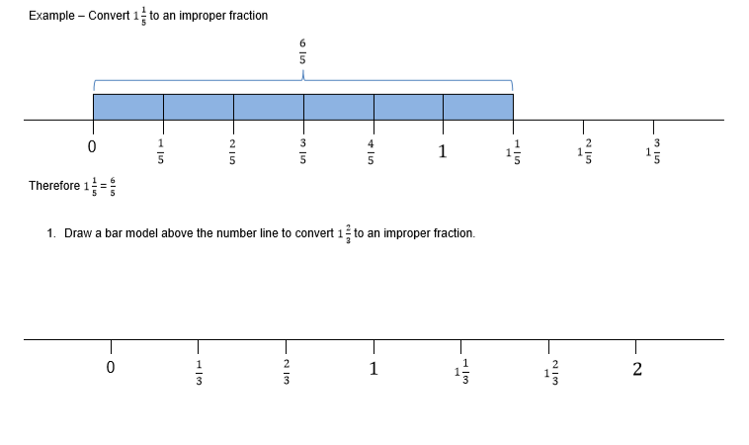
Once you have finished, open the answers document to check your work.

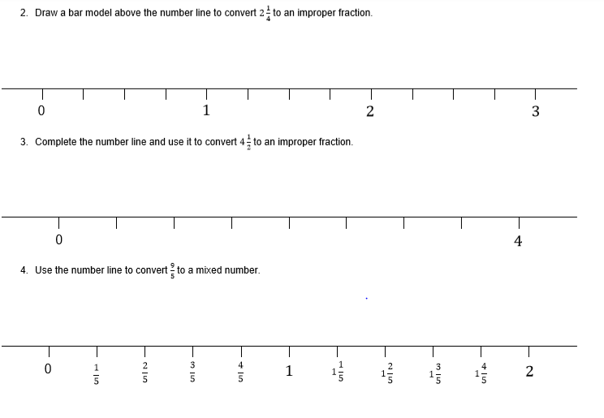
Lesson 3 – Challenge Questions
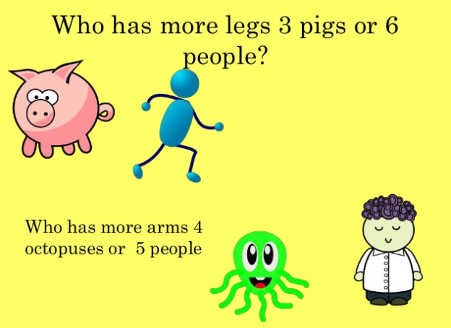
Starter –

Challenge Questions –
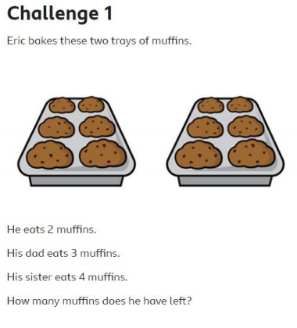
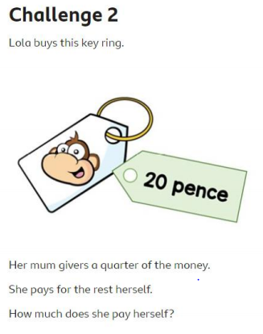

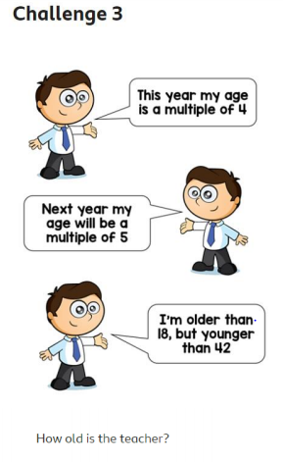
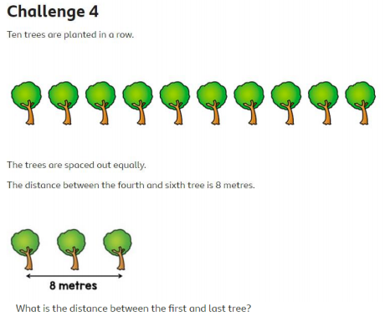

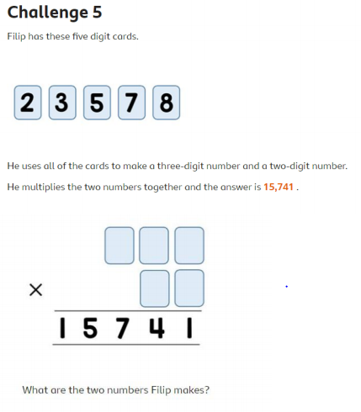
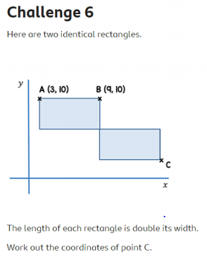

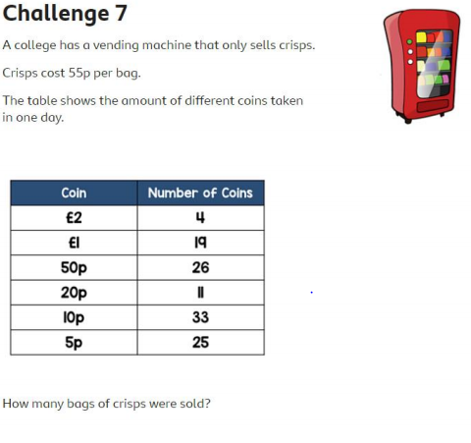

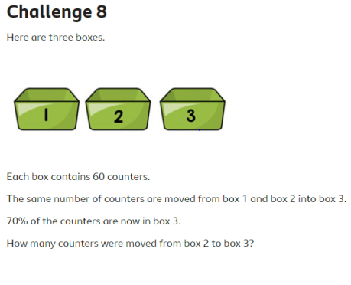

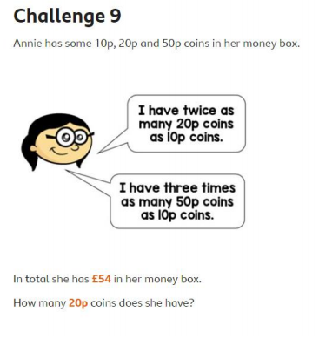

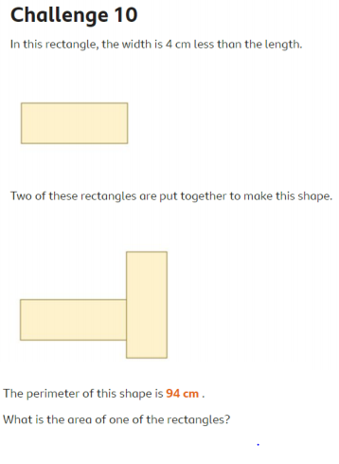

Well done for completing you Maths Pack!
An extension is below for you to have a go at

Extension – Fraction Maths Problems
