TOYS
Year 1 Homework – Spring 2
Choose at least one of the tasks to complete at home this half term. You can choose when to bring your homework back to school or you can submit a photo of it on Google Classroom but this must be before we break up for Easter. Good luck!
Sort your toys into groups. You  can decide how you sort them, e.g.  new and old or wheels and no  wheels or which material they are  made from.  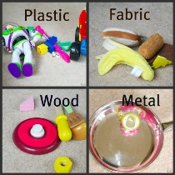 | 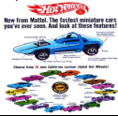  Design a poster for a toy. Make it eye catching and include information about the toy. Write a description of the toy, what it does and why people should buy it. | With a parent or sibling create a toy shop at home. Give some of your toys price labels. (no more than 20p). Take it in turns to be the shop keeper and customer. Choose an item and find the correct coins to pay if you don’t have coins you could make some.  Extra challenge: choose 2 items and add the prices together to find the total.  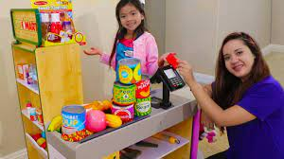  .
Put your imagination cap on and write a story about one of your toys coming alive think about Toy Story for some inspiration. What do you toys get up to whilst you are at school. If it is tricky to write it tell it to a grown up verbally.  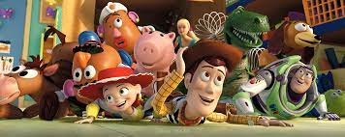 | Create a picture of your favourite toy. You could use pencils, pens, paint or chalk.  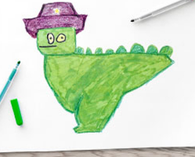 | Design your own board game or design and build a 3D model of a toy. You could use junk modelling or construction to make your toy. Can you include a moving part?  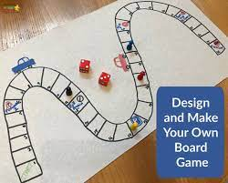
Don’t forget to try and read at home at least 3 times per week

