Year R Home Learning Menu – 29.6.20
Try to complete as many of the activities on this menu as you can during the week. If you would like more, log on to Teach Your Monster to Read, Oxford Owls or use some of the websites provided in the original pack. Please remember to take photos of any of the activities anng upload onto EyLog so we can see what you have been doing!
Jungle Writing  Can you draw a picture of your favourite jungle animal?  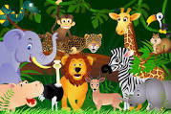  For more of a challenge, can you write a sentence about it? | Ordering by Size  Using the tiger sheet can you cut out the tigers, and stick them in order from smallest to largest.  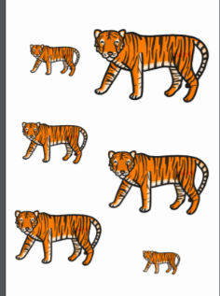  For more of a challenge, can you measure the tigers with a ruler? If you do not have one, there is one for you to cut out. | Reading  Ask a grown-up to hide a teddy or other toy around the house. Get them to write some simple clues such as ‘on the chair’, ‘in the box’ or ‘under the bed’. Follow the hunt to see if you can find the teddy.  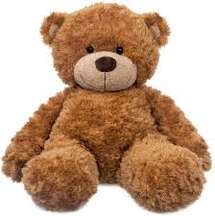  For more of a challenge, can you hide the teddy and write a clue for your grown to read and find the teddy.
Junk modelling  Can you use recycling boxes and tubs to make your favourite jungle animal?  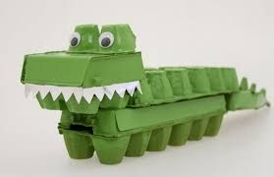  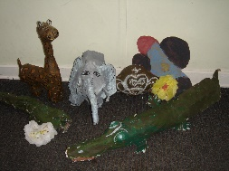  For more of a challenge can you take a photo of it yourself for your grown up to upload on to Eylo | Guess the animal-Teacher challenge  Watch Miss Carter’’s video. Can you guess the aniamal she is describing  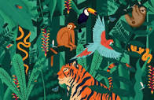  Can you describe animals for your family to guess? | Warm Up Song  Can you listen to the actions in the song and do the moves to the warm up song.  https://www.youtube.com/watch?v=MugzDjGDYjo  For more a challenge can you draw a picture of you doing your favourite move.

