Year 1 Maths Support Pack - Week 10
In this pack, you will find instructions on how to complete your Maths lessons for this week. Follow the links on your home learning menu, or on our class page on the website, to watch the videos. You can then complete the worksheets by printing them, or viewing them on the screen and writing the answers on your own paper.
Week 10 Lesson 1: Ordering numbers within 50
Watch the short videos, then complete the tasks below. 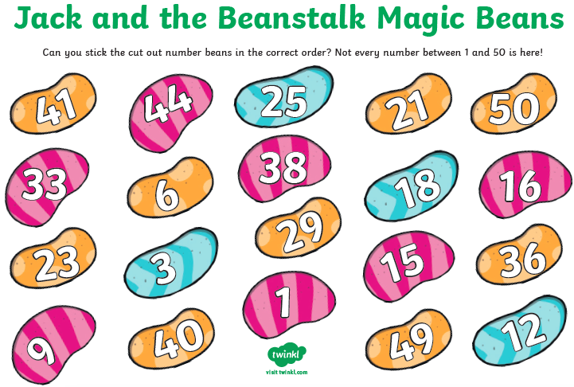
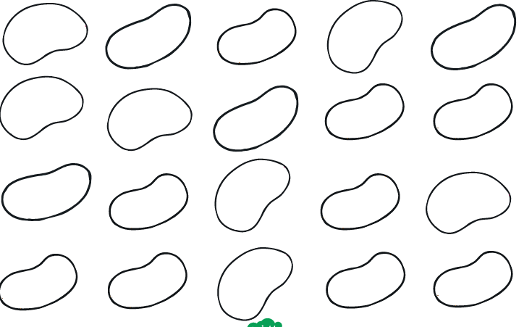

Lesson 2: Number bonds to 10
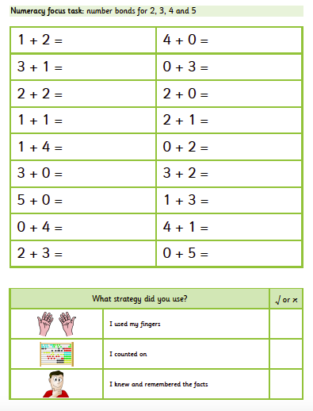
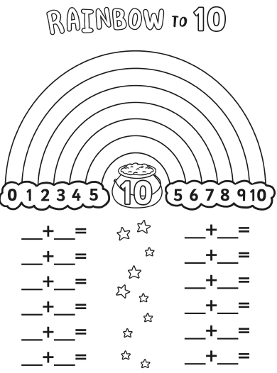

Lesson 3: Fact families
