Year 2 English Support Pack – Week 14
Lesson 1 – Inference and prediction
Look at the image below. This is the tiny dragon. No one knows much about this unusual creature but perhaps you can help to tell us more? This week you are going to write an information text to teach us about the tiny dragon. First you need to answer the questions below using your best inference and prediction skills and don’t forget your imagination!
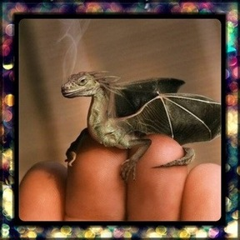

Where do you think it is from?
__________________________________________________________________________________________________________________
Why is it so small?
__________________________________________________________________________________________________________________
Does it have a name? (other than tiny dragon)
_________________________________________________________

Will you keep it a secret or tell someone?
__________________________________________________________________________________________________________________
Is it magic? What magic can it do?
__________________________________________________________________________________________________________________
Are there more like him?
__________________________________________________________________________________________________________________
How would you look after it?
___________________________________________________________________________________________________________________________________________________________________________
Does it remind you of anything? (other dragons in stories or films)
___________________________________________________________________________________________________________________________________________________________________________

Lesson 2 – Information planning
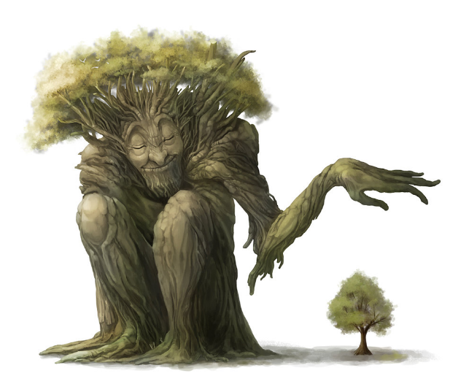
Have a look at this non-chronological report about a different mythical creature. This information report tells you all you need to know about The Tree Giant, including what it looks like, where it lives, what it eats and any other interesting facts.

The Tree Giant
The Tree Giant is a type of giant that has become very rare. What an interesting creature this is! Read on to find out more.

Appearance
Would you be able to recognise a male Tree Giant if you saw one? Like most giants, they have long legs, the body of a large man and a huge head. Typically, they are about the size of a house and are often mistaken for an oak tree as they are similar in stature. However, a few have been spotted that are much smaller and may easily be mistaken for bushes. The main feature of the male Tree Giant is that its skin peels rather like the bark of a rough tree.

Habitat
Like the Common Giant, the Tree Giant lives in solitary groups. They are very shy. During the daytime, they sleep in forests or small clumps of trees. However, at night, dusk and dawn, Tree Giants emerge and, if you are lucky, can be seen trimming hedges and tending to their gardens. They are easy to detect because they make a low rumbling sound as they breathe.

Diet
Tree Giants have a fairly limited diet. Usually, they live on leaves, bushes, small trees and other forms of vegetation that they grow in the wild. However, they can also be tempted with various fruits and are fond of nuts and garden vegetables. Be careful if you come across a Tree Giant in case it mistakes you for a large form of turnip!

Did you know?
The most amazing thing about Tree Giants is that if you meet one, it may grant you a magical wish. For this reason, they have been hunted across the world. This has led to them becoming almost impossible to find. Would you be happy to encounter one in the wild?

You are going to write your own report, just like this one, about the tiny dragon. Use this planning frame to help you jot down all your ideas for your own report. Remember, use your imagination!
Introduction

What is it? Is it related to any other creatures?
Appearance

What does it look like? Include lots of description
Habitat

Where would you find it? Does it live in groups?
Diet

What does it eat? How does it eat? Where/how does it find/catch its prey?
Interesting facts

What can it do that is special?
Lesson 3 – Informative writing

Now that you have planned your information about the tiny dragon, you are going to write your own non-chronological report in the same style as the one about the Tree Giant. The point of your report is that everyone can find out all about this strange creature so make sure you include as much detail as possible. Don’t forget a title – this could be the name of the creature.

______________________________
______________________________________________________________________________________________________________________________________________________________________________

Appearance
____________________________________________________________________________________________________________________________________________________________________________________________________________________________________________________________________________________________________________________________________________________________

Habitat
____________________________________________________________________________________________________________________________________________________________________________________________________________________________________________________________________________________________________________________________________________________________
Diet
____________________________________________________________________________________________________________________________________________________________________________________________________________________________________________________________________________________________________________________________________________________________
Interesting Facts
____________________________________________________________________________________________________________________________________________________________________________________________________________________________________________________________________________________________________________________________________________________________

Extension
Choose one of these strange looking mythical creatures. Can you plan and write a new report based on one of these creatures? Remember, use your imagination! They can be whatever you want them to be! Don’t forget to give them an interesting name!
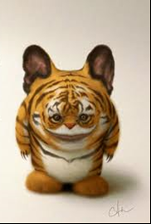
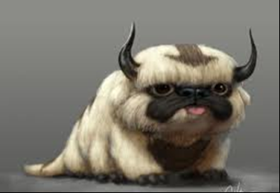
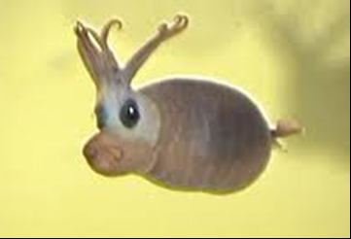
Introduction

What is it? Is it related to any other creatures?
Appearance

What does it look like? Include lots of description
Habitat

Where would you find it? Does it live in groups?
Diet

What does it eat? How does it eat? Where/how does it find/catch its prey?
Interesting facts

What can it do that is special?

______________________________
______________________________________________________________________________________________________________________________________________________________________________

Appearance
____________________________________________________________________________________________________________________________________________________________________________________________________________________________________________________________________________________________________________________________________________________________

Habitat
____________________________________________________________________________________________________________________________________________________________________________________________________________________________________________________________________________________________________________________________________________________________

Diet
____________________________________________________________________________________________________________________________________________________________________________________________________________________________________________________________________________________________________________________________________________________________
Interesting Facts
____________________________________________________________________________________________________________________________________________________________________________________________________________________________________________________________________________________________________________________________________________________________

