Year 4 Home Learning 4.5.20 – 8.5.20
Literacy Support Pack

This week we will be looking at emotions and vocabulary with a view to creating a high quality diary entry from Bess’ point of view in ‘The Highwayman’ Poem.

Lesson 1 – Finding different words with the same meaning (synonyms)
Try and find at least 4 different emotions that mean the same as the emotions listed below. You could use a dictionary or an online version, whichever you prefer.
The emotions that will be looking at are:
Scared
Happy
Tired
Confused
Angry
Relieved
Sad
Love

Challenge 1: Using the words from Literacy Task 1, choose a synonym for each emotion and put it into a sentence where it is appropriate.

Lesson 2 – Emotions Graph for Bess during ‘The Highwayman’

I have included the poem below as a reminder.
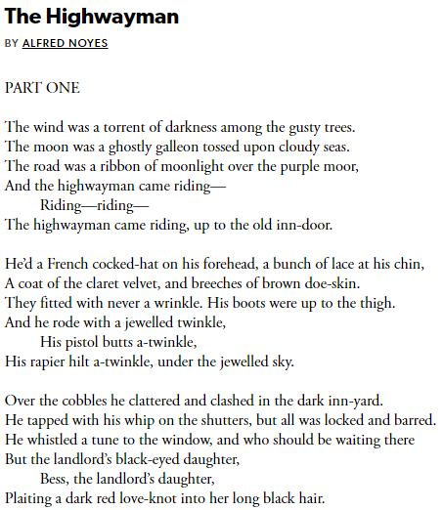
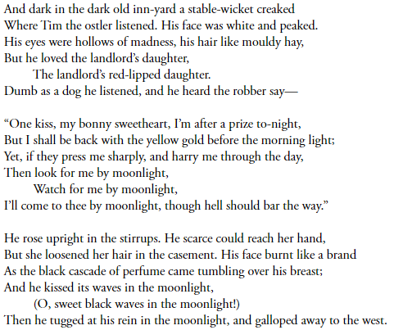
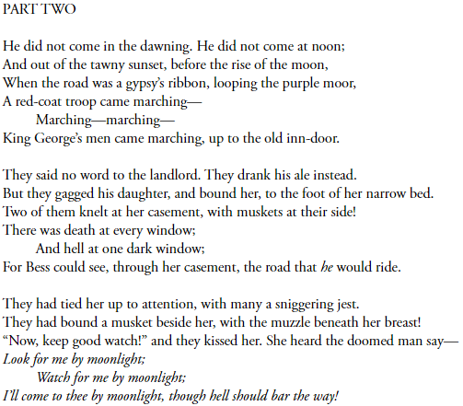
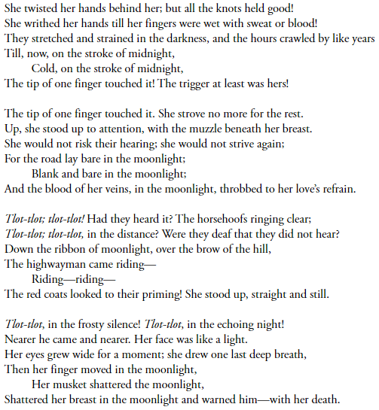
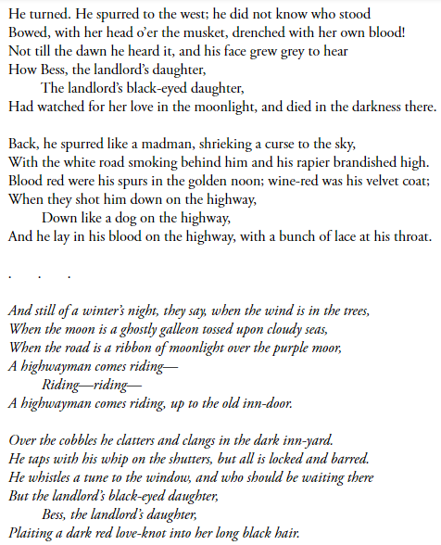
Bess has a range of emotions throughout the poem.
For your task I would like you to pick out her emotion and how she was feeling at these key points:
- Bess waiting at the window and seeing the Highway Man riding up.
- The Highway Man telling Bess he is going to a job and will be back tomorrow night.
- Bess seeing the troops and being tied to the bed post.
- Bess shooting herself to warn the Highway Man to save him.
- Bess living with the Highway Man as a ghost.

I would like you to display your emotions on a graph. I have included a graph example below, however you could draw the graph however you wish to. Once you have drawn your graph, label each point with an emotion that Bess is feeling. Try to use some of your synonyms from the previous session.
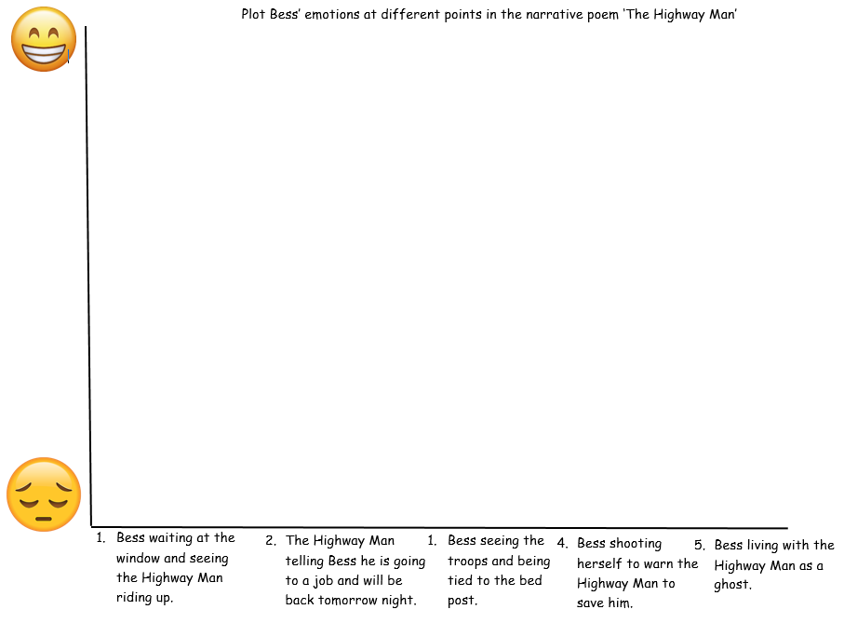
Lesson 3 – Writing a diary entry as Bess
Using the 5 key events from the previous graph, write a diary entry as Bess. Remember to include a range of emotions and also techniques used by the author of the poem. He uses a lot of repetition and this is something that you could use in you diary entry.
Here is a model of a diary entry.

Thursday 16th May 1810
Dear Diary,
Today, my life changed forever. I suppose that’s what love does to you. I just didn’t expect it to change my life this dramatically. Waiting, that is how I had started my day. Waiting for my beloved Highway Man to return from his life stacking robbery. His words replayed in my head all day… ‘One kiss, my bonny sweetheart’.
As the day progressed, my nerves began to race uncontrollably. My love had not yet returned from his job. Dawning came and went, as did noon and the tawny sunset. Still no Highway Man. The anxiety began washing over me like a dark and traitorous sea.
Hope was almost lost when I heard the crashing and clattering of horses hooves against the cobbled road. An unsettling feeling grew in the pit of my stomach, I knew the sound of me sweet Highway Man, riding-riding, to my inn window, and this was not him. It was King George’s red-coat troops, marching-marching. My heart sank deep to the pit of my stomach.
Gagging me, they tied me to the bed post of the bed with a cold hard musket pressed up against me. Despite the terrible danger I was in, all I feared was the safety of my true love. I had to warn him. Wriggling my hands I tried to get free. The searing pain coming from my wrists and hands did not come close to the pain and panic I felt in my heart.
Relief. Relief washed over me for a second as soon as I heard the familiar sound of the Highway Man making his way to me. However, the fear soon returned, what if the troops heard him before I got the chance to warn him. That’s when I pressed the shivering trigger with the hope my efforts would be enough. BANG! That was the last sound I heard.

My efforts did not save my beloved, but all was not lost. We now llive in a world of our own. Together. On a winter’s night, I still plait a red love-knot in my long black hair, while I listen to the comforting sound of my true love riding down the purple moor.
I fear this is the last entry I will write in you, thank you for the pages we have shared.

Take note of a few key features:
- The date – Remember this is not set in the present time.
- Paragraphs
- Emotions and feelings
Thoughts written down as though she was actually speaking them (eg. I fear this is the last entry I will write in you, thank you for the pages we have shared.)

This would have been your success criteria:
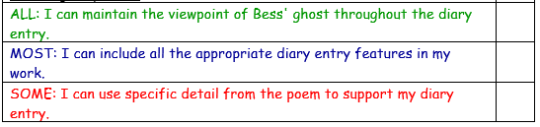
Appropriate Diary entry features are:
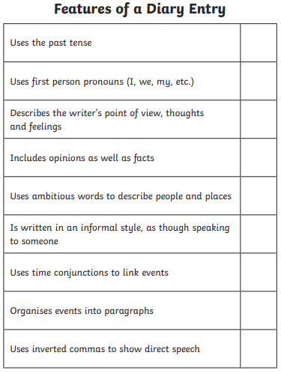
You may also want to use the resource below to remind you of some fronted adverbials which you could use. Remember that you must use a comma, just like the resource does.
