Year 2 Topic Support Pack – Week 8
Topic Task 1 – History
Here is a map of the British Isles. How many different places can you find and label? Can you find England? London? The English Channel? Could you try and label where you think Farnborough is on the map? Do you remember the picture of Grace O’Malley from last week’s History learning? She was from Ireland – Can you find and label this on the map below?
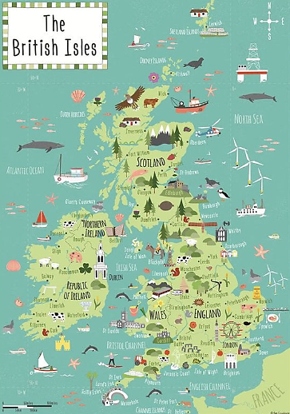

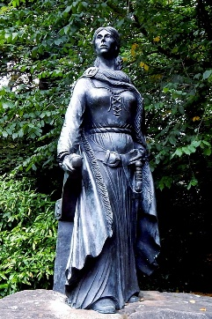
Grace O’Malley was born around 1530 and lived in Clew Bay in County Mayo, Ireland in the 16th Century. That is over 500 years ago! After listening to the amazing story of the Queen Pirate, Grace O’Malley can you order the cards to create a timeline of her life? Use the dates to help you.
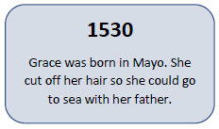
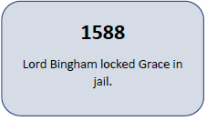
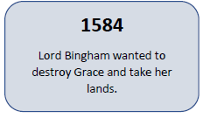
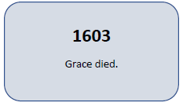
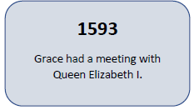
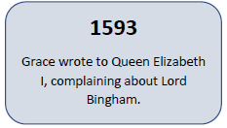
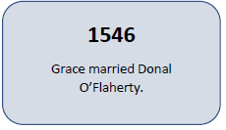
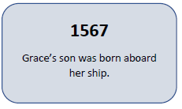
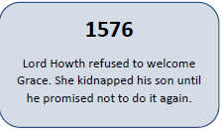
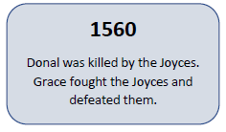
Topic Task 2 - French

Once you have mastered numbers 0-10 in French from our previous weeks learning, it is time to learn up to 20. Watch the YouTube clip to help you learn how to say the numbers.
Then see if you can work out which numbers these are below:
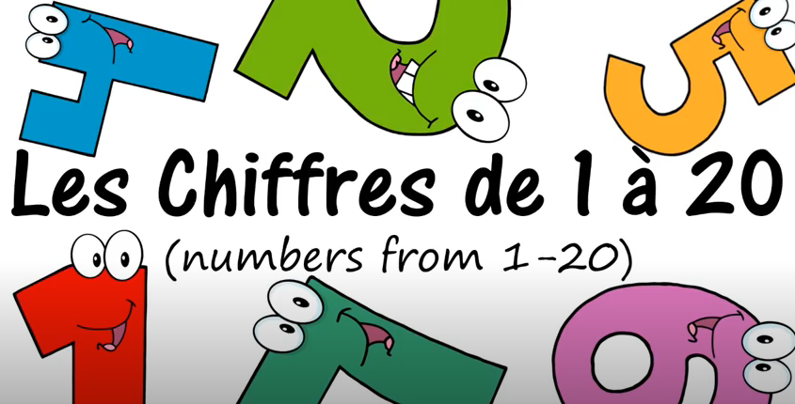

deux = _______ onze = ______

huit = _______ un = _______

treize = _______ quinze = ______

vingt = _______ cinq = ______

Topic Task 3 – Science
Watch the BBC Science video that explains how flowers and plants are pollenated. You can also have a go at reading this information text to help you understand. Make sure you ask a grown up to help you if you are finding it tricky to read.
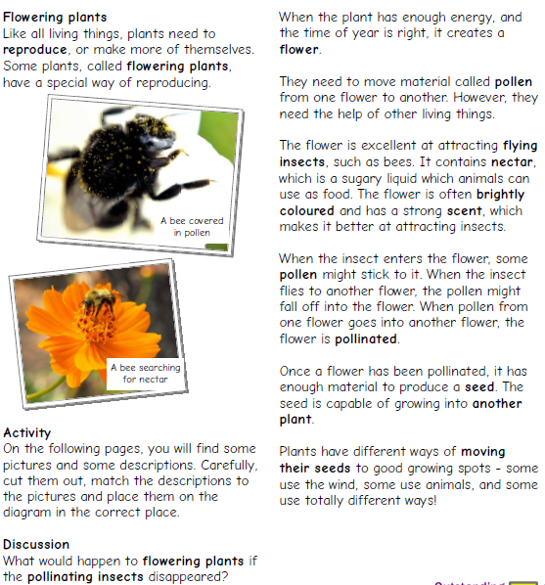
On the next page you will see some pictures and some descriptions. Can you carefully cut out each of them and match the picture to the correct description?
Challenge – What do you think would happen to flowering plants if all the pollinating insects disappeared?
