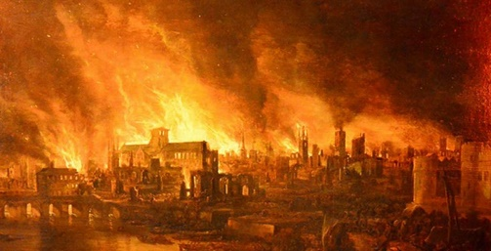
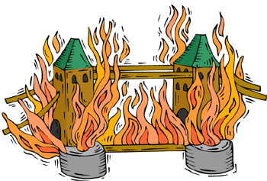
Fire Fire!
Year 2 Homework - Spring 2
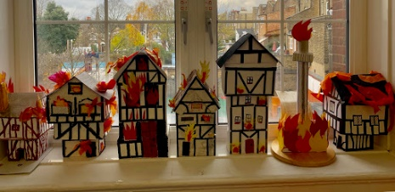  Create a model of 1666 London on fire! Include houses, smoke and flames. You may also include part of the River Thames and The Tower of London in it. | 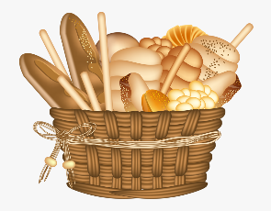  The Great Fire of London started in a bakery on Pudding Lane. Have a go at baking something you could sell in bakery. Take a picture of the final product to show us or bring it in for us to try! | 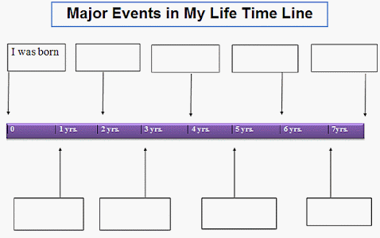  Create a time line of your life so far that includes key events such as the year you were born, the year you started school etc.
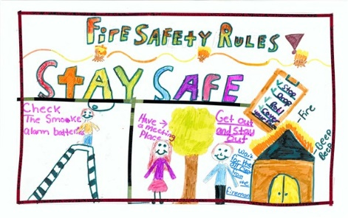  Make a poster to tell people about the importance of fire safety. | Samuel Pepys kept a diary of events during The Great Fire of London. Keep your own diary for a weekend and write about all the things you do. | Teach a friend or family member 5 facts about the Great Fire of London, once you have learnt them in school.  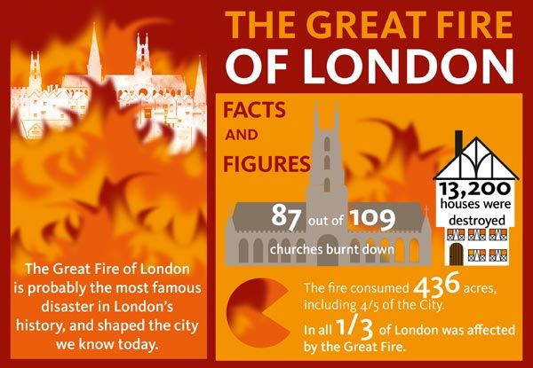
Don’t forget to try and read at home at least 3 times per week.
Choose at least one of the tasks to complete at home this half term. You can choose when to bring your homework back to school but this must be before we break up for Easter. Good luck!

