Year 4 Home Learning 11.5.20-15.5.20
Maths Support Document
This week you will continue looking at decimals. You will have 3 lessons following the same format as last week. You can also find the tasks with the link provided. Remember you will need to watch the video before completing the activity for each session. You will have a variety of practise questions as well as reasoning and problem solving questions. This will provide you the opportunity to really show us your understanding. https://whiterosemaths.com/homelearning/year-4/ Week 2
Lesson 1: Divide 2 digits by 10 (Week 2 Lesson 1) https://whiterosemaths.com/homelearning/year-4/
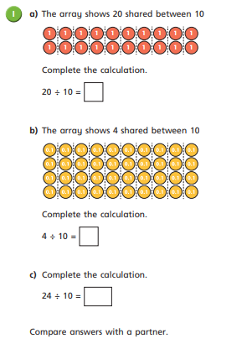

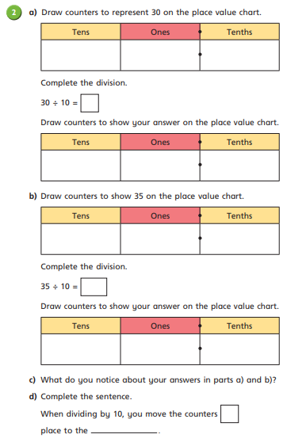

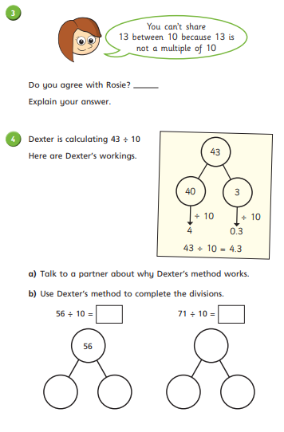

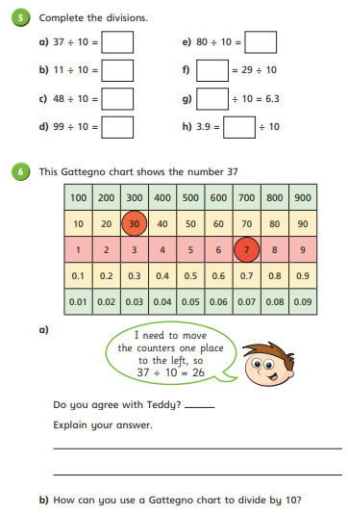

Lesson 2: Hundredths as decimals (Week 2 Lesson 3) https://whiterosemaths.com/homelearning/year-4/
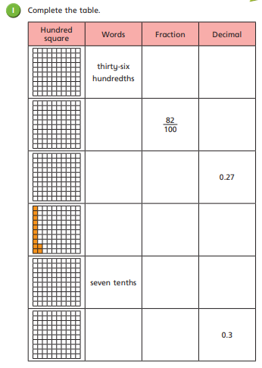

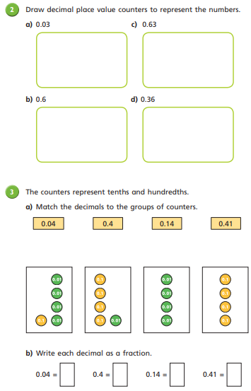

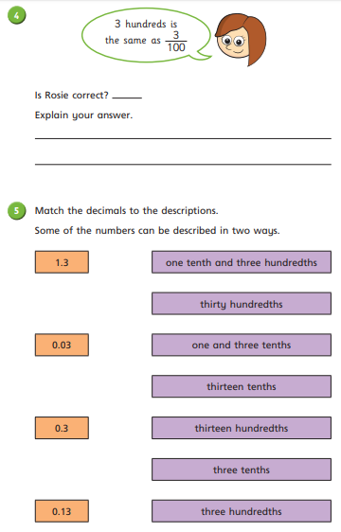

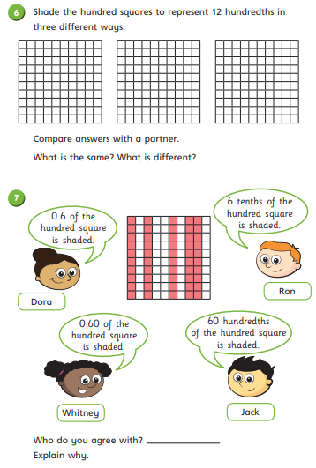

Lesson 3: Divide 1 or 2 digits by 100 (Week 2 Lesson 5) https://whiterosemaths.com/homelearning/year-4/
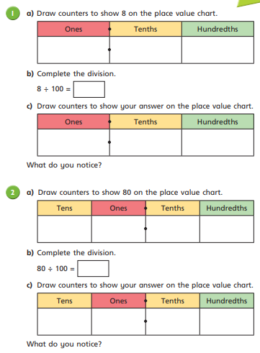

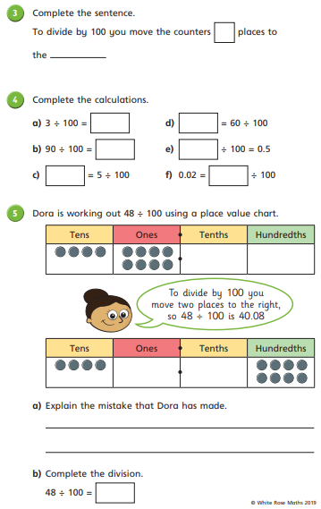

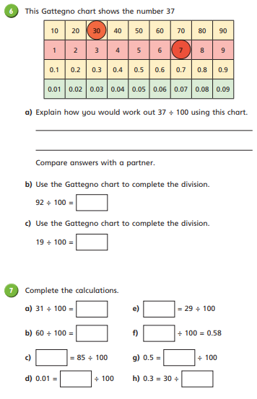

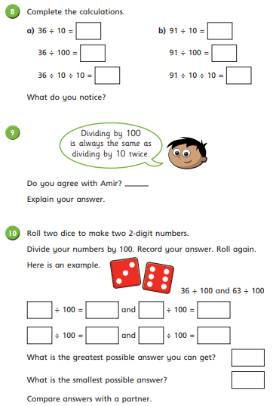

You can use an electronic dice if you do not have a physical one.

