Maths Answer Pack – Week 12
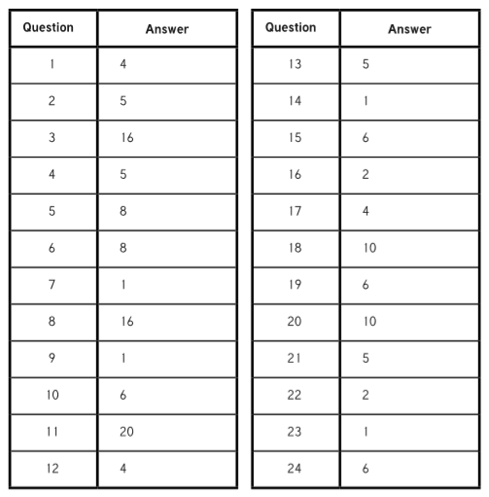
Lesson 1 – Teach and Practise – Equivalent fractions

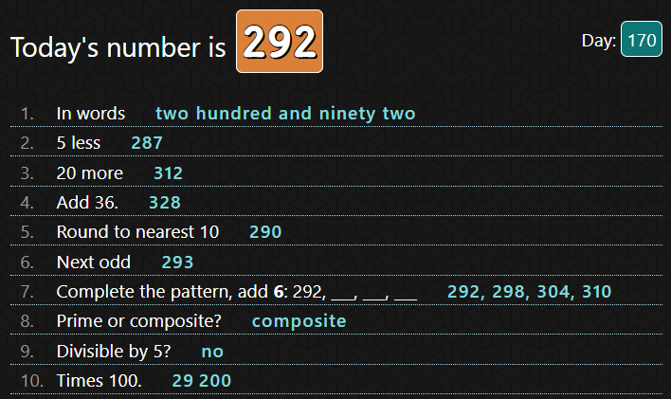
Lesson 2 – Teach and Practise- Converting improper fractions to mixed numbers and vice versa

- 5
3
- 9
4
- 9
2
- 1 4
5
- 3 2
3
- 3

Lesson 3 – Challenge Questions
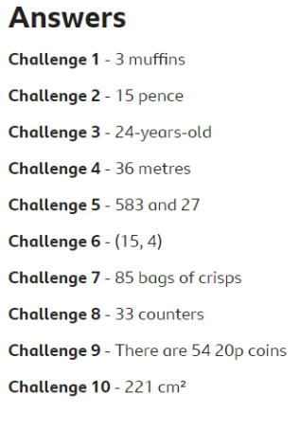
They both have the same amount.
The octopuses have more arms.

Extension – Fraction Maths Problems
- 1 square should be left uncoloured.
- 127
5
- A) 8 B) 12 C) 8
32 15 28
- A) 24 B) 30 C) 35
36 36 56

