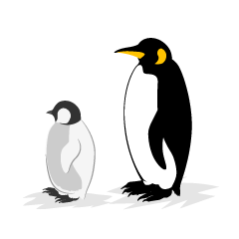
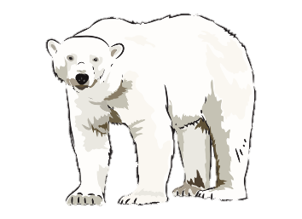
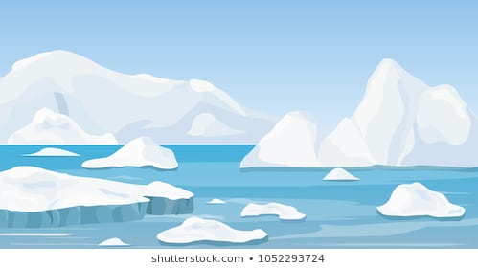
Frozen Planet
Year 2 Homework - Spring 1
Collect words to do with cold, ice, white… write a poem using your words and draw a picture to go with it. | Create a fact file about an Arctic or Antarctic animal. Can you include how they are suited to living in a cold place?  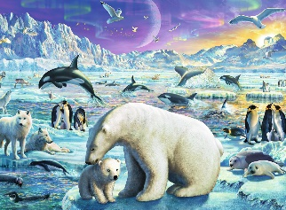 | 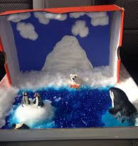  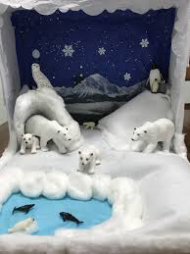  Design and make a polar shoebox scene.
Pretend to be a Polar Explorer and write a story about your adventures. | The ice caps are in danger of melting. Find out about climate change and create a poster giving people advice on how to stop it!  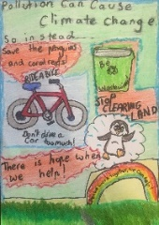 | 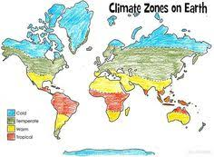  Teach a family member or friend about the four main climate zones.
Don’t forget to try and read at home at least 3 times per week.
Choose at least one of the tasks to complete at home this half term. You can choose when to bring your homework back to school but this must be before we break up for February half term. Good luck!

