Year 5/6 Home Learning Answer Pack- Week 15
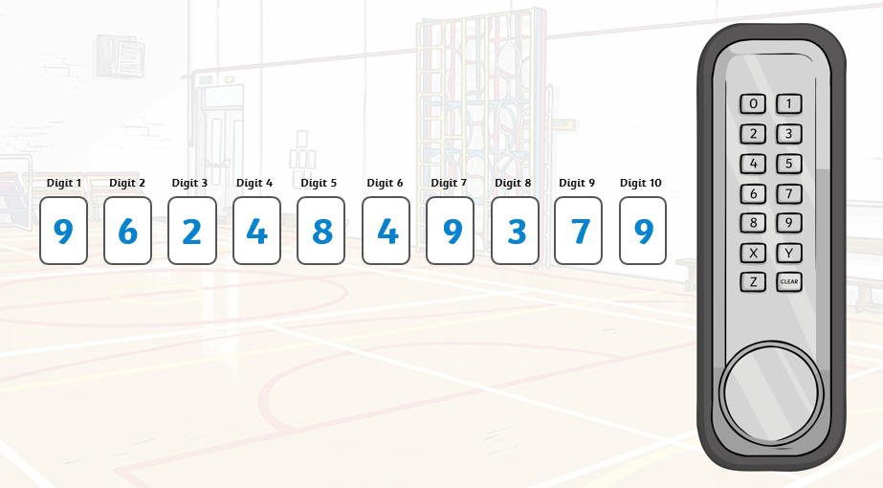
Activity 1- Maths Escape Room

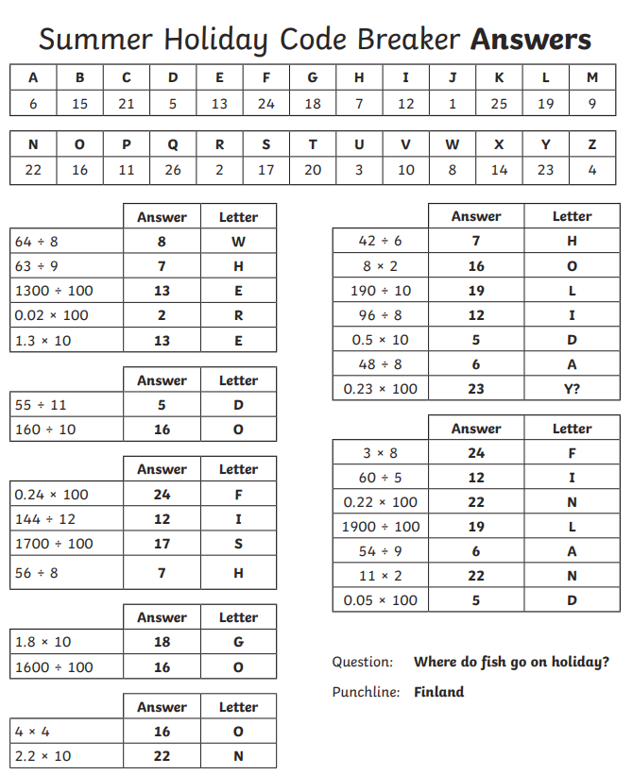
Activity 4- Code breaker
Activity 9- Riddles

- What has four fingers and one thumb but isn’t alive? Glove
- If an electric train is travelling north and there is a strong easterly wind, what direction with the steam be blowing? There is no steam, the train is electric.
- If I dig a hole that is 4.7m wide and 8.9m deep, how much dirt is in the hole? No dirt, it’s a hole.
- What gets wetter when it dries? A towel.
- What starts with a T, end with a T and has T in it? Teapot
- The more you have of it, the less you see. What is it? Darkness
- Two in a corner, 1 in a room, 0 in a house, but 1 in a shelter. What am I? The letter ‘r’
- I have streets but no pavement, I have cities but no buildings, I have forests but no trees, and I have rivers yet no water. What am I? A Map

