Year 2 English Support Pack – Week 12
Lesson 1 – Sentence types
https://www.youtube.com/watch?v=BWiwftl8pqE&feature=emb_logo
Watch the Oxford Owl video to find out about the four different sentence types – statements, questions, commands and exclamations. You can also read the information and examples of each sentence type below.
Then complete the worksheet.
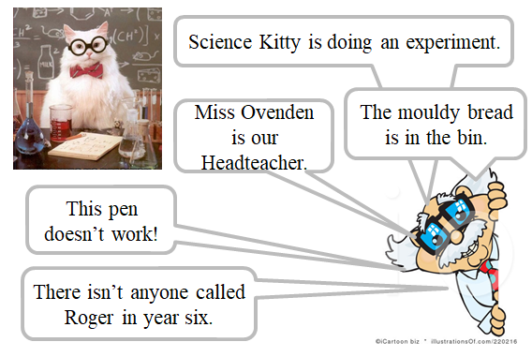
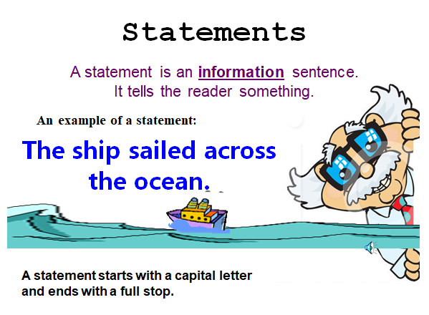

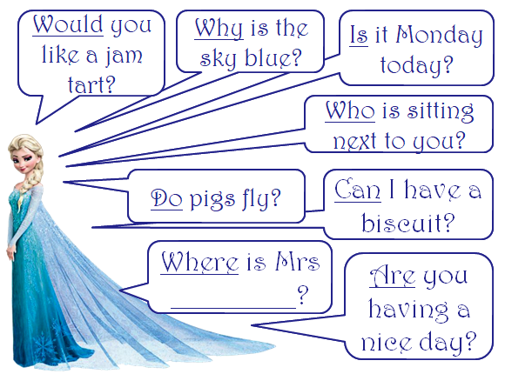
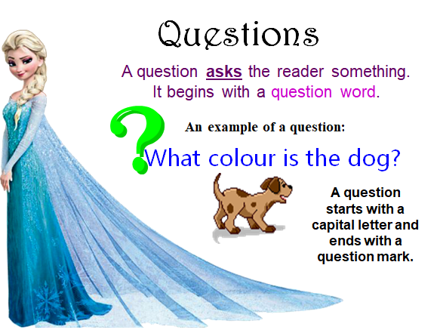
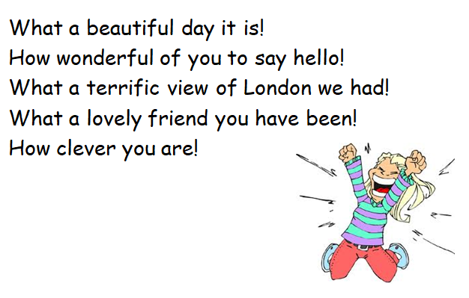
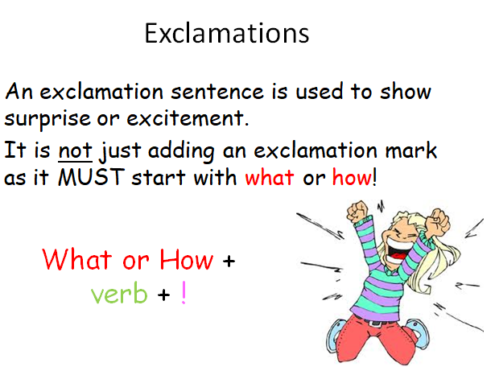
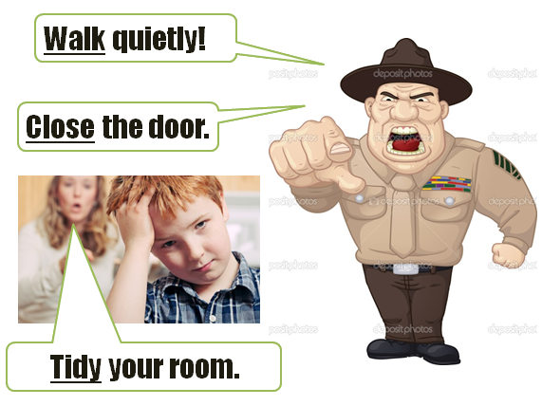
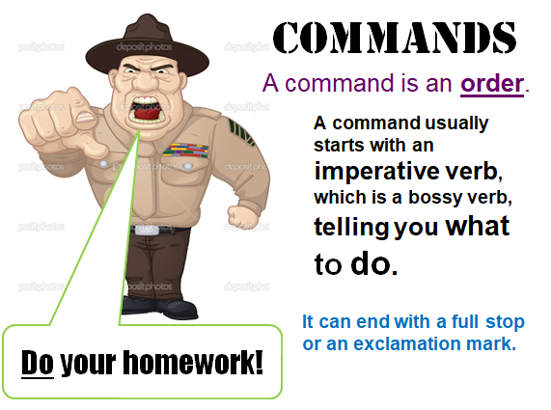

Task 1 - Can you tick one box for each sentence to identify which type of sentence it is?

Exclamation
Statement
Question
Command

- When is the bus due to arrive
- What a tricky test that was
- Elephants have long trunks
- What a nice surprise to see you
- Put your rubbish in the bin
- What time do you go to bed
- How old are you
- The girl was running
- How silly these rules are
- Tuck your chairs under the table

Task 2 – Can you add the correct missing punctuation?

Lesson 2 – Comprehension
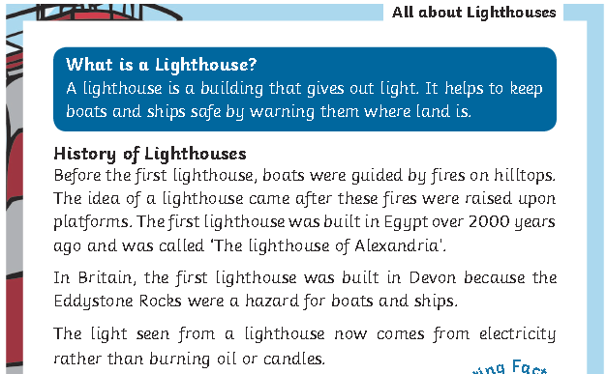
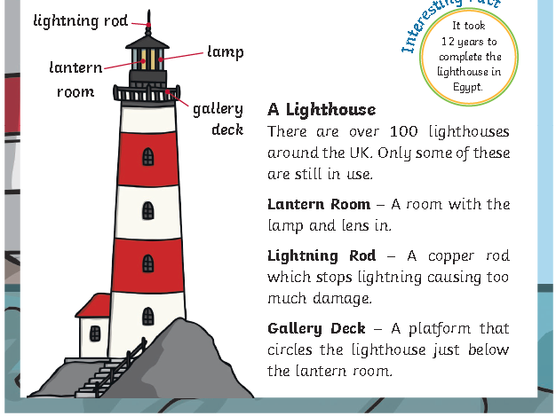
Read the information about lighthouses and then complete the comprehension questions on the next page. There are two different texts, the second one more tricky, so you can choose your level of challenge.
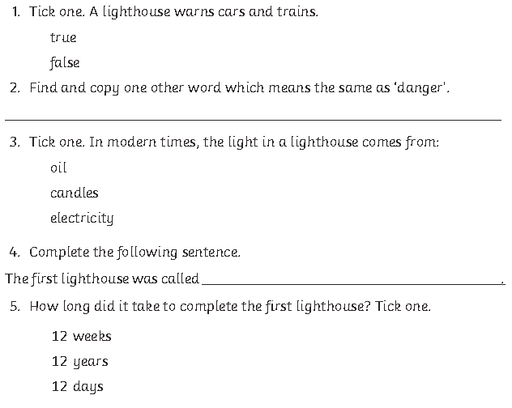
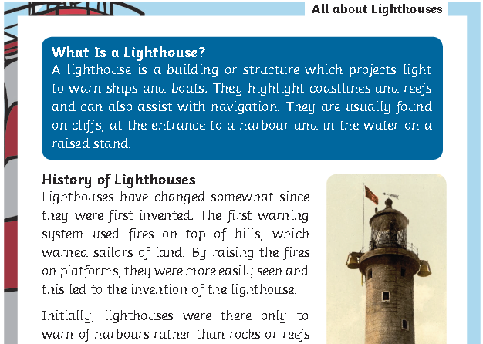
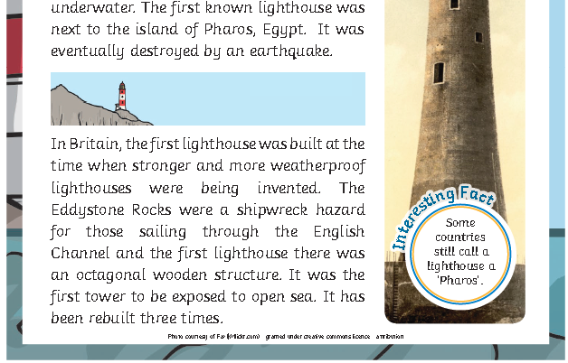
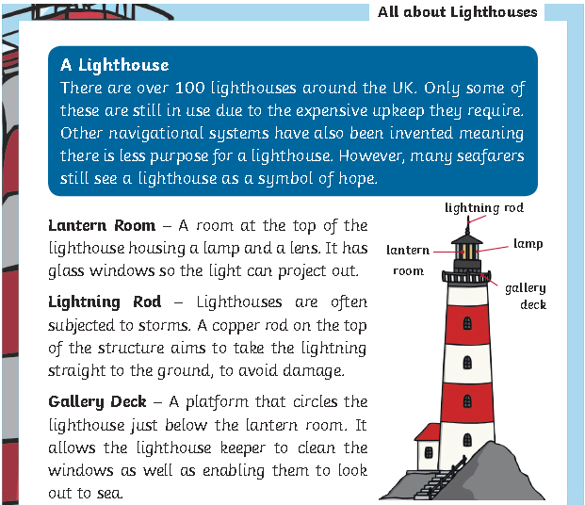
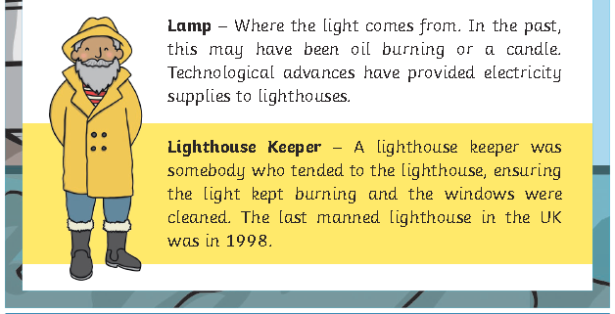
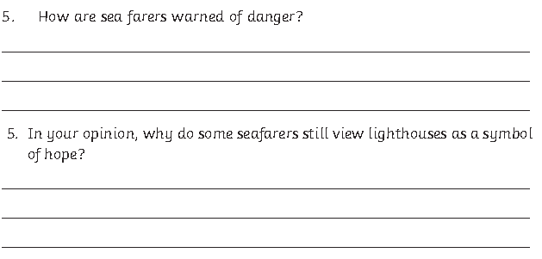
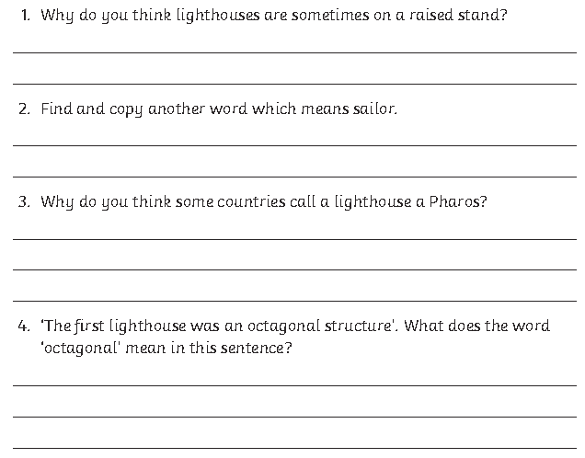
Lesson 3 – Letter writing
Read the letter from Mr Kind (the fisherman at the end of The Lighthouse Keeper’s Lunch) who is now having a problem with the seagulls pinching his lunch, instead of Mr Grinling’s. Imagine you were Mr Grinling and had received the letter. What would you reply? Write a letter to Mr Kind in role as Mr Grinling, giving him your best advice on how to stop the seagulls. There is a list on the next page of ideas to include in order to try to make your letter your best writing!

Mr Kind
Fisherman’s Cottage
Lighthouse Village

Dear Mr Grinling,
I’m having a real problem with some pesky seagulls that keep pinching my lunch every morning. I’ve heard that you’ve recently had a similar problem. Is this true? Please tell me you have because I would really like your help.
The scavenging seagulls keep swooping down and eating my food when I’m not looking. As you can imagine, this is most annoying! Why don’t they pinch my fish instead? I feel hopeless! I just want to eat the whole of my delicious lunch in peace.
Could you please give me some great ideas to try and stop the seagulls because I don’t think I can go hungry any more?
I would be thankful if you could send a fast reply.
From Mr Kind (the fisherman)

In your writing, can you include…
Conjunctions
because when if that

Contractions
can’t don’t wasn’t you’re I’ll

Year 2 Challenge Words
poor behind eye hour most

hold great after could should

would fast whole even every

A question with a ?
Who Where What When

Imperative Verbs
Put Add Squeeze Pour
Turn Mix Cut Spread
______________________________________________________________________________________________________________________________________________________________________________________________
Mr & Mrs Grinling
Little White Cottage
High Cliffs
Lighthouse Village
___________________________
_________________________________________________________________________________________________________________________________________________________________________________________________________________________________________________________________________________________________________________________________________________________________________________________________________________________________________________________________________________________________________________________________________________________________________________________________________________________________________________________________________________________________________________________________________________________________________________________________________________________________________________________________________________________________________________________________________________________________________________________________________
Extension
Read these riddles that include each of the four sentence types. Can you solve the riddles and work out what animals they are?
Statement
Exclamation
Command
Question
I have a long, fluffy mane.
What sharp teeth I have!
Don't try to stroke me!
Can you hear me roar?
What am I? ____________

I like to dart around in the blue ocean.
What a clever animal I am!
Don't put your hands near my blowhole.
Would you like to swim with me?
What am I? ____________

Now can you have a go at writing your own animal riddle, using each of the four sentence types?

________________________________________________________________________________________________________________________________________________________________________________
What am I?

________________________________________________________________________________________________________________________________________________________________________________
What am I?

