Year 2 Home Learning Menu – Week 5
Literacy  The word ‘said’ is a criminal word and has been put in word jail!  Can you think of 10 other words you could use instead of ‘said’?  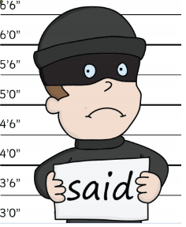  These are called synonyms. Can you now put your synonyms into sentences? | Guided Reading  Can you read the character descriptions and use the information to draw a detailed picture of each of the characters from the story. Now listen to Miss Stratton read the story ‘Pirates Next Door’. Can you answer the comprehension questions?  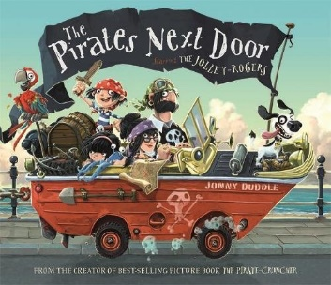 | Science  This term our topic is ‘Plants’.  To start our topic, when you complete your daily exercise or even in your own outdoor space at home. Can you go on a plant hunt? How many different flowers and plants can you find?  Draw, colour and label the different plants you find.  Challenge! – Can you spot any minibeasts too?
French  Follow the links provided in the Y2 Home Learning tab to learn numbers 1-10 in French!  Can you record yourself saying them and send it to us?  Can you teach a family member how to say them?  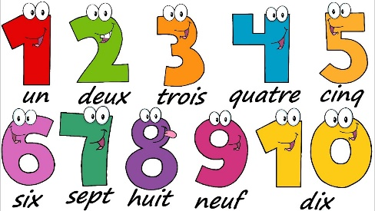 | Maths  Log on to MyMaths and complete the Division homework. | DT  With the weather heating up it’s the perfect time to make a healthy snack to enjoy in the sunshine! Can you design your own fruit kebab using your favourite fruit? Have a go at making it and after think about whether you would change anything.  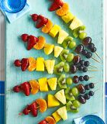  Don’t forget to send us some photos!  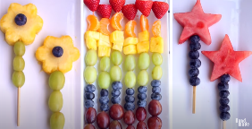  Challenge! – Can you write instructions of how to make your fruit kebab?
Try to complete as many of the activities on this menu as you can during the week. If you would like to do extra work, you can log onto your Times Table Rock Stars, My Maths and Oxford Owl accounts or look on the links on the school website for other fun websites for different activities.

