Home Learning 4.5.20-8.5.20
Maths Answer
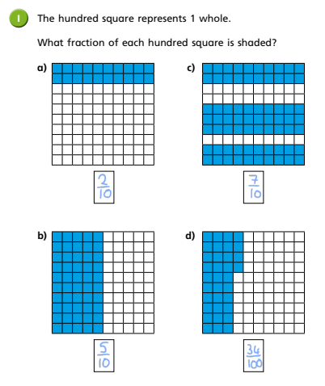
Lesson One:
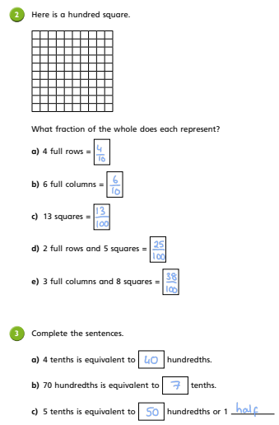

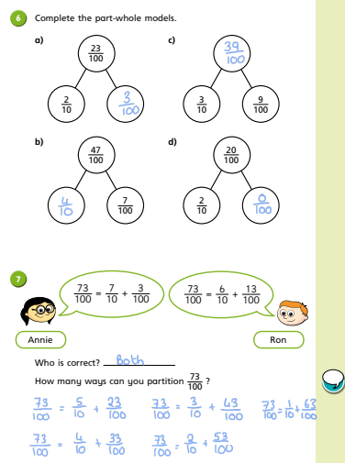
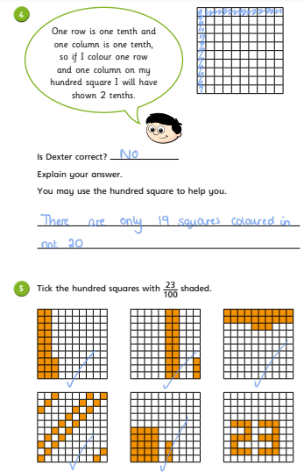

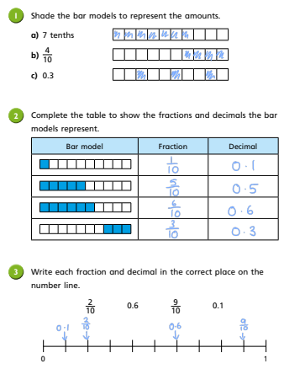
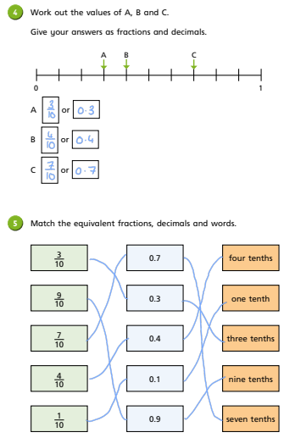
Lesson 2: tenths as a decimal.

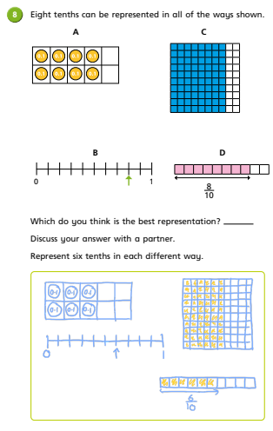
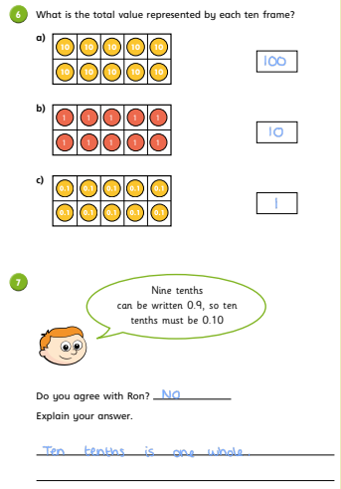

Lesson 3: Test style questions. There are fewer questions here, due to the volume of questions for the two previous activities.
- 0.4, 0.42, 0.49, 0.7, 0.73, 0.8, 0.95
0.4 = 0.40
0.7 = 0.70
0.8 = 0.80
- Decimals written as fractions.
  - 0.2 = 2/10 or 20/100
  - 0.67 = 67/100
  - 0.75 = 75/100 or ¾
  - 0.40 = 40/100 or 4/10

