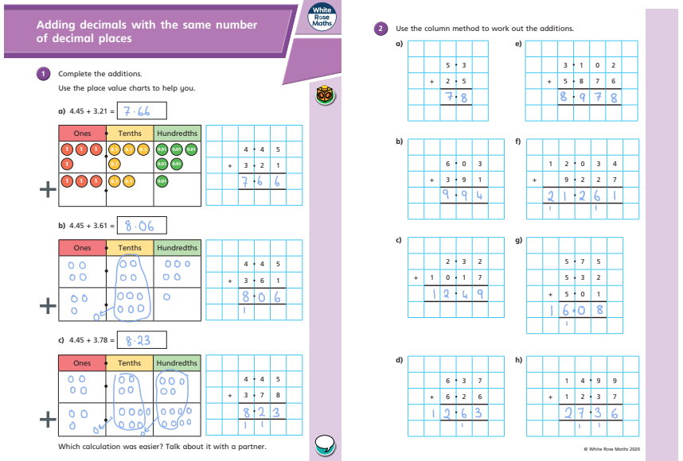
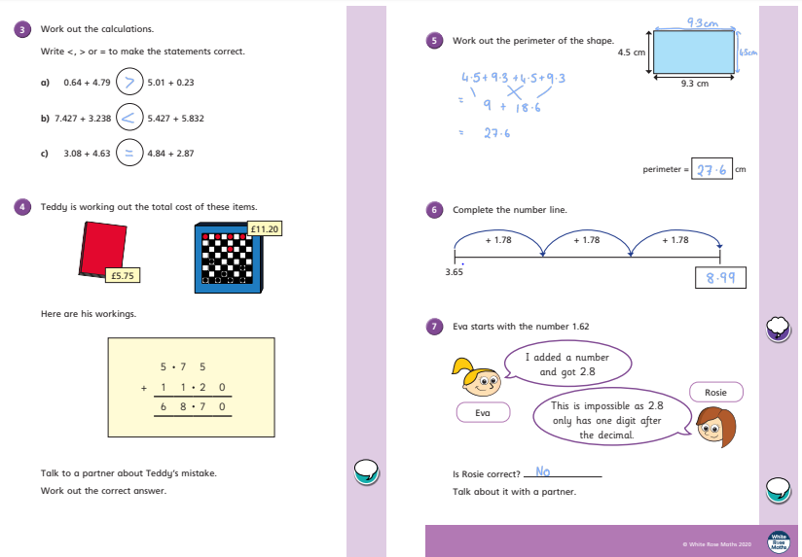
Maths Answer Pack – Week 8
Lesson 1 – Teach and Practise – Adding Decimals with the same number of Decimal places
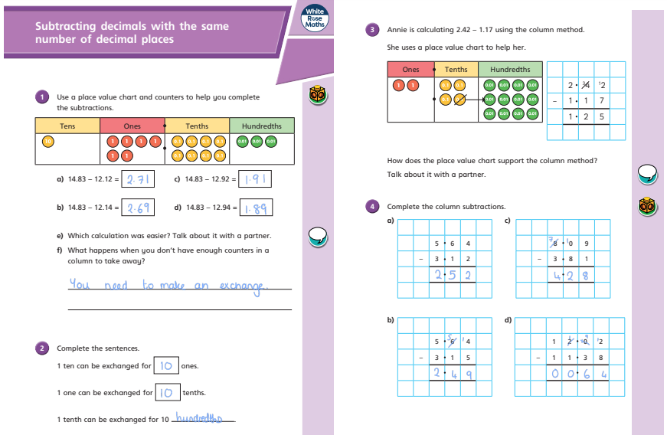
Lesson 2 – Teach and Practise – Subtracting Decimals with the same number of Decimal places
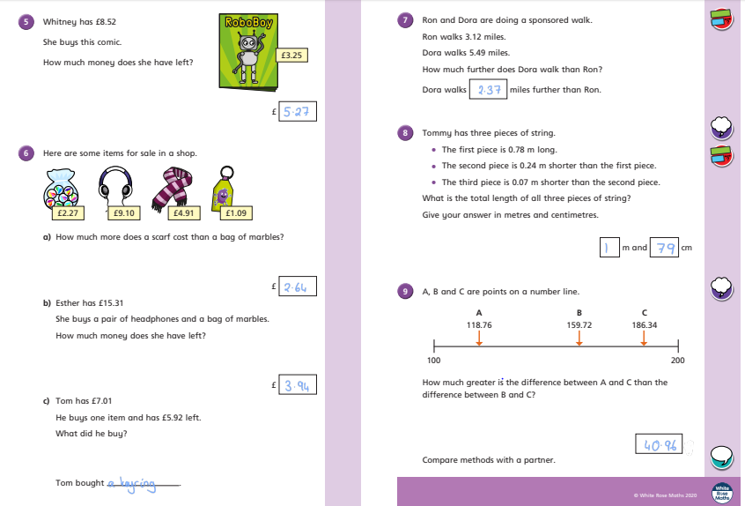
Question | Answer | Question  Lesson 3 – Challenge/Apply | Answer
EXAMPLE: 3 X 4 = | 12
1. 1364 + 9163 = | 10,527 | 6. 8 x 8 = | 64
2. 11 squared= | 121 | 7. 27 x 100 = | 2,700
3. 9 x 8 = | 72 | 8. 20 x 6 = | 120
4. 7 x 6 = | 42 | 9. 2278- 2059 = | 219
5. 560 + 200 = | 760 | 10. 15609 + 23452 = | 39,061
1.A 6.78
5. 6.41 – 1.09 = 5.32
3.94 – 3.06 = 0.88

6. Holly = 2.13l
George = 1.76l
Kieron = 3.52l
Hannah = 2.35l
9.76l

10.65l – 9.76l = 0.89l
Hannah is correct as there is 0.89l left, which is more than 0.5l.
1.B 8.91
2. 3.76 + 6.01 = 9.77
3.81 + 5.96 = 9.77
3.69 + 6.08 = 9.77
3. Accept any combinations that equal 14.69m or above, up to 15.03m.
4.A X
4.B correct
4.C X
4.D correct
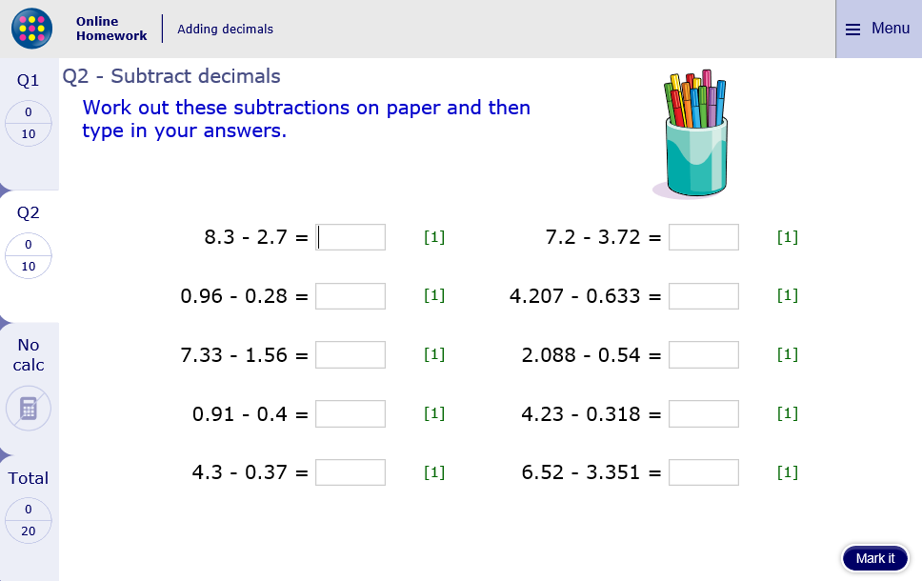
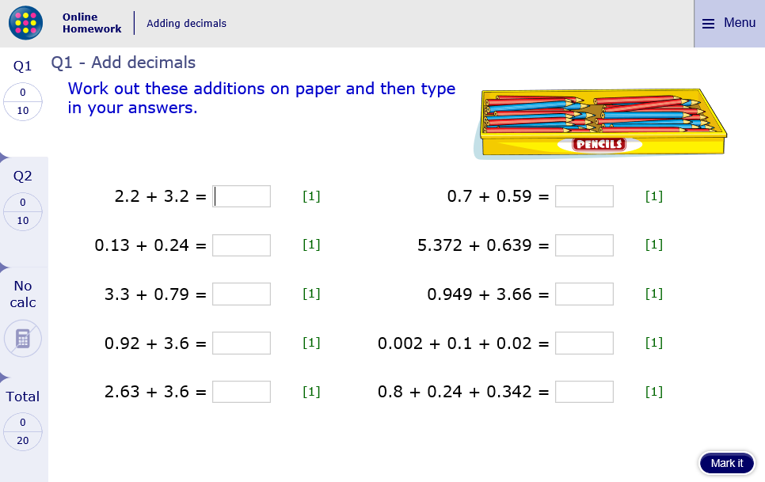
Extension – MyMaths Challenge
3.48
3.574
1.548
3.912
3.169
5.6
0.68
5.77
0.51
3.93
1.29
6.011
4.609
0.122
1.382
5.4
0.37
4.09
4.52
6.23

