Year R Home Learning Menu – 6.7.20
Try to complete as many of the activities on this menu as you can during the week. If you would like more, log on to Teach Your Monster to Read, Oxford Owls or use some of the websites provided in the original pack. Please remember to take photos of any of the activities anng upload onto EyLog so we can see what you have been doing!
Jungle Writing  Can you research a jungle animal on the computer?  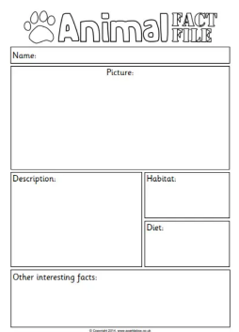  For more of a challenge, you could use the sheet in the pack to write an animal fact file. | 3D Shapes  Find some small objects that are 3D shapes, such as small ball, a building brick, a dice, a glue stick. Hide the objects in a bag. Then put your hand in the bag to choose one of the objects. Describe the shape to an adult and see if they can guess the shape you are holding. Then they could describe a shape for you to guess.  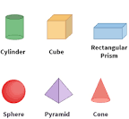 | Reading  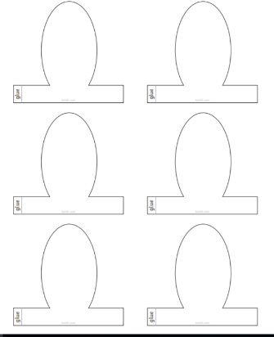  Retell a story you have read using toys and puppets. Can you remember what happened in the story? Tell your grown-up the story through a puppet show. You could draw the characters on the finger puppets in the pack.
Making a Snake  Can you make a snake? It could be a painting, a picture, a sock puppet, a paper chain or using up unwanted cardboard boxes or containers.  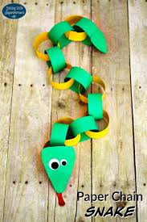 | Tally Chart  Can you use the tally chart provided to create a tally chart of your family’s favourite animal.  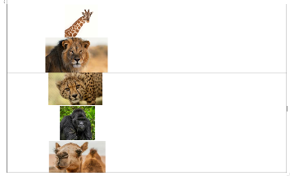  For more of a challenge, you could create your own tally charts on other favourite things. | Yoga  https://www.youtube.com/watch?v=ZvJH8Kbzj54  Follow the Cosmic Kids yoga video. Lulu the Lioness.  