Maths Answers
Lesson 1 – Recognising coins and counting and comparing amounts

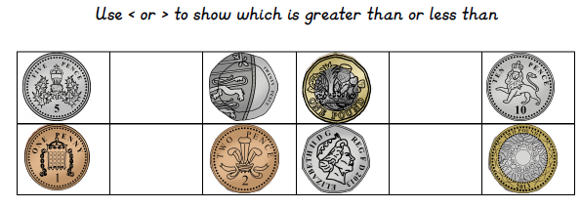
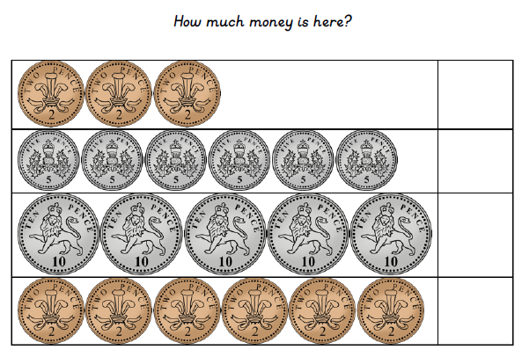
12p
50p
30p
6p
>
<
<
<
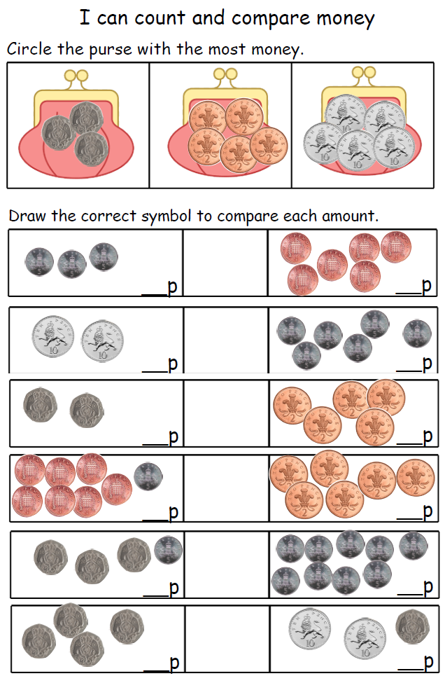
40
80
45
65
12
12
10
40
30
20
6
15
>
>
=
>
>
<

Lesson 2 – Finding different combinations of coins to make the same amount
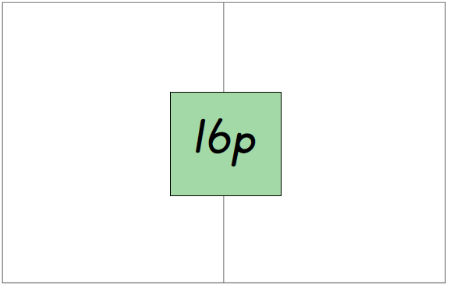

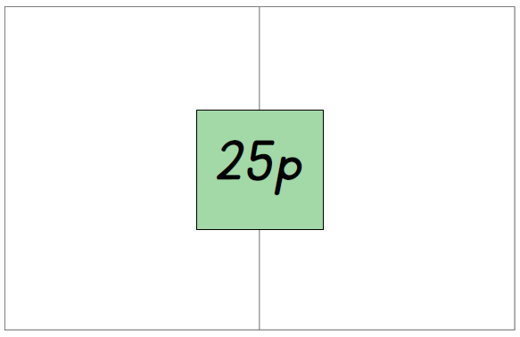
5p
20p
5p
10p
10p
2p
2p
2p
10p
10p
5p
1p
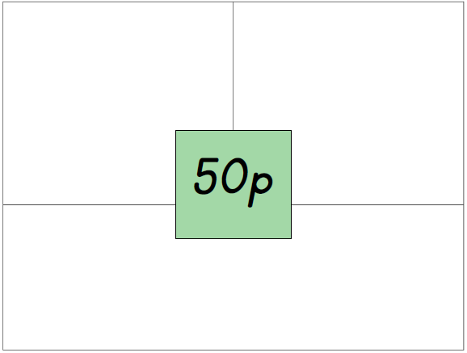

20p
20p
50p

10p

10p
10p
10p
10p
10p

Chilli Challenge!
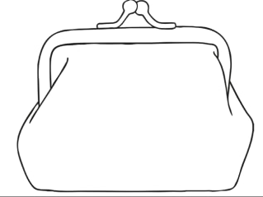
I have 26p in my purse. I only have three coins. What coins are in my purse?

1p
20p
5p

Extra Hot Chilli Challenge!
What if I now had four coins. How could I make 26p?

10p
10p
5p
1p

