Week 14 English Support Pack
In this pack, you will find all of the instructions, resources, and questions that you will need to complete your English lessons for this week. We are carrying on with our Summer text driver, Cogheart. This week, we will be looking at Chapter 4. Chapter 4 is read by Miss Riley and will have the pages of the book shown in the video recording on the website and the VLE.
Lesson 1 –Guided Reading
Starter:
How many words can you make with these letters?
a e c s n t

Lesson:
Listen again to Chapter 4 on the website or VLE. It is a long Chapter so we have decided to look into it further this week!
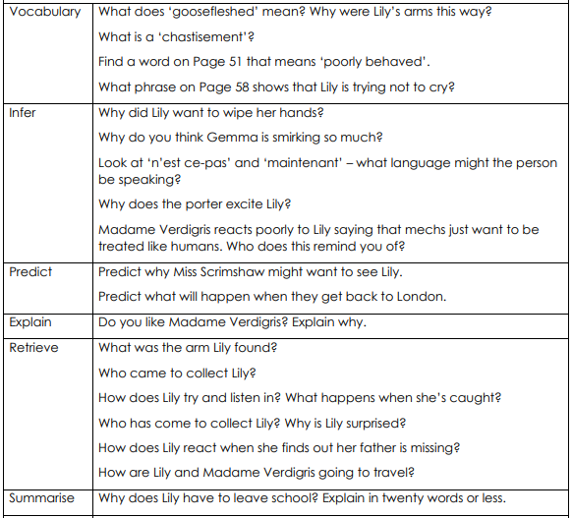

Lesson 1 Answers
Lesson 2 – Guided Reading
Starter:
Starting with the word ‘beach’, how long can you make your word chain? Each word has to begin with the last letter of the word before. E.g. beach, happy, yellow, watch…

Lesson:
Design your own Airship! Be as creative as you can. Label your drawing with specific phrases to show off how creative your design is!

Lesson 3 – Writing

Starter:
Can you rearrange each line of letters to make a word? You have to use all the letters!
l a m n i a

l c c k o

e s f r o t

Lesson:
Imagine you are Lily and you step foot into your Father’s shop after he has gone missing. Write a descriptive paragraph to show how she felt and what she feel, hear, see smell and touch.

Example:
Stepping into my Father’s shop, I notice the brittle, broken clock – ticking every 3 seconds – lying on the floor. The smell of rust and leather ran through the air bouncing from wall to wall. The sounds of the clocks ticking are making me more relaxed by each second. Where could my Farther be? Reaching out, I slid my hand across the splintered, wooden table, feeling the dust particles that had gathered, before sneezing. I wish my Father would come back. I would give anything to see him again.

Extension: Draw a picture to show what you think Lily looked like in her dusty dress with her suitcase in this chapter.

