History Lesson:

Can you cut out these pictures and sort them into old (toys from the past), and new (toys from the present day)
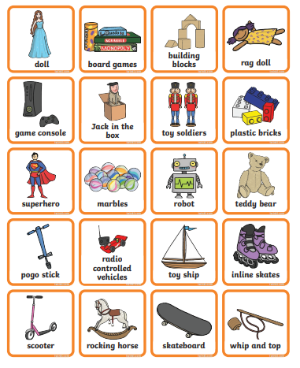

Geography Lesson:
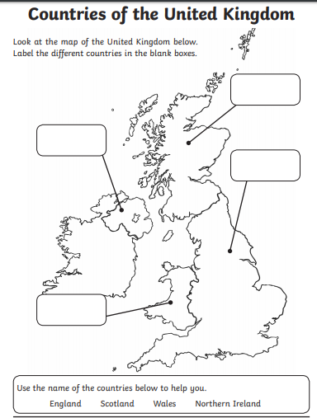

French Lesson:
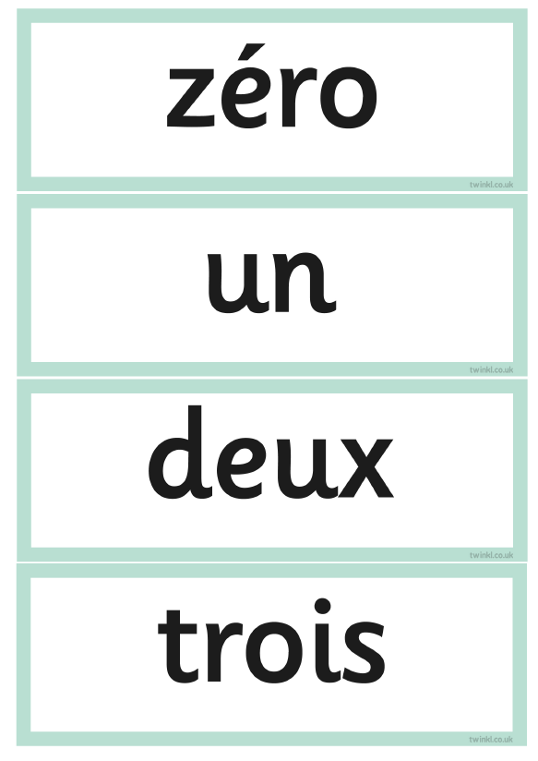 0, 1, 2, 3 (twah),
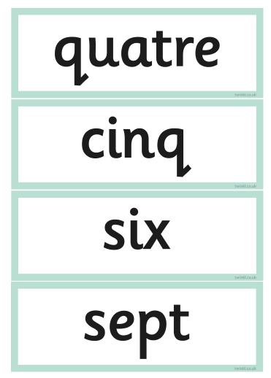4(cat), 5(sank), 6(sees), 7(set)
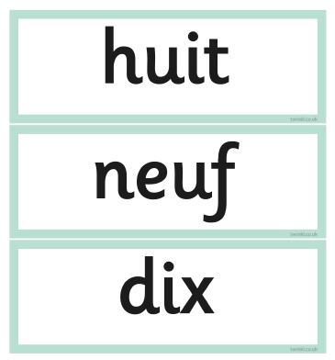8(weet), 9(nerf), 10 (dees)

