Year 2 English Support Pack – Week 6
In this pack, you will find instructions on how to complete your English lessons for this week. This week we are using the story The Pirates Next Door by Johnny Duddle as a focus for our English work. You can hear the story read by Miss Stratton on the VLE or the website, under the Year 2 home learning tab.
Lesson 1 – Vocabulary
Read the vocabulary from the story carefully. Which other words have the same meaning and could be used instead? Circle them.
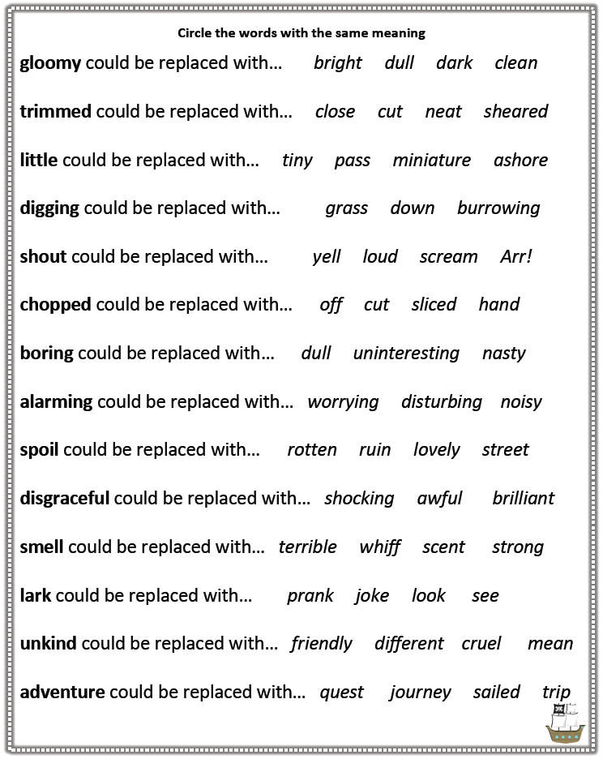
Lesson 2 – Story planning
Now you know the story, try to think of the six main parts. What happens in the most important parts of the story? Draw pictures to create a storyboard showing the six main parts.
4 | 1
5 | 2
6 | 3
Lesson 3 – Story writing
Now you have planned the story, it is time to re-write it in your own words. Can you improve the story as you are writing it, by adding extra detail or changing some of the vocabulary, using the synonyms you learnt in lesson 1?
Have a look at my example below to help you. I have only started the story, but you need to try and write the whole story. You can either write yours on paper and send a photo of it to me on the VLE, or you can type your story into a message on the VLE. There is a checklist on the next page to help you with what to include.

It had been a quiet week in the gloomy seaside town of Dull-on-Sea. Everything was looking beautiful on Matilda’s street. The lawns were mowed, the cars were washed and the hedges sheared neatly. The house next door to Tilda’s had been for sale since she was a baby and she desperately wanted a friend to move in to play with. One day, Tilda was out riding her bike when she saw a boy! A pirate boy! “AHOY!” he called. He had patched-up jeans, an eyepatch and a wooden-legged dog! “We’re the Jolley-Rogers,” shouted the boy. “We’ve had to come ashore to fix our ship.”
The next morning, Tilda was thrilled with her new friend that had moved in next door. But her parents were not so thrilled! “We’d rather you were friends with NORMAL girls and boys,” they exclaimed.

Checklist of things to try and include in your story:
- Year 2 challenge spellings
- Speech
- Time related words
- Conjunctions (and, but, or, when, if, that, because)
- Punctuation (full stops, exclamation marks, commas)
- Capital letters
______________________________________________________________________________________________________________________________________________________________________________________________________________________________________________________________________________________________________________________________________________________________________________________________________________________________________________________________________________________________________________________________________________________________________________________________________________________________________________________________________________________________________________________________________________________________________________________________________________________________________________________________________________________________________________________________________

